**Mars Quest**

**NASA’s Mission to the Desert Planet**

**Developed by:   
Dr. Dan Bruton, Physics**

**Module Overview:**

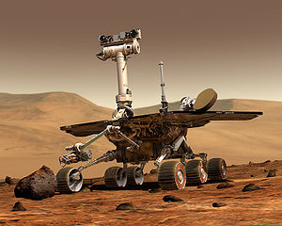NASA's Mars Exploration Rover Mission (MER) is an ongoing robotic space mission which involves two rovers, Spirit and Opportunity, that explore the planet Mars. The mission began in 2003 by sending these two rovers to explore the Martian surface and geology. The mission's scientific objective was to search for, and characterize, a wide range of rocks and soils that hold clues to past water activity on Mars.

Students will first be informed about the Martian environment by attending a planetarium show called “Mars Quest”. The planetarium show is followed by hands-on robotic challenges that are similar to those encountered by NASA’s Mars Exploration Rover team.

**Objectives:**

After watching the planetarium show the students will be able to identify the difficulties that manned-missions to Mars face in order to better understand the need for robotic missions.

During the robot activities the students will be able to convert angular distances to linear distances in order to accurately program their robot rover to travel through a simulated Martian landscape.

**Equipment and Supplies:**

* 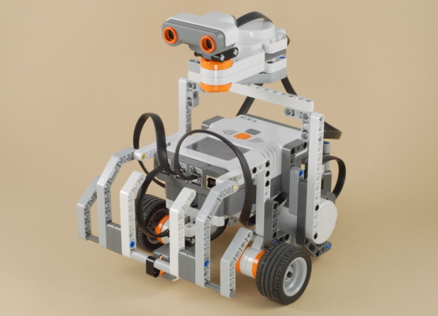Planetarium Show Tickets ($2 each)
* NXT Mindstorm Robots
* Meter Sticks
* Timers
* Protractors
* Calculators
* Metric Tape Measures
* Student Investigations Handouts

**Resources:**

* Construction Plans for the Robot Rover
* Programming Guide for the NXT Mindstorm Cube
* Science and Mathematics TEKS

**Process:**

* 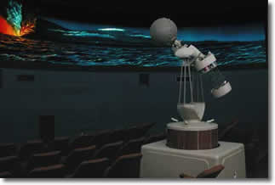The process will begin with a planetarium show called "Mars Quest" that gives students and overview of the Martian environment. The educational content of this show is given as an attachment to this document. An alternative to this planetarium show would be a PowerPoint show that shows the Martian terrain and an overview of Mars exploration.
* After the planetarium show the students will move to the robotics lab and construct a robot rover. Students will be assigned to a team of 3 or 4 students.
* Participants will use the NXT Mindstorm robot technology to construct and program basic robotic structures that simulate the Mars Exploration Rovers. Instructors will introduce the fundamentals of construction and 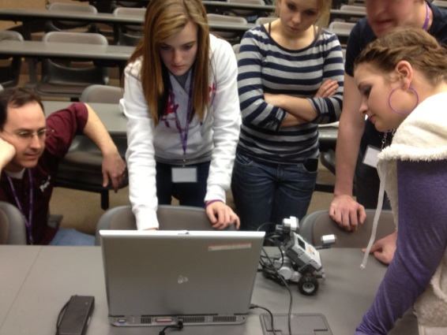programming, while also allowing for students to learn through experimentation and guidance.
* Students will use a basic design with 2 motors, 3 wheels, and 3 sensors. The first challenge will be to accurately move the robot rover to a simulated Martian rock that can be analyzed with a light sensor. The goal will be to get the rover as close as possible to the rock without hitting it.
* 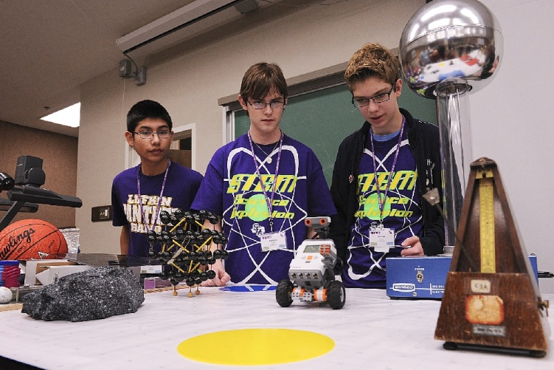*Math Moment: What’s π?* Students will discover *π* by measuring several circular objects and examining the ratio of the circumference and the diameter. Each group will be given one cylindrical object (one of which will be the wheel from the rover) and will measure the circumference and diameter. The group will then be asked to calculate the ratio of the circumference to the diameter. Each group will then report out their calculated ratio. This ratio will then be defined to be the approximation of *π*.
* Students will determine the circumference of the wheels mathematically and experimentally. Students will use the circumference of the tires to calculate the number of wheel rotations required to achieve this goal.
* The final activity will be to program the robot to navigate through obstacles (rocks and craters) in a simulated Martian environment. This requires accurate turning and linear travel. The touch sensor, ultrasonic sensor, and sound sensor may be used to help the robot rover navigate through the obstacle course.

**Timeline:**

Mars Quest Planetarium Show 40 minutes

Math Moment: *What’s π?* 10 minutes

Objective I Circumference Calculations 25 minutes

Objective II Speed Calculations 25 minutes

Objective III Angle Calculations 25 minutes

Objective IV Programming the Robot 45 minutes

*Total time required: 2 hours 50 minutes*

**Mars Quest Investigation**

NASA's Mars Exploration Rover Mission (MER) is an ongoing robotic space mission which involves two rovers, Spirit and Opportunity, that explore the planet Mars. The mission began in 2003 by sending these two rovers to explore the Martian surface and geology. The mission's scientific objective was to search for, and characterize, a wide range of rocks and soils that hold clues to past water activity on Mars.

**Project**: NASA is in the market for a new Mars rover. You are required to design and construct a robot that is capable of following a set of commands to explore the planet's surface. Before the robot is deployed, it must be extensively tested to ensure it will perform as expected. You can't fly a technician to Mars to reboot the robot!

**Equipment Required (per group):**

* 1 NXT robot
* 1 laptop computer
* 1 meter stick
* 1 metric measuring tape
* 1 timer
* 1 circular container (at least 5 containers for the module)
* 1 meter of string

**What’s π?**

Using the materials provided, measure the circumference and diameter of object provided to your group. In the Mystery Ratio column, calculate the ratio of the **Circumference** to the **Diameter** for each object.

|  |  |  |  |  |
| --- | --- | --- | --- | --- |
| **Group** | **Object Name** | **Circumference in centimeters** | **Diameter in centimeters** | **Mystery Ratio** |
| **Group A** | **Cylinder 1** |  |  |  |
| **Group B** | **Cylinder 2** |  |  |  |
| **Group C** | **Cylinder 3** |  |  |  |
| **Group D** | **Cylinder 4** |  |  |  |
| **Group E** | **Cylinder 5** |  |  |  |

**Objective #1: How many rotations?**

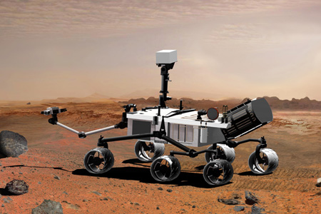On Mars, the robot rovers must get their sensors as close to the rock samples as possible in order to be able to measure their composition. You will program your robot to move from the start line on the table in the front of the room to a rock sample that is 90 centimeters away. Your mission is to determine how many rotations of your robot’s wheels will get your robot's sensor less than 1 centimeter away from the rock sample without hitting the rock.

The first step required is to characterize the robots performance. This means, take measurements to determine the specifications of the robot’s movement. Calculating the circumference of the robot rover's wheels can be done either *mathematically* or *experimentally*.

Mathematically: The circumference of a wheel can be calculated using the formula

c = π × d

where *c* is the ***circumference*** of the wheel, π = 3.14 (approximately) and *d* is the ***diameter*** of the wheel.

Measure the diameter of the wheel and calculate its circumference.

Diameter of the Wheel: d = _______________ centimeters

Circumference of the Wheel: c = π × d =_______________ centimeters

Experimentally: Locate a spare tire for the rover and make a mark on the tire with either chalk or masking tape. Create a starting mark on the table and line up our tire mark with it. Now slowly roll the wheel until the tire mark again touches the ground. Make another mark at this point and use a ruler to measure the distance.

Experimental Circumference of the Wheel: c =_______________ centimeters

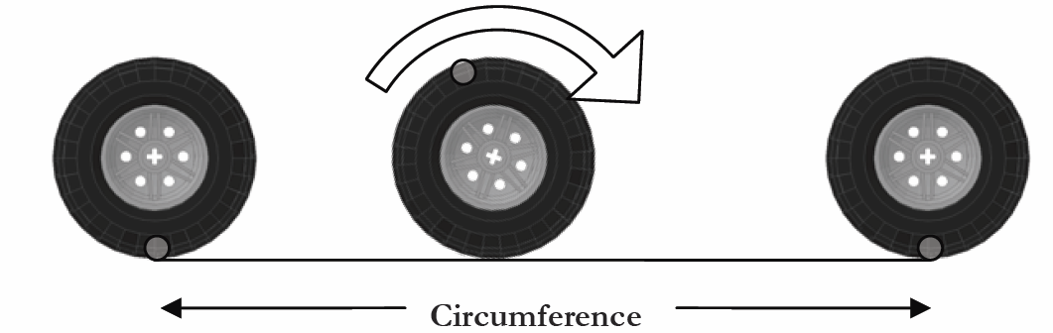

Based on your results above, how many rotations must the wheel make in order to travel 90 centimeters?

$$Number of Rotations= \frac{Distance to Travel}{Circumference of the Wheel}$$

*Number of Rotations = ___________ rotations*

**Programming the Rover $\frac{distance to travel}{circumference of the wheel}$**

1. 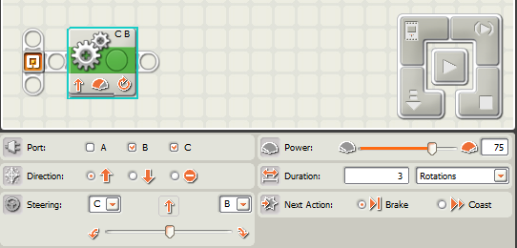Now connect your rover to the laptop computer using a USB cable. Drag the "Move" action cube over to the workspace and configure it to rotate 3 times as shown below.

**Step 1.** Place "Move" Action Cube

**Step 3.** Click Here to Run

**Step 2.** Set to 3 Rotations

1. Run the program on the robot rover and measure that distance that it travels. Did the rover travel 3 times the circumference of your wheels?
2. Now change the number of rotation so that the rover travels 90 centimeters. Create a testing area at your station that consists of a start line made of tape and an object that will represent a Martian rock.
3. Position your rover behind the start line and see how close your rover's sensor gets to the rock. If the sensor touches the rock, write "BANG" in the "How Close..." column. Note that robots are not perfect so you will need to adjust the wheel rotations to achieve the best results.
4. Re-program your rover with 5 different rotation values in an effort to improve your robots performance. Record your results below.

|  |  |  |
| --- | --- | --- |
| **Trial** | **Wheel Rotations** | **How Close in Millimeters?** |
| 1 |  |  |
| 2 |  |  |
| 3 |  |  |
| 4 |  |  |
| 5 |  |  |

**Objective #2: Speed Calculation**

The robot rovers can travel fast across hard-flat surfaces on Mars but it must travel slowly in the sandy dunes to avoid getting stuck. Measure the speed of your rover for different motor power levels and record your results below.

To calculate the speed, find the number of seconds required for your rover to travel 1 meter. Recall: $Speed= \frac{Distance}{Time}$

$$Speed= \frac{Distance}{Time}$$

Note that 1 meter/second = 2.23 miles/hour.

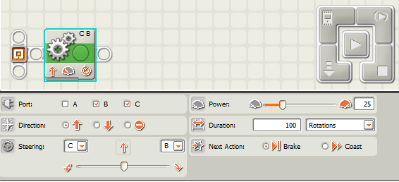

25% Power

100 Rotations

|  |  |  |  |  |
| --- | --- | --- | --- | --- |
| **Group** | **Motor Power**  **Level** | **Time Required to**  **Travel 1 Meter (seconds)** | **Speed (meter/second)** | **Speed**  **(miles/hour)** |
| Group A | 20% |  |  |  |
| Group B | 40% |  |  |  |
| Group C | 60% |  |  |  |
| Group D | 80% |  |  |  |
| Group E | 100% |  |  |  |

**Objective #3: Maneuvering the Robot**

The robot rovers must make accurate turns on Mars to avoid obstacles. Measure the angle that your rover rotates when you use different wheel rotation values.

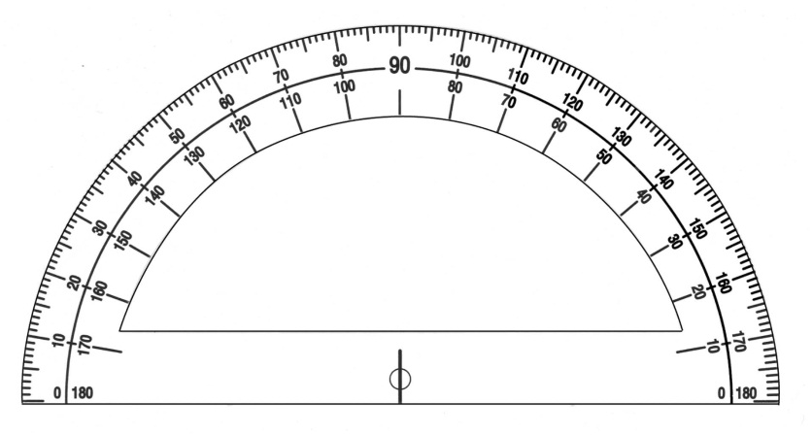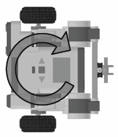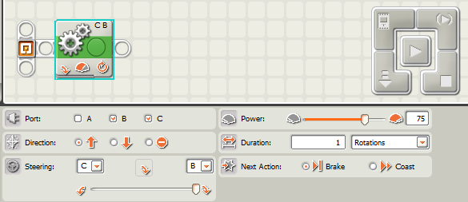

Sharp Turn

Set Rotations

|  |  |
| --- | --- |
| **Wheel Rotations** | **Robot Turn Angle (Degrees)** |
| 1 |  |
| 2 |  |
| 3 |  |
| 4 |  |
| 5 |  |

**Objective #4: The Obstacle Course**

On Mars, the robot rovers must navigate through the terrain and avoid rocks and craters. You will program your robot to move from the "Start Point" through obstacles to the "Check Point". The rover must then go over a "Crossing" and navigate to the "End Point". See an example obstacle course on the next page. If the rover hits an obstacle or goes out of the boundary then the rover must start the trip over again. The landscape will be marked with a grid so that you can quickly measure the distances between objects on the simulated Martian landscape.

The steering angle is controlled via the slider bar at the bottom of the configuration panel. This will range from a gentle turn to a tight turn on the spot depending on how far this slider is taken.

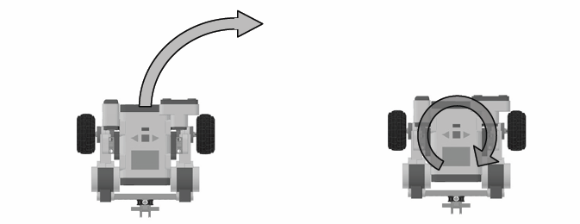

**Gentle Turn Sharp Turn**

By connecting "Move" action cubes together you can command the robot rover to perform a series of tasks.

**Example Program**

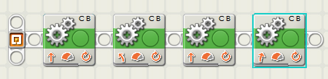

Turn Left Sharply 0.4 rotations

Move forward 2.2 rotations

Turn Left Sharply 0.7 Rotations

Move forward 1.75 Rotations

**Team Evaluations**

1. How many "Move" actions cube were required to reach the check point? What did you think the minimum number of "Moves" might be?

2. Does high power or low power for the motors give you high accuracy movement?

3. How many seconds were required to reach the "End Point" on the obstacle course? How could you improve upon this time?

4. We used "dead reckoning" for robot motions in this activity. What kind of sensors could we use to improve upon the accuracy of motion of the robot rover?**Mars Quest Obstacle Course**

**Crossing**

**Canyon**

**Sand Dunes**

**Flat Lands**

**The "Mars Quest" Planetarium Show**

* [](http://www.physics.sfasu.edu/planetarium/shows/mq.html)The Mars Quest planetarium show traces humanity’s centuries-long cultural and scientific fascination with the planet Mars. In the show's first section, "Homage," we trace Mars through history. We explore Mars all the way from an "incantation" of the various War God forms given by different cultures to the early observations of Schiaparelli and Lowell, and the infamous "canals" which led to science-fiction stories about Martians. We hear excerpts from H. G. Wells’s "War of the Worlds" and Edgar Rice Burroughs's "Barsoom" novels.
* "Mars In Focus" details the Mars of our time as seen in the night sky, through binoculars and telescopes, and from our Mars explorations. Mission findings from Viking, Pathfinder and Mars Global Surveyor feature reports on Mars weather, climate, and atmosphere. We compare the climate and terrain of both Earth and Mars, and present the current thinking about the atmospheric history of the planet, and a rationale for future exploration.
* “Mars in the Future” examines how on Earth we can prepare to live on Mars, what will be needed to get crewed missions to the Red Planet, and what the first landing may be like.
* The show ends with “Rhapsody on a Red Planet,” a poetically-styled “ode to Mars,” this time from a future perspective. It is an eloquent soliloquy tracing the efforts that led to humanity’s first footsteps onto the desolate and dusty Martian surface.

**Mars Quest Planetarium Show - Science Education Content**

The focus of Mars Quest is to present Mars via a set of multidisciplinary themes. These ideas are woven throughout the program and help relate the information presented in the show to the lives of students, families, and the general public. Show content is relevant in the following subject areas:

* **Physical Sciences:**

· Positions and motions of Earth and Mars

· Mars and Earth orbits, relative positions over time

· Orbital effects on climate, seasons

* **Earth and Space Sciences:**

· Objects in the sky: Earth, Mars, Mars satellites

· Comparative planetology of Earth and Mars

· Mars environment, climate change, evolution, surface

* **Life Sciences:**

· The search for life on Mars and likely environments where it might exist

* **Science and Technology:**

· Mars through binoculars, telescopes

· Exploration of Mars by spacecraft missions

· Technological challenges of future explorations

· Science drivers for Mars exploration

· Remote sensing and spacecraft

· Technological planning for future Mars studies

* **History of Science/Science as a Human Endeavor:**

· The ancient perception of Mars as a war god

· The scientific exploration of the planet

· Mars in science fiction and fantasy

· Future human exploration of the planet

* **This show adheres to principles put forth in the National Academy of Sciences’ Education Standards published in 1996. For more details, visit the NAS Standards Web site at: http://books.nap.edu/html/nses/html/index.html**

**Science TEKS:**

* 6.11 Earth and space. The student understands the organization of our solar system and the relationships among the various bodies that comprise it. The student is expected to:
* (A) describe the physical properties, locations, and movements of the Sun, planets, Galilean moons, meteors, asteroids, and comets;
* (B) understand that gravity is the force that governs the motion of our solar system; and
* (C) describe the history and future of space exploration, including the types of equipment and transportation needed for space travel.
* 7.2 Scientific investigation and reasoning. The student uses scientific inquiry methods during laboratory and field investigations. The student is expected to:
* (A) plan and implement comparative and descriptive investigations by making observations, asking well-defined questions, and using appropriate equipment and technology;
* (B) design and implement experimental investigations by making observations, asking well-defined questions, formulating testable hypotheses, and using appropriate equipment and technology;
* (C) collect and record data using the International System of Units (SI) and qualitative means such as labeled drawings, writing, and graphic organizers;
* (D) construct tables and graphs, using repeated trials and means, to organize data and identify patterns; and
* 7.9 Earth and space. The student knows components of our solar system. The student is expected to:
* (A) analyze the characteristics of objects in our solar system that allow life to exist such as the proximity of the Sun, presence of water, and composition of the atmosphere; and
* (B) identify the accommodations, considering the characteristics of our solar system, that enabled manned space exploration.
* 8.2 Scientific investigation and reasoning. The student uses scientific inquiry methods during laboratory and field investigations. The student is expected to:
* (E) analyze data to formulate reasonable explanations, communicate valid conclusions supported by the data, and predict trends.
* 8.3 Scientific investigation and reasoning. The student uses critical thinking, scientific reasoning, and problem solving to make informed decisions and knows the contributions of relevant scientists. The student is expected to:
* (A) in all fields of science, analyze, evaluate, and critique scientific explanations by using empirical evidence, logical reasoning, and experimental and observational testing, including examining all sides of scientific evidence of those scientific explanations, so as to encourage critical thinking by the student;
* (B) use models to represent aspects of the natural world such as an atom, a molecule, space, or a geologic feature;
* (C) identify advantages and limitations of models such as size, scale, properties, and materials; and
* (D) relate the impact of research on scientific thought and society, including the history of science and contributions of scientists as related to the content.
* 8.4 Scientific investigation and reasoning. The student knows how to use a variety of tools and safety equipment to conduct science inquiry. The student is expected to:
* (A) use appropriate tools to collect, record, and analyze information, including lab journals/notebooks, beakers, meter sticks, graduated cylinders, anemometers, psychrometers, hot plates, test tubes, spring scales, balances, microscopes, thermometers, calculators, computers, spectroscopes, timing devices, and other equipment as needed to teach the curriculum.

8.9 Earth and space. The student knows that natural events can impact Earth systems. The student is expected to:

* (C) interpret topographic maps and satellite views to identify land and erosional features and predict how these features may be reshaped by weathering.

**Mathematics TEKS:**

* 7.3 Patterns, relationships, and algebraic thinking. The student solves problems involving direct proportional relationships. The student is expected to:
* (B) estimate and find solutions to application problems involving proportional relationships.
* 7.4 Patterns, relationships, and algebraic thinking. The student represents a relationship in numerical, geometric, verbal, and symbolic form. The student is expected to:
* (A) generate formulas involving unit conversions within the same system (customary and metric), perimeter, area, circumference, volume, and scaling; and
* (B) graph data to demonstrate relationships in familiar concepts such as conversions, perimeter, area, circumference, volume, and scaling.
* 7.7 Geometry and spatial reasoning. The student uses coordinate geometry to describe location on a plane. The student is expected to:
* (A) locate and name points on a coordinate plane using ordered pairs of integers.
* 7.8 Geometry and spatial reasoning. The student uses geometry to model and describe the physical world. The student is expected to:
* (C) use geometric concepts and properties to solve problems in fields such as art and architecture.
* 7.9 Measurement. The student solves application problems involving estimation and measurement. The student is expected to:
* (A) estimate measurements and solve application problems involving length (including perimeter and circumference).
* 7.13 Underlying processes and mathematical tools. The student applies Grade 7 mathematics to solve problems connected to everyday experiences, investigations in other disciplines, and activities in and outside of school. The student is expected to:
* (A) identify and apply mathematics to everyday experiences, to activities in and outside of school, with other disciplines, and with other mathematical topics; and
* (B) use a problem-solving model that incorporates understanding the problem, making a plan, carrying out the plan, and evaluating the solution for reasonableness.
* 8.3 Patterns, relationships, and algebraic thinking. The student identifies proportional or non-proportional linear relationships in problem situations and solves problems. The student is expected to:
* (B) estimate and find solutions to application problems involving percents and other proportional relationships such as similarity and rates.
* 8.7 Geometry and spatial reasoning. The student uses geometry to model and describe the physical world. The student is expected to:
* (B) use geometric concepts and properties to solve problems in fields such as art and architecture; and
* (D) locate and name points on a coordinate plane using ordered pairs of rational numbers.
* 8.10 Measurement. The student describes how changes in dimensions affect linear, area, and volume measures. The student is expected to:
* (A) describe the resulting effects on perimeter and area when dimensions of a shape are changed proportionally.
* 8.14 Underlying processes and mathematical tools. The student applies Grade 8 mathematics to solve problems connected to everyday experiences, investigations in other disciplines, and activities in and outside of school. The student is expected to:
* (A) identify and apply mathematics to everyday experiences, to activities in and outside of school, with other disciplines, and with other mathematical topics;
* (B) use a problem-solving model that incorporates understanding the problem, making a plan, carrying out the plan, and evaluating the solution for reasonableness; and
* (D) select tools such as real objects, manipulatives, paper/pencil, and technology or techniques such as mental math, estimation, and number sense to solve problems.
* 8.15 Underlying processes and mathematical tools. The student communicates about Grade 8 mathematics through informal and mathematical language, representations, and models. The student is expected to:
* (A) communicate mathematical ideas using language, efficient tools, appropriate units, and graphical, numerical, physical, or algebraic mathematical models.