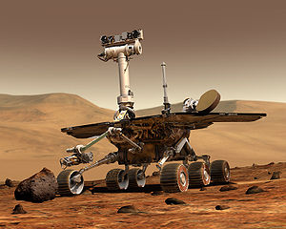
Mars Quest
NASA’s Mission to the Desert Planet
NASA's Mars Exploration Rover Mission (MER) is an ongoing robotic space mission involving two rovers, Spirit and Opportunity, exploring the planet Mars. It began in 2003 by sending these two rovers to explore the Martian surface and geology. The mission's scientific objective was to search for and characterize a wide range of rocks and soils that hold clues to past water activity on Mars.
Project: NASA is in the market for a new Mars rover. You are required to design and construct a robot that is capable of following a set of commands to explore the planet's surface. Before the robot is deployed, it must be extensively tested to ensure it will perform as expected. You can't fly a technician to Mars to reboot the robot!
Equipment Required (per group):
- 1 NXT robot
- 1 laptop computer
- 1 meter stick
- 1 timer
- 1 circular container (at least 5 containers for the module)
- 1-meter of string

What is π?
Using the materials provided, measure the circumference and diameter of object provided to your group. In the Mystery Ratio column, calculate the ratio of the Circumference to the Diameter for each object.
Group | Object Name | Circumference in centimeters | Diameter  in centimeters | Mystery Ratio
Group A | Cylinder 1
Group B | Cylinder 2
Group C | Cylinder 3
Group D | Cylinder 4
Group E | Cylinder 5

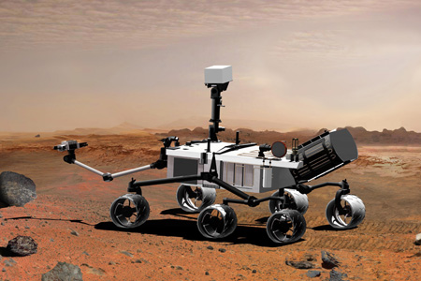
Objective #1: On Mars, the robot rovers must get their sensors as close to the rock samples as possible in order to be able to measure their composition. You will program your robot to move from the start line on the table in the front of the room to a rock sample that is 90 centimeters away. Attempt to get your robot's sensor less than 1 centimeter away from the rock sample without hitting the rock.
The first step required is to characterize the robots performance. This means, take measurements to determine the specifications of the robots movement. Calculating the circumference of the robot rover's wheels can be done either mathematically or experimentally.
Mathematically: The circumference of a wheel can be calculated using the formulae: c = π × d
Where c= circumference, π = 3.14 (approx) and d is the diameter of the wheel.
Measure the diameter of the wheel and calculate its circumference.
Diameter of the Wheel = d = _______________ centimeters
Circumference of the Wheel = c = π × d =_______________ centimeters

Experimentally: Locate a spare tire for the rover and make a mark on the tire with either chalk or masking tape. Create a starting mark on the table and line up our tire mark with it. Now slowly roll the wheel until the tire mark again touches the ground. Make another mark at this point and use a ruler to measure the distance.
Experimental Circumference of the Wheel = c =_______________ centimeters
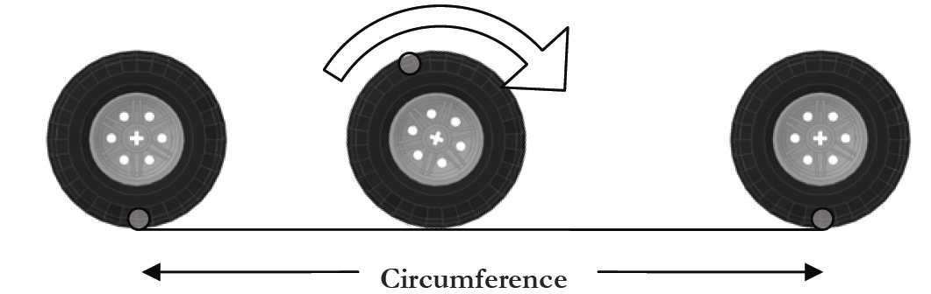

Based on your results above, how many rotations must the wheel make in order to travel 90 centimeters?
Number of Rotations = (Distance to Travel) / (Circumference of the Wheel)
Number of Rotations = ____________________ rotations

Programming the Rover
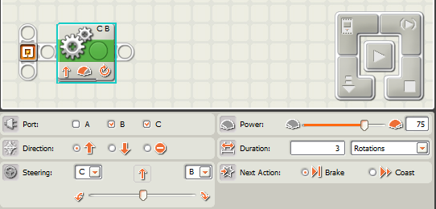
1. Now connect your rover to the laptop computer using a USB cable. Drag the "Move" action cube over to the workspace and configure it to rotate 3 times as shown below.
Step 1. Place "Move" Action Cube

Step 3. Click Here to Run

Step 2. Set to 3 Rotations

2. Run the program on the robot rover and measure that distance that it travels. Did the rover travel 3 times the circumference of your wheels?

3. Now change the number of rotation so that the rover travels 90 centimeters. Create a testing area at your station that consists of a start line made of tape and an object that will represent a Martian rock.

4. Position your rover behind the start line and see how close your rover's sensor gets to the rock. If the sensor touches the rock write "N/A" for "How Close...". Note that robots are not perfect so you will need to adjust the wheel rotations to achieve the best results.
5. Re-program your rover with 8 different rotation values in an effort to improve your robots performance. Record your results below.

Trial | Wheel Rotations | How Close in Centimeters?
1
2
3
4
5

Objective #2: The robot rovers can travel fast across hard-flat surfaces on Mars but it must travel slowly in the sandy dunes to avoid getting stuck. Measure the speed of your rover for different motor power levels and record your results below. To calculate the speed by finding the number of second required for your rover to travel 1 meter. Recall that Speed = Distance / Time.
Note that 1 meter/second = 2.23 miles/hour.
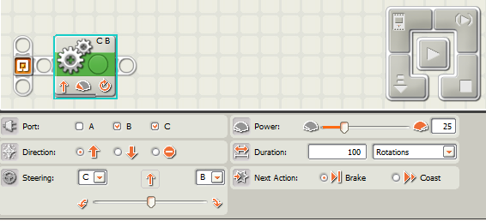
100 Rotations
25% Power

Group | Motor Power  Level | Time Required to  Travel 1 Meter (seconds) | Speed (meter/second) | Speed  (miles/hour)
Group A | 20%
Group B | 40%
Group C | 60%
Group D | 80%
Group E | 100%

Objective #3: The robot rovers must make accurate turns on Mars to avoid obstacles. Measure the angle that your rover rotates when you use different wheel rotation values.
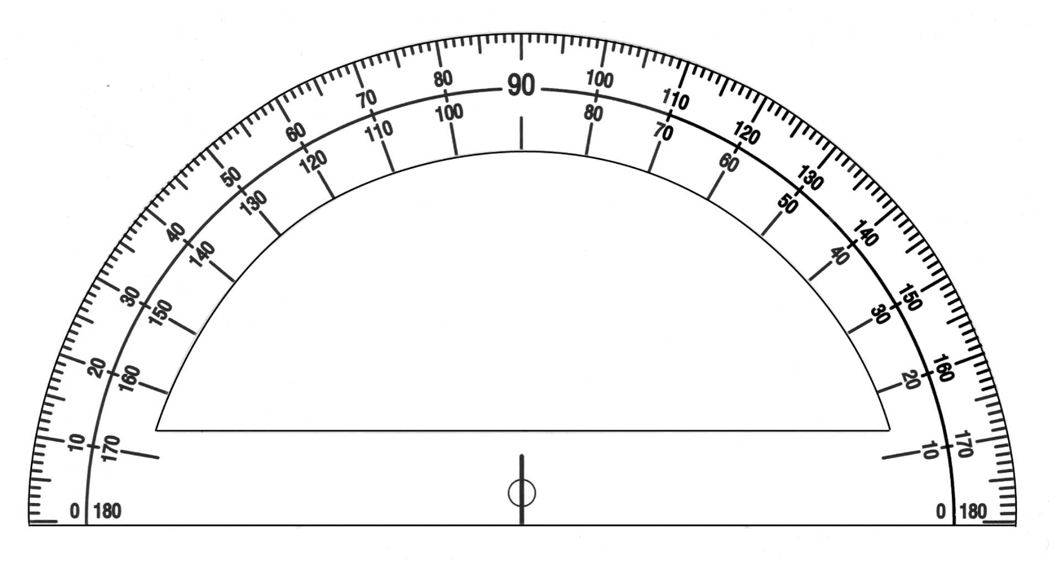

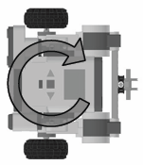

Set Rotations
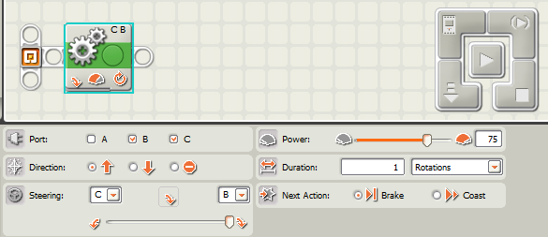
Sharp Turn
Wheel Rotations | Robot Turn Angle (Degrees)
0.25
0.5
0.75
1
1.25

Objective #4: On Mars, the robot rovers must navigate through the terrain and avoid rocks and craters. You will program your robot to move from the "Start Point" through obstacles to the "Check Point". The rover must then go over a "Crossing" and navigate to the "End Point". See an example obstacle course on the next page. If the rover hits an obstacle or goes out of the boundary then the rover must start the trip over again. The landscape will be marked with a grid so that you can quickly measure the distances between objects on the simulated Martian landscape.
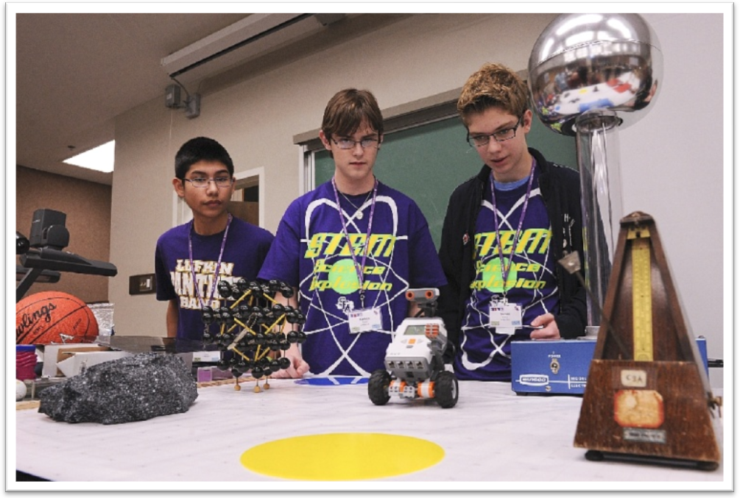
The steering angle is controlled via the slider bar at the bottom of the configuration panel. This will range from a gentle turn to a tight turn on the spot depending on how far this slider is taken.

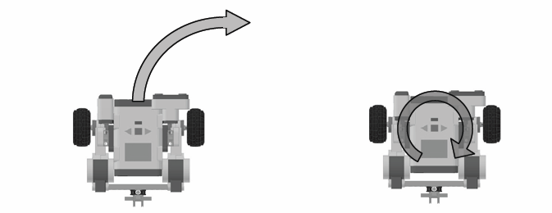
Gentle Turn Sharp Turn



By connecting "Move" action cubes together you can command the robot rover to perform a series of tasks.

Example Program
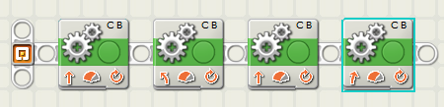

Move forward 1.75 Rotations
Turn Left Sharply 0.7 Rotations
Move forward 2.2 rotations
Turn Left Sharply 0.4 Rotations

Team Evaluations
1. How many "Move" actions cube were required to reach the check point? What did you think the minimum number of "Moves" might be?

2. Does high power or low power for the motors give you high accuracy movement?

3. How many seconds were required to reach the "End Point" on the obstacle course? How could you improve upon this time?

4. We used "dead reckoning" for robot motions in this activity. What kind of sensors could we use to improve upon the accuracy of motion of the robot rover?
Mars Quest Obstacle Course
End Point

Sand Dunes

Crossing

Canyon

Flat Lands
Check Point

Start Point

