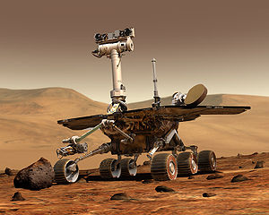
Mars Quest
NASA’s Mission to the Desert Planet

Module Overview:
NASA's Mars Exploration Rover Mission (MER) is an ongoing robotic space mission involving two rovers, Spirit and Opportunity, exploring the planet Mars. It began in 2003 by sending these two rovers to explore the Martian surface and geology. The mission's scientific objective was to search for and characterize a wide range of rocks and soils that hold clues to past water activity on Mars.
Students will first be informed about the Martian environment by attending a planetarium show called “Mars Quest”. The planetarium show is followed by hands-on robotic challenges that are similar to those encountered by NASA’s Mars Exploration Rover team.
Objectives:
After watching the planetarium show the students will be able to identify the difficulties that manned-missions to Mars face in order to better understand the need for robotic missions.
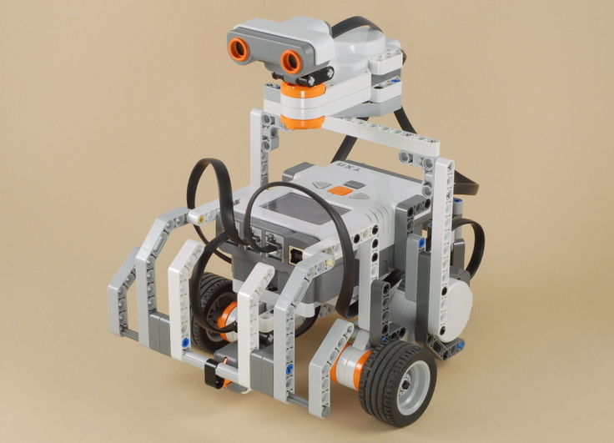
During the robot activities the students will be able to convert angular distances to linear distances in order to accurately program their robot rover to travel through a simulated Martian landscape.
Supplies:
- Planetarium Show Tickets ($2 each)
- NXT Mindstorm Robots, Meter Sticks, Timers, and Protractors (Provided by the Department of Physics and Astronomy)
- Handouts (See Below)
Handouts:
- Construction Plans for the Robot Rover
- Programming Guide for the NXT Mindstorm Cube
Process:
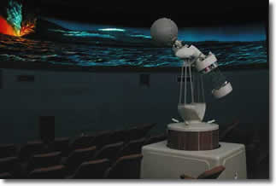
- The process will begin with a planetarium show called "Mars Quest" that gives students and overview of the Martian environment. The educational content of this show is given as an attachment to this document. An alternative to this planetarium show would be a PowerPoint show that shows the Martian terrain and an overview of Mars exploration.
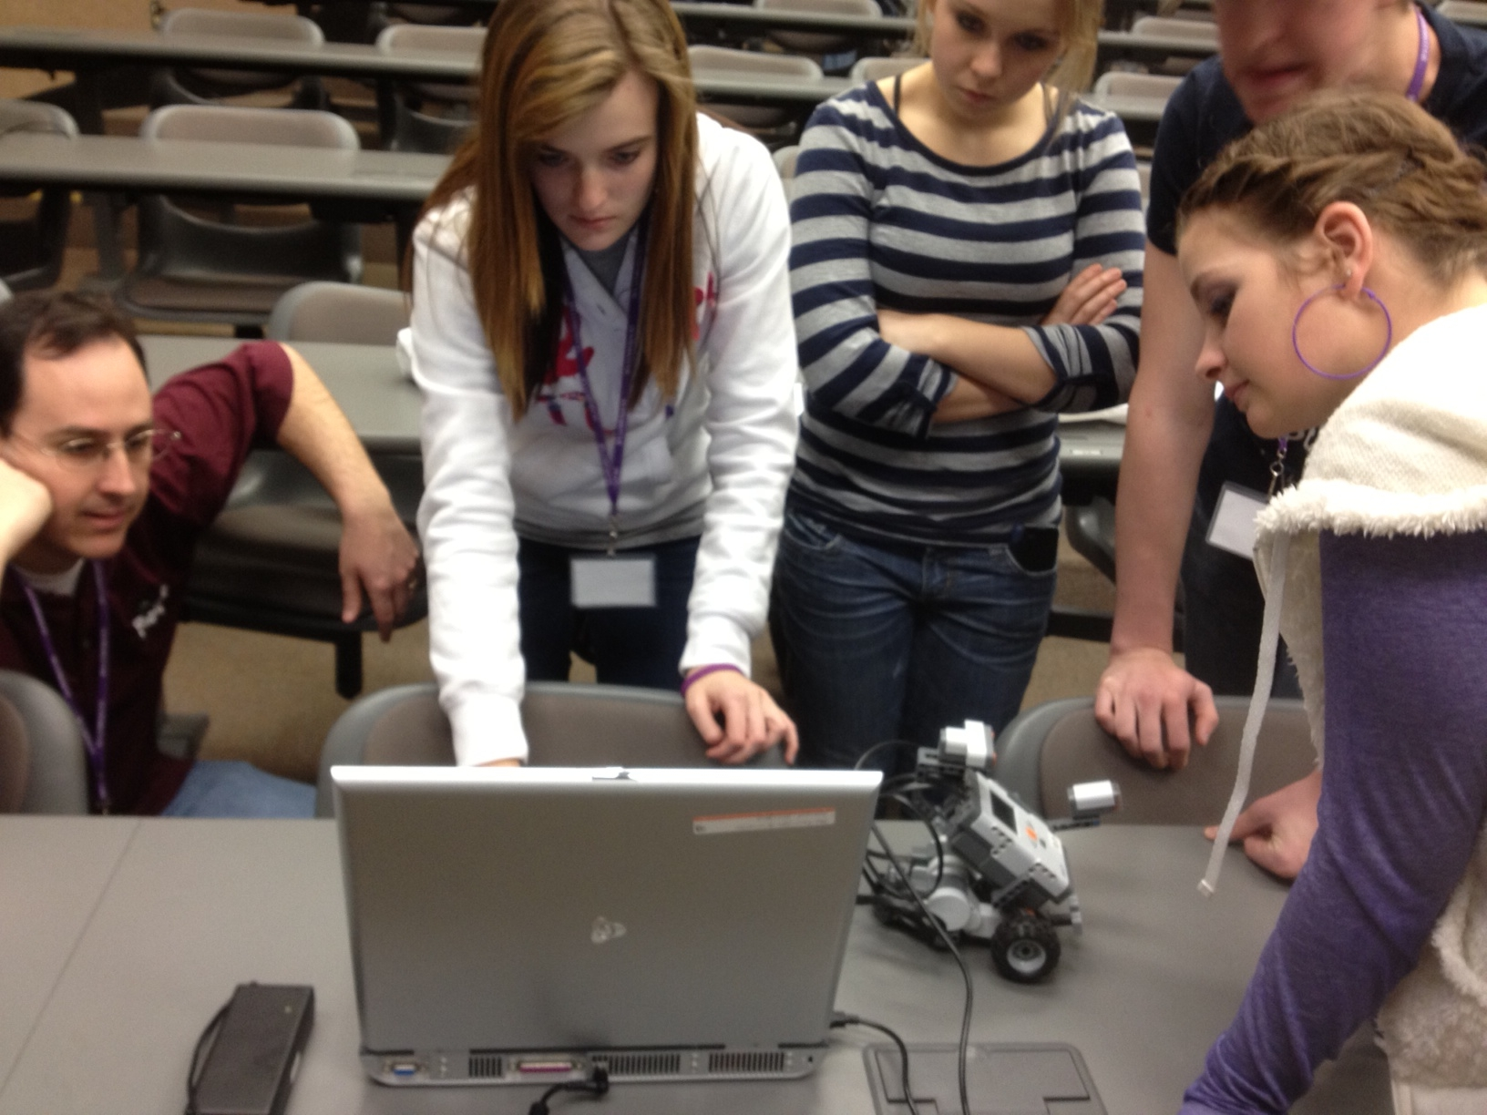
- After the planetarium show the students will move to the robotics lab and construct a robot rover. Students will be assigned to a team of 3 or 4 students.
- Participants will use the NXT Mindstorm robot technology to construct and program basic robotic structures that simulate the Mars Exploration Rovers. Instructors will introduce the fundamentals of construction and programming, while also allowing for students to learn through experimentation and guidance.
- Students will use a basic design with 2 motors, 3 wheels, and 3 sensors. The first challenge will be to accurately move the robot rover to a simulated Martian rock that can be analyzed with a light sensor. The goal will be to get the rover as close as possible to the rock without hitting it. Student will determine the circumference of the wheels mathematically and experimentally. Students will use the circumference of the tires to calculate the number of wheel rotations required to achieve this goal.
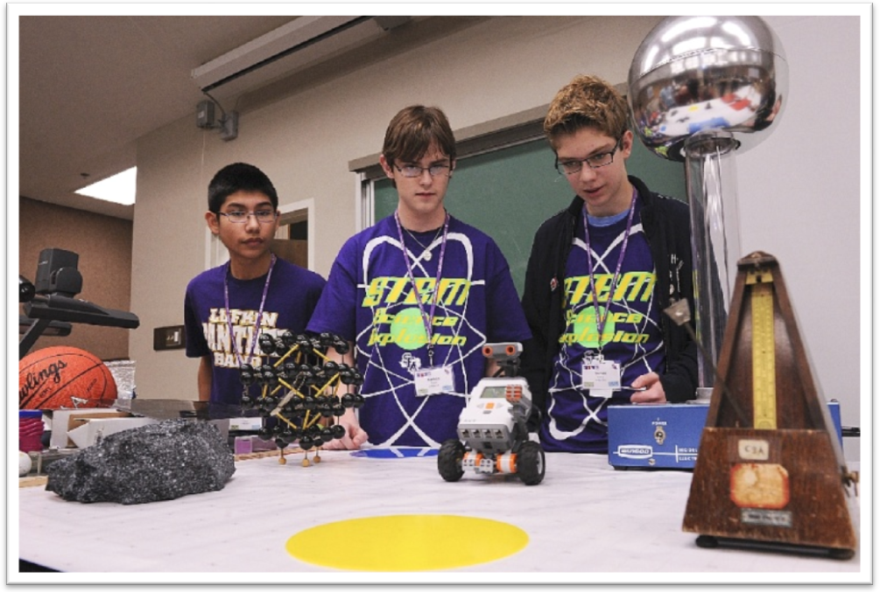
- The final activity will be to program the robot to navigate through obstacles (rocks and craters) in a simulated Martian environment. This requires accurate turning and linear travel. The touch sensor, ultrasonic sensor, and sound sensor may be used to help the robot rover navigate through the obstacle course.

TimeLine:
Time | Duration | Activity
9:20-10:00am | 40 min | "Mars Quest" Planetarium Show
10:00-10:25am | 25 min | Robotics Objective #1 - Linear and Rotation Motion
10:25-10:50am | 25 min | Robotics Objective #2 - Measuring Speed
10:50-11:15am | 25 min | Robotics Objective #3 - Turning Accurately
11:15-11:55am | 40 min | Robotics Objective #4 - Obstacle Course

