**Explore a STEM Career**

* **Actuary**
* **Analyst**
* **Astronaut**
* **Bookkeeper**
* **Chemical Consultant**
* **CIA Officer**
* **Controller**
* **Cryptographer**
* **Ecologist**
* **Electrician**
* **Engineer**
* **FBI Agent**
* **Forensic Scientist**
* **Geologist**
* **Geophysicist**
* **Health Professional**
* **Lawyer**
* **Loan Officer**
* **Mathematician**
* **NSA Officer**
* **Nurse**
* **Park Ranger**
* **Pharmaceutical Salesman**
* **Pharmacist**
* **Physician**
* **Professor**
* **Program Manager**
* **Programmer**
* **Quality Control Manager**
* **Researcher**
* **Scientist**
* **Software Developer**
* **Statistician**
* **Teacher**

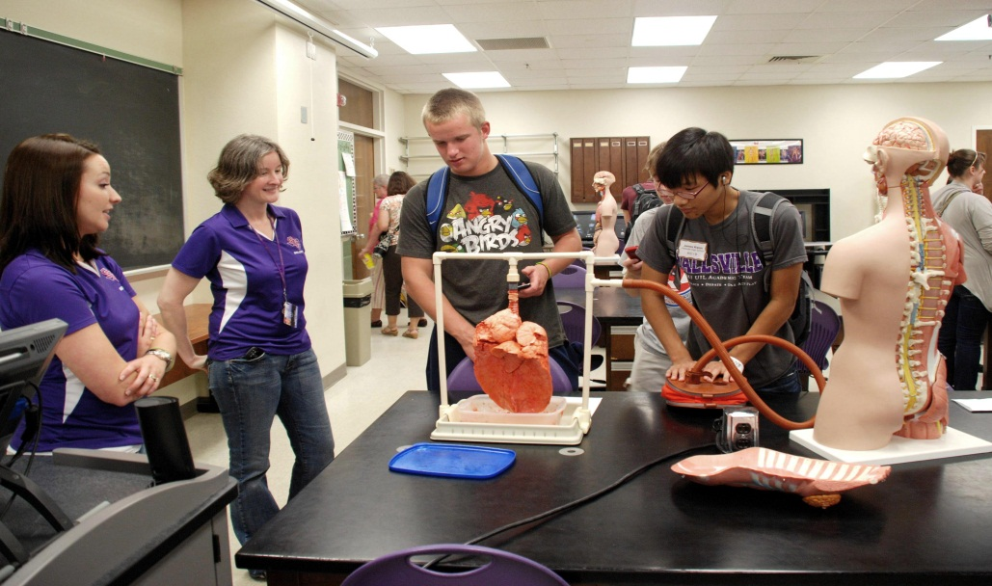

**America Needs You!!!**

**“STEM education will determine whether the United States will remain a leader among nations…” PCAST 2010**