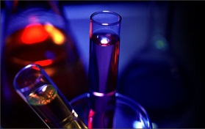

**Majors**

* **Biology**
* **Biochemistry**
* **Chemistry**
* **Geology**
* **Mathematics**
* **Nursing**
* **Physics**

**Pre-Health Professions**

* **Dentistry**
* **Medicine**
* **Optometry**
* **Occupational Therapy**
* **Pharmacy**
* **Physical Therapy**
* **Physician Assistant**
* **Veterinary Medicine**

**Minors**

* **Applied Statistics**
* **Astronomy**
* **Biology**
* **Chemistry**
* **Engineering**
* **Geology**
* **Mathematics**
* **Physics**

**STEM Programs: The Pipeline for a Stronger Future**

**Departments**

* **Biology**
* **Chemistry**
* **Geology**
* **Mathematics and Statistics**
* **Physics and Astronomy**
* **School of Nursing**

**Who Are We?**