**Stephen F. Austin State University**

**DeWitt School of Nursing**

**Advanced Pharmacology**

**Course Number: NUR 541**

**ALL INFORMATION IN THIS SYLLABUS IS SUBJECT TO THE WRITTEN POLICIES AND PROCEDURES OF THE SCHOOL OF NURSING, STEPHEN F. AUSTIN STATE UNIVERSITY, NACOGDOCHES, TEXAS**

**IN THE CASE OF COMMISSION, OMISSION, AMBIGUITY, VAGUENESS, OR CONFLICT, THE POLICIES AND PROCEDURES OF THE SCHOOL OF NURSING SHALL CONTROL.**

**EACH STUDENT SHALL BE RESPONSIBLE FOR ACTUAL AND/OR CONSTRUCTIVE KNOWLEDGE OF THE POLICIES AND PROCEDURES OF THE SCHOOL OF NURSING AND FOR COMPLIANCE THEREWITH.**

**THE STUDENT IS RESPONSIBLE FOR ALL INFORMATION IN THIS SYLLABUS.**

***This syllabus is provided for information purposes only.***

**Faculty Information**

**Name:**

**Department: Nursing**

**Email:**

**Phone:**

**Office:**

**Office Hours:**

**Class Meeting Time and Place:** This course is taught in an online format.

|  |  |  |
| --- | --- | --- |
| Week | Date | Topic |
| 1 |  | Fundamental principles of pharmacology  Ethnic and economy influences |
| 2 |  | Pharmacology across the lifespan  Pharmacology of psychiatric illnesses |
| 3 |  | Pharmacology of the autonomic nervous system |
| 4 |  | Pharmacology of the central nervous system |
| 5 |  | Pharmacology of the cardiovascular system |
| 6 |  | Pharmacology of the immune system |
| 7 |  | Pharmacology of infectious and neoplastic disease |
| 8 |  | Pharmacology of the gastrointestinal system |
| 9 |  | Pharmacology of the endocrine system |
| 10 |  | Pharmacology of respiratory disorders |
| 11 |  | Pharmacology of bone and joint disorders |
| 12 |  | Pharmacology of dermatologic and eye/ear disorders |
| 13 |  | Pharmacology of emergencies: Bioterrorism and poisoning |
| 14 |  | Community resources and cost effectiveness |
| 15 |  | Decision making for prescribing; Pain management |
| 16 |  | Review and summary of course |

Advanced Pharmacology

**Course Description**

This course provides students with the knowledge and skills to develop and manage a patient’s pharmacological regimen in a safe, high quality, cost-effective manner. This course includes information on prescription and non-prescription pharmacological agents.

**Prerequisites** Admission to SON Graduate Program

**Credit Hour Distribution**

3 credit hours

**Course Objectives**

Upon completion of this course, the student is expected to:

1. Assemble concepts and principles of the arts, sciences, humanities, and nursing in order to make advanced practice nursing decisions regarding pharmacological management of patients.
2. Synthesize responsibility and accountability using consistent behavior patterns and professional communication.
3. Incorporate evidenced based practice into the use of pharmacological agents.
4. Analyze the kinetics, dynamics, and therapeutics of broad categories of pharmacological agents.
5. Examine the relationship between pharmacologic agents and physiologic/pathologic responses.
6. Integrate moral, ethical, economic, cultural, and legal issues into advanced practice nursing decisions in the pharmacological management of patients.

**Topics**

Fundamental principles of pharmacology

Pharmacology across the lifespan

Ethnic and economic influences

Pharmacology of Psychiatric illnesses

Pharmacology of the Autonomic Nervous System

Pharmacology of the Central Nervous System

Pharmacology of the Cardiovascular System

Pharmacology of the Immune System

Pharmacology of Infectious and Neoplastic Disease

Pharmacology of the Gastrointestinal System

Pharmacology of the Endocrine System

Pharmacology of the Respiratory System

Pharmacology of Bone and Joint Disorders

Pharmacology of Dermatologic Disorders

Pharmacology of Eye and Ear Disorders

Pharmacology of Emergencies: Bioterrorism and Poisoning

Community resources and cost effectiveness

**Instructional Methods**

Discussion board, PowerPoint presentations, case studies

**Teaching Strategies**

Online discussion, reading assignments, case studies, online lecture modules, tests

**Required Textbooks**

Selected readings

**Grades and Grading**

*Exam I* 15%.

*Exam II* 15%.

*Exam III* 15%.

*Exam IV* 15%.

*Discussion Average* 20 %

*Case Studies Average*  20%.

**Grading Scale**

A 90-100

B 80-89

C 70-79

D 60-69

F <60

See current Stephen F. Austin State University Graduate Bulletin for probation, suspension, and readmission details.

**Exams**

Exam I – Fundamentals principles of pharmacology, pharmacology across the lifespan, ethnic and economic influences, pharmacology of psychiatric illnesses

Exam II – Pharmacology of the central nervous system, pharmacology of the immune system, pharmacology of infectious and neoplastic disease

Exam III – Pharmacology of the gastrointestinal system, pharmacology of the endocrine system, pharmacology of the respiratory system

Exam IV – Pharmacology of bone and joint disorders, pharmacology of dermatologic disorders, pharmacology of eye and ear disorders, pharmacology of emergencies: bioterrorism and poisoning

**Discussions**

Average of all Weekly Discussions. See Online Discussion Requirements and Grading Rubric

**Case Studies**

Average of all Case Studies. Minimum of three case studies through the semester. Case studies may be assigned to group to be presented on the discussion board on an assigned date. See Case Study Grading Rubric

**Stephen F. Austin State University**

**MSN-FNP Online Discussion Requirements and Grading Rubric**

*Background and Rational for Weekly Discussion Requirements and Grading*

For this online nursing course, you are completing 16 weeks of class room time (3 hours per week), course work and assignments online. It is important for online learners to understand that guidelines for online learning are given by the U.S. Department of Education and professional accrediting bodies through which Stephen F. Austin State University and the DeWitt School of Nursing are accredited. The following has been prepared to clarify weekly discussion requirements and grading for students participating in online nursing courses.

The purpose of the Weekly Discussions is to develop a scholarly and dynamic exchange between you, faculty, and other students in the course promoting an active and engaging on-line learning community. Your success and the success of your classmates in a positive learning environment is dependent on discussion participation and timely completion of assignments.

*Weekly Discussion Requirements*

* Students are expected to participate in weekly discussions on at **least three separate days out of seven** in the electronic week.
* The three weekly posts consist of ***one Main post and a minimum of two responses to peers. All will be posted on separate days.***
* The electronic week begins on Monday at 12:01 am CST and ends on Sunday at 12 midnight CST.
* There are no “make-ups” for not posting to the Weekly Discussions. If you need to be away or do not have computer access, you need to make alternative arrangements for participation and actively engaging in the course to meet weekly discussion requirements.
* Students must post a Main post to the Discussion board each week on or before Wednesday at 12 midnight CST.
* One point per day will be deducted for not having the Main post completed on or before Wednesday each week ensuring that all students have the opportunity for active learning and engagement with peers and course faculty.
* Students must read and respond to ***a minimum of two peer posts*** each week.
* Students ***must provide references in current APA format for all posts.***
* It is recommended that you prepare your weekly discussion posts in Microsoft Word and then cut and paste into the Blackboard discussion. This is because Blackboard ‘times out’.
* All discussions posted must reflect proficient writing standards.

Posts must be in the correct Weekly Discussion board or no points will be awarded.

*Discussion Rubric*

|  |  |  |  |  |  |
| --- | --- | --- | --- | --- | --- |
| Category | Exceeds  3 | Average  2 | Below  1 | Unacceptable  0 | POINTS |
| Main Post Discussion | Displays an outstanding integration of required reading and other scholarly works supporting the points and topics of discussion. | Displays some integration of required reading and other scholarly works supporting the points and topics of discussion. | Displays poor integration of required reading and other scholarly works supporting the points and topics of discussion. | No post. |  |
| Peer Response Discussion | Displays outstanding knowledge of concepts and issues presented in the courses as well as in their peers’ postings. | Displays some knowledge of concepts and issues presented in the course as well as in their peers’ postings. | Displays poor knowledge of concepts and issues presented in the course as well as their peers’ postings. | No post. |  |
| Scholarly Writing | Posts have no grammar, spelling, or current APA edition format mistakes. | Posts have few grammar, spelling, and/or current APA edition format mistakes. | Posts have multiple grammar, spelling, and/or current APA edition format mistakes. | No post. |  |

*Case Study Grading Rubric*

|  |  |  |  |  |  |  |
| --- | --- | --- | --- | --- | --- | --- |
|  | 25 | 20 | 15 | 10 | 0 | POINTS |
| Quality of Content  (25 points) | Rich in content, full of thought, insight and synthesis with clear connections to previous or current content and/or to real life situations made with depth and detail. | Substantial information, thought, insight and analysis has taken place with some connection to previous or current content and/or to real life situations but lack of depth and detail. | Generally competent in summarizing learning, but information is thin and commonplace with limited connections and vague generalities. | Rudimentary and superficial regurgitation of content with no connections and/or completely off topic. | Not submitted or instructions not followed. |  |
| Relevance  (25 points) | The key issues within the prompt are indentified and answered. The discussion is consistently clear with few digressions. | The key issues within the prompt are identified but not all answered. The discussion is clear most of the time. | Some of the key issues within the prompt are identified but not answered. The discussion is not clear. | Confused, hard to follow and the key issues within the prompt are not identified or answered. | Not submitted or instructions not followed. |  |
| Reading and Resources  (25 points) | Readings and other resource materials are used to support comments. All references are documented according to current APA format. No APA format errors. | There is some reference to readings and other resource material. Most references are documented according to current APA format. Minimal APA format errors. | Little if any reference is made to readings. Major errors in references documented according to current APA format. Major APA format errors. | Readings and resources are not cited. No APA references. | Not submitted or instructions not followed. |  |
| Professionalism  (25 points) | Written in a professional manner, free of typos, spelling and mechanical errors. | Most writing in a professional manner, free of typos, spelling and mechanical errors. | Some writing written in a professional manner, free of typos, spelling and mechanical errors. | Most writing NOT written in a professional manner, free of typos, spelling and mechanical errors. | Not submitted or instructions not followed. |  |

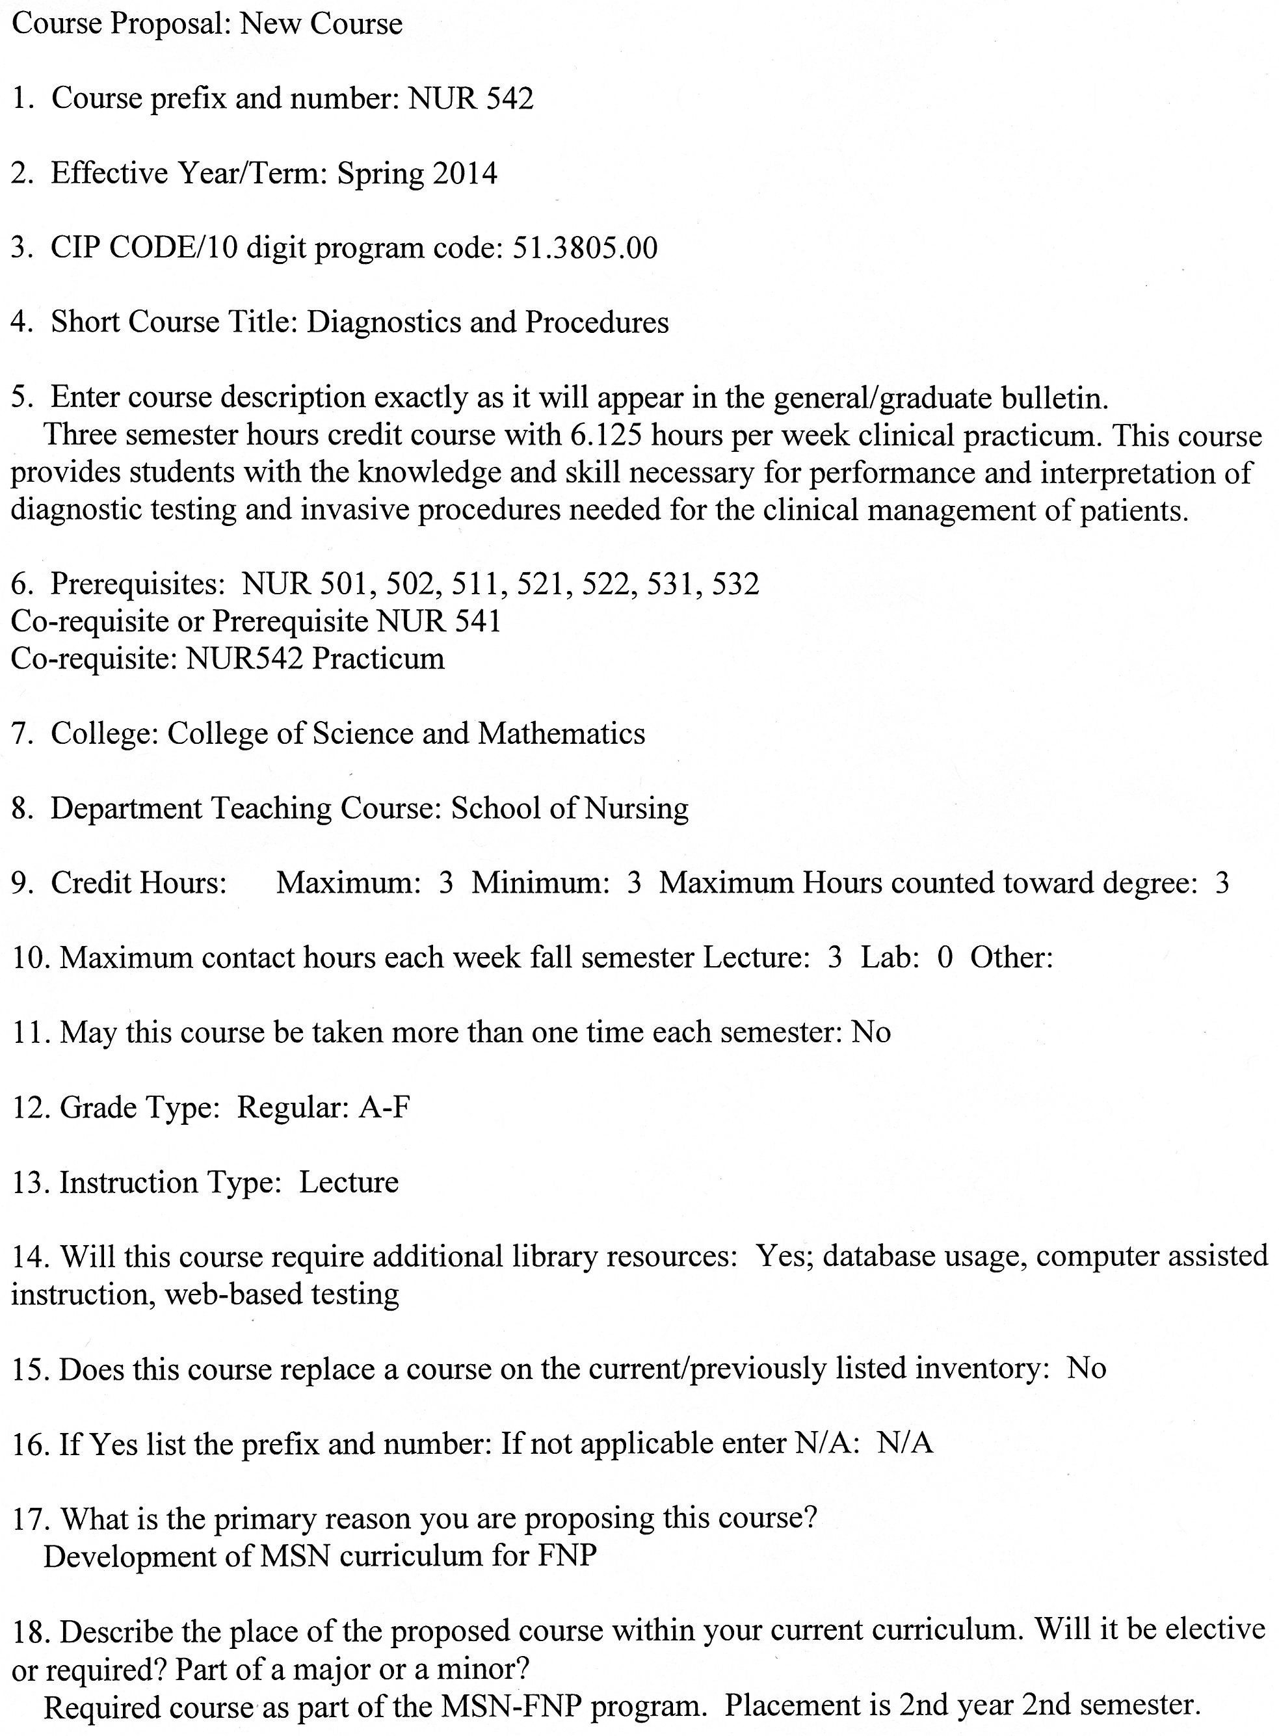

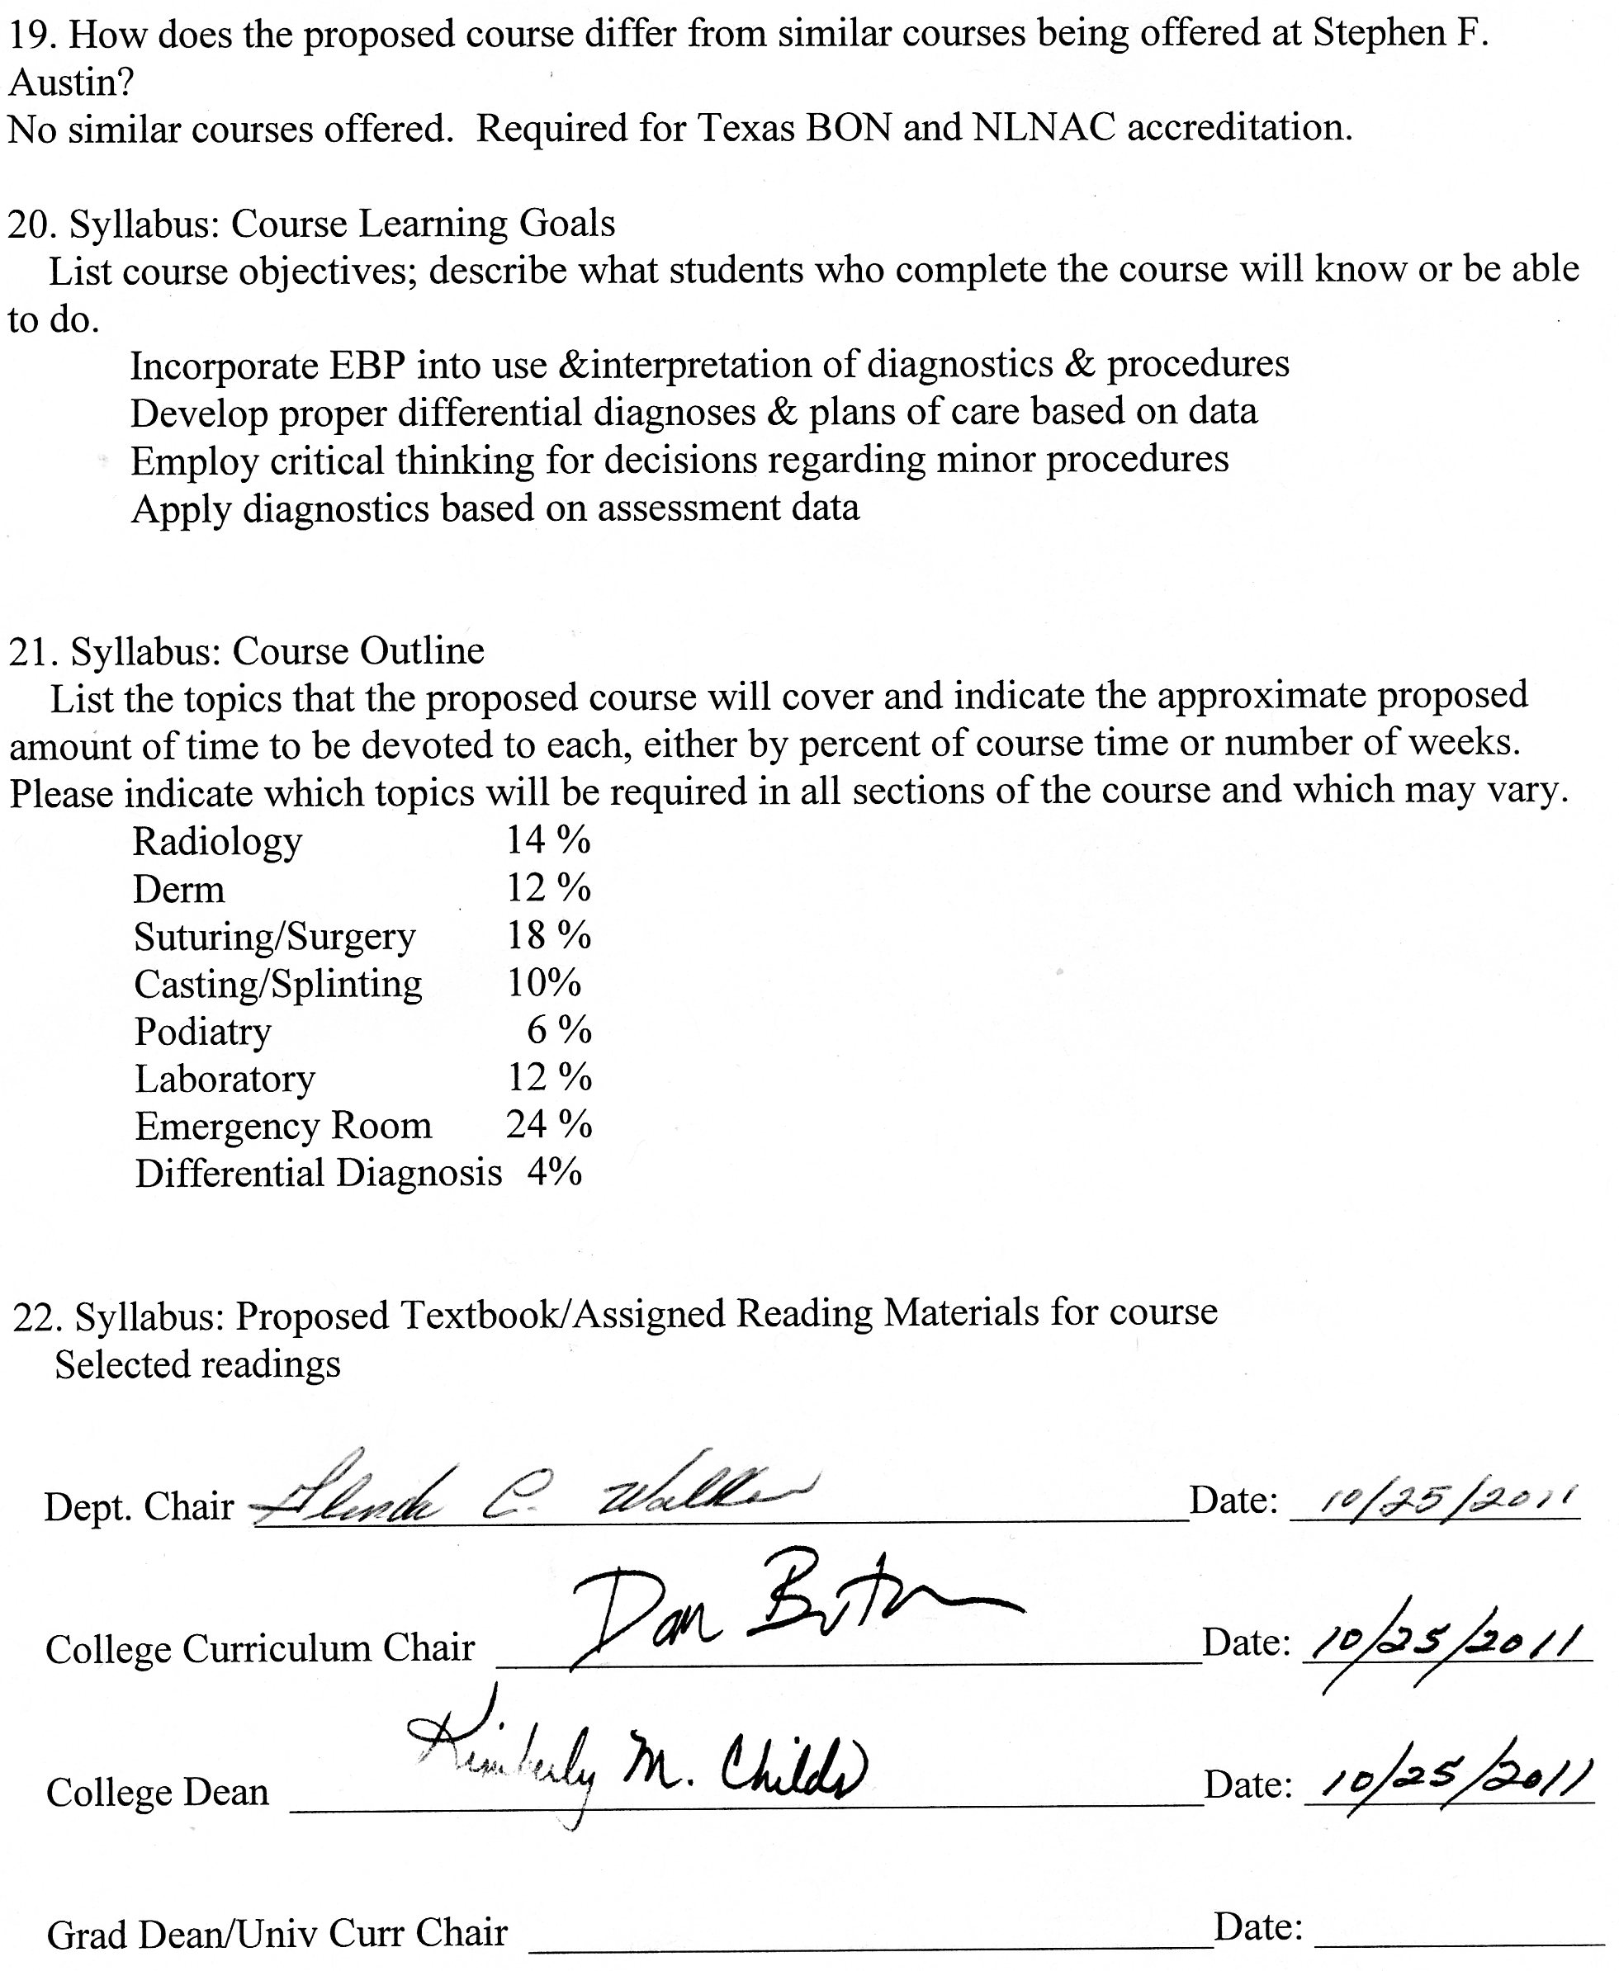

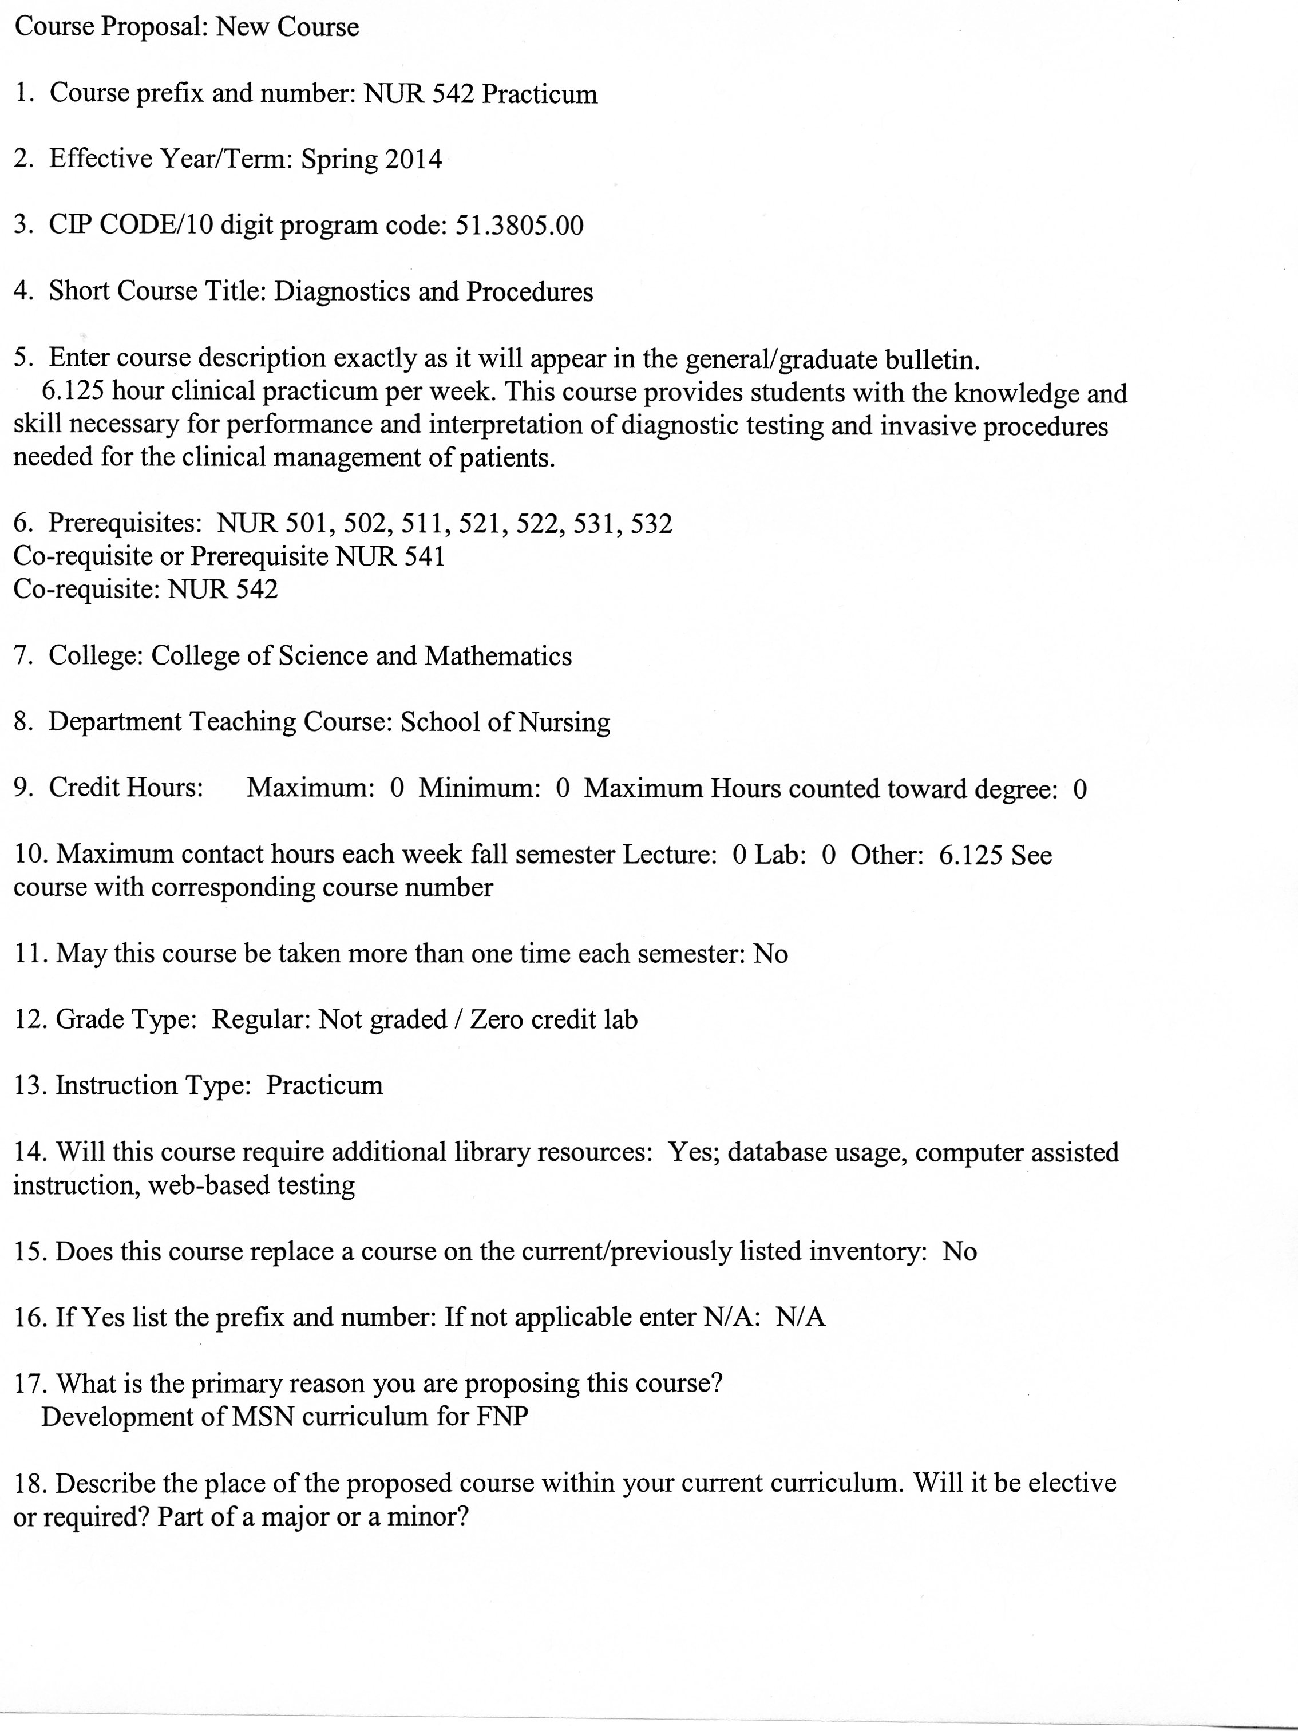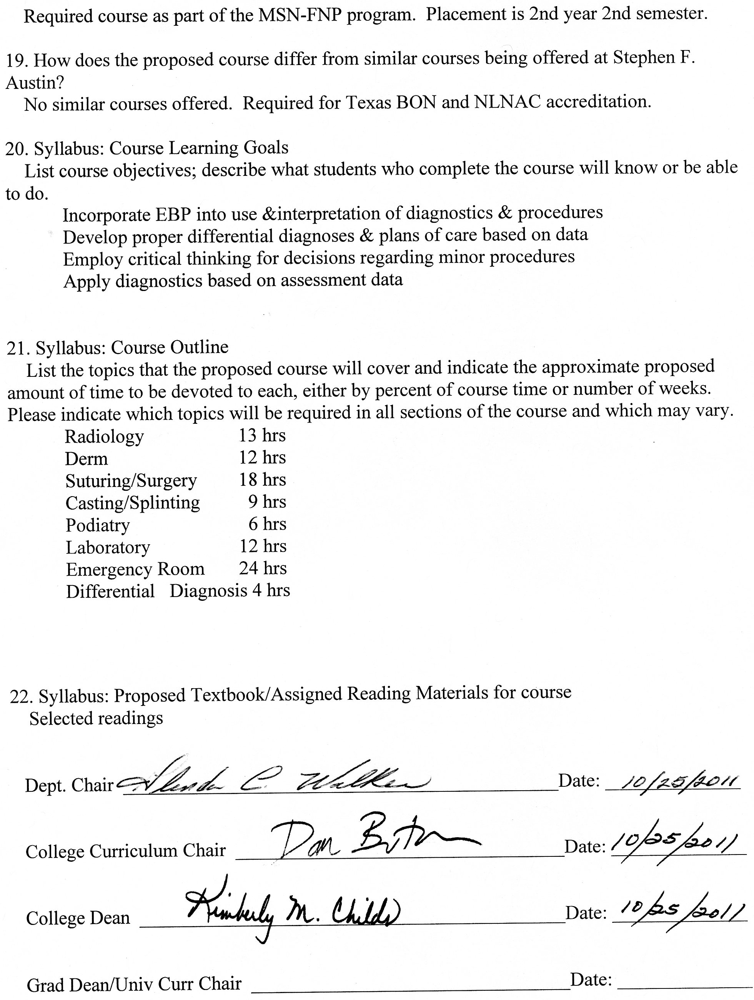

**Stephen F. Austin State University**

**DeWitt School of Nursing**

**Diagnostics and Procedures**

**Course Number: NUR 542**

**ALL INFORMATION IN THIS SYLLABUS IS SUBJECT TO THE WRITTEN POLICIES AND PROCEDURES OF THE SCHOOL OF NURSING, STEPHEN F. AUSTIN STATE UNIVERSITY, NACOGDOCHES, TEXAS**

**IN THE CASE OF COMMISSION, OMISSION, AMBIGUITY, VAGUENESS, OR CONFLICT, THE POLICIES AND PROCEDURES OF THE SCHOOL OF NURSING SHALL CONTROL.**

**EACH STUDENT SHALL BE RESPONSIBLE FOR ACTUAL AND/OR CONSTRUCTIVE KNOWLEDGE OF THE POLICIES AND PROCEDURES OF THE SCHOOL OF NURSING AND FOR COMPLIANCE THEREWITH.**

**THE STUDENT IS RESPONSIBLE FOR ALL INFORMATION IN THIS SYLLABUS.**

***This syllabus is provided for information purposes only.***

**Faculty Information**

**Name:**

**Department: Nursing**

**Email:**

**Phone:**

**Office:**

**Office Hours:**

**Class Meeting Time and Place**

This course is taught in an online format.

**Course Calendar**

|  |  |  |  |
| --- | --- | --- | --- |
| Week | Date | Topic | Readings |
| 1 |  | Laboratory Regulations and Procedures |  |
| 2 |  | Laboratory Interpretation |  |
| 3 |  | Laboratory Interpretation |  |
| 4 |  | Microscopy use in Primary Care |  |
| 5 |  | Radiology |  |
| 6 |  | Radiology |  |
| 7 |  | Splinting and Casting |  |
| 8 |  | Diagnostic Testing |  |
| 9 |  | EKG Interpretation |  |
| 10 |  | Laceration Management and Excisional Biopsy |  |
| 11 |  | Wound Management and Special Procedures |  |
| 12 |  | Foreign Body Management |  |
| 13 |  | Differential Diagnosis |  |
| 14 |  | Review and summary of course |  |
| 15 |  | Final examination of clinical competences |  |
| 16 |  | Final examination of clinical competences |  |

**Course description:**

This course provides students with the knowledge and skill necessary for performance and interpretation of diagnostic testing and invasive procedures needed for the clinical management of patients.

**Prerequisites:** NUR 501, 502, 511, 521, 522, 531, 532

**Co-requisite or Prerequisite:** NUR 541

**Credit hours:**

3 credit hours

98 hours clinical practicum

**Course objectives:**

Upon completion of this course, the student is expected to:

1. Assemble concepts and principles of the arts, sciences, humanities, and nursing in order to make advanced practice nursing decisions regarding diagnostics and procedures.
2. Synthesize responsibility and accountability using consistent behavior patterns and professional communication.
3. Incorporate evidenced based practice into the use and interpretation of diagnostics and procedures.
4. Integrate moral, ethical, economic, and legal issues into the provision of nursing care to clients, families, and the global community.
5. Collaborate with the interdisciplinary healthcare team respecting holistic, socio-economic, spiritual, and ethno-culturally diverse characteristics of clients.
6. Develop proper differential diagnoses and plans of care based on the interpretation of diagnostic data for diverse populations across the lifespan.
7. Employ critical thinking for decisions regarding minor surgical procedures.
8. Apply appropriate diagnostics based on patient assessment data.

**Topics**

Laboratory Regulations and Procedures Laboratory Interpretation Microscopy use in Primary Care Radiology Splinting and Casting Diagnostic Testing EKG Interpretation Laceration Management and Excisional Biopsy Wound Management and Special Procedures Foreign Body Management

**Instructional Methods**

Discussion board, PowerPoint presentations, case studies

**Teaching Strategies**

Online discussion, reading assignments, case studies, online lecture modules, exams, clinical experiences

**Required Textbooks**

Selected readings.

**Grades and Grading**

The student’s achievement of the course objectives is evaluated based on the following activities:

**Exams**

15% - Exam I 15% - Exam II 15% - Exam III

A minimum average grade of 80% on the 3 exams must be achieved in order to pass the course. Even if the final course grade is 80% or more, the average grade on the 3 exams must be 80% or higher to pass the course. There is no provision for re-taking exams in the course.

**Scholarly Papers/Presentations**

15% - Case Presentation 20% - Case Studies 20% - Discussion Board

**Clinical**

Pass/Fail - Clinical Practice Hours (98 minimum), Clinical Logs, and Clinical Skills Check-Off.

**Grading Scale**

A 90-100

B 80-89

C 70-79

D 60-69

F <60

See current Stephen F. Austin State University Graduate Bulletin for probation, suspension, and readmission details.

**Exams**

All exams will be given online. Exams will be time limited. Exams will usually be objective items (multiple choice or matching), but may include questions requiring short answer or essay. In order to prepare for national board exams, only one question is displayed at a time for answering and students MAY NOT go back to change their answer. Each of the 50 questions is given 1 ½ minutes. The exam will be available for 75 minutes.

Absolute integrity is expected from each student in all aspects of this course. Cheating on exams will not be tolerated. Students may be dismissed from the program for violation of academic integrity. Exams are not open-book. No notes, books, papers or aids are to be used during the exam. Students are also expected to work individually and submit the test within the allotted time frame.

**Scholarly Papers/Presentations**

1. **Case Presentation**

For this assignment the student will present a case study of a fictitious patient or one from their clinical experience to illustrate selected diagnostic laboratory and/or imaging studies. Focus should be on how the studies are used in differentiating the diagnoses. Students should choose from the following list of topics:

Headache Abdominal Pain: RUQ Abdominal Pain: RLQ Abdominal Pain: Epigastric Abdominal Pain: LUQ Pelvic Pain Fatigue Shortness of Breath Hematuria Rash Joint Pain Fever Dizziness Chest Pain Vaginal Discharge Diarrhea Low Back Pain

**B. Case Studies** Four case studies will be posted online during the semester. The case study will be comprised of patient history and physical findings with attached critical thinking questions. The scores from the four case studies will be averaged together for final grading calculation.

**C: Discussion Board**

The Stephen F. Austin State University on-line nursing courses means you are essentially completing 16 weeks of class room time (3 hours per week), course work and assignments on-line. It is important for on-line learners to understand that standards for on-line learning are set by the U.S. Department of Education and professional accrediting bodies which Stephen F. Austin State University and the DeWitt School of Nursing are accredited through. The following has been prepared to clarify weekly discussion requirements and grading for students and faculty participating in on-line nursing courses.

The purpose of the Weekly Discussions is to develop a scholarly and dynamic exchange between you, faculty, and other students in the course promoting an active and engaging on-line learning community. Your success and the success of your classmates in a positive learning environment are dependent on discussion participation and timely completion of assignments.

**Grading Rubric for Case Presentation**

|  |  |  |
| --- | --- | --- |
| **Criteria** | **Potential Points** | **Points Received** |
| **Part I:** Data Base and Overview of Case (gender, age, culture, chief complaint, diagnosis, diagnostic tests). | **5** |  |
| **Part II:** Compare and contrast the diagnostic tests. Include the following information for each:  *type of specimen needed (if applicable)  *function the test examines  *what methods are used to measure the function test addresses  *typical normal findings or normal range  *common abnormal findings in disease states | **15** |  |
| **Part III:** Rationale for tests used referencing pathophysiology or patient-specific characteristics, such as developmental stage, etc. (why this test & not another?) | **15** |  |
| **Part IV:** Evidence related to this test for this problem (according to USPS Task Force, Cochrane Data Base, DARE, or other reputable source) (Is it recommended? What is the level of evidence for this test?) | **20** |  |
| **Part V:** Cost of test (compare cost from at least two different agencies) | **5** |  |
| **Part VI:** Interpretation of results (What does it mean? How does it support your working diagnosis? How does affect your patient care?) | **25** |  |
| **APA, Grammar and Spelling** | **15** |  |
| **Total** | **100** |  |
| **Comments:** |  |  |
| **Evaluator:** |  |  |

**Stephen F. Austin State University**

**MSN-FNP On-Line Discussion Requirements and Grading Rubric**

*Background and Rational for Weekly Discussion Requirements and Grading*

For this on-line nursing course, you are completing 16 weeks of class room time (3 hours per week), course work and assignments on-line. It is important for on-line learners to understand that guidelines for on-line learning are given by the U.S. Department of Education and professional accrediting bodies through which Stephen F. Austin State University and the DeWitt School of Nursing are accredited. The following has been prepared to clarify weekly discussion requirements and grading for students participating in on-line nursing courses.

The purpose of the Weekly Discussions is to develop a scholarly and dynamic exchange between you, faculty, and other students in the course promoting an active and engaging on-line learning community. Your success and the success of your classmates in a positive learning environment is dependent on discussion participation and timely completion of assignments.

*Weekly Discussion Requirements*

* Students are expected to participate in weekly discussions on at **least three separate days out of seven** in the electronic week.
* The three weekly posts consist of ***one Main post and a minimum of two responses to peers. All will be posted on separate days.***
* The electronic week begins on Monday at 12:01 am CST and ends on Sunday at 12 midnight CST.
* There are no “make-ups” for not posting to the Weekly Discussions. If you need to be away or do not have computer access, you need to make alternative arrangements for participation and actively engaging in the course to meet weekly discussion requirements.
* Students must post a Main post to the Discussion board each week on or before Wednesday at 12 midnight CST.
* One point per day will be deducted for not having the Main post completed on or before Wednesday each week ensuring that all students have the opportunity for active learning and engagement with peers and course faculty.
* Students must read and respond to ***a minimum of two peer posts*** each week.
* Students ***must provide references in current APA format for all posts.***
* It is recommended that you prepare your weekly discussion posts in Microsoft Word and then cut and paste into the Blackboard discussion. This is because Blackboard ‘times out’.
* All discussions posted must reflect proficient writing standards.
* Posts must be in the correct Weekly Discussion board or no points will be awarded.

***Tips for postings***

* Avoid postings that are limited to 'I agree' or 'great idea', etc. If you agree (or disagree) with a posting then say why you agree by supporting your statement with concepts from the readings or by bringing in a related example or experience.
* Address the questions as much as possible
* Try to use quotes from the articles that support your postings. Include page numbers when you do that.
* Build on others responses to create threads.
* Bring in related prior knowledge (work experience, prior coursework, readings, etc.)
* Use proper etiquette (address your peer by name, proper language, typing, etc.)

*Discussion Rubric*

|  |  |  |  |  |  |
| --- | --- | --- | --- | --- | --- |
| Category | Exceeds  3 | Average  2 | Below  1 | Unacceptable  0 | POINTS |
| Main Post Discussion | Displays an outstanding integration of required reading and other scholarly works supporting the points and topics of discussion. | Displays some integration of required reading and other scholarly works supporting the points and topics of discussion. | Displays poor integration of required reading and other scholarly works supporting the points and topics of discussion. | No post. |  |
| Peer Response Discussion | Displays outstanding knowledge of concepts and issues presented in the courses as well as in their peers’ postings. | Displays some knowledge of concepts and issues presented in the course as well as in their peers’ postings. | Displays poor knowledge of concepts and issues presented in the course as well as their peers’ postings. | No post. |  |
| Scholarly Writing | Posts have no grammar, spelling, or current APA edition format mistakes. | Posts have few grammar, spelling, and/or current APA edition format mistakes. | Posts have multiple grammar, spelling, and/or current APA edition format mistakes. | No post. |  |

**Late Assignments**

Late papers will be assessed a 10% penalty daily including weekends. This applies to all papers and projects for this course. For pass/fail work, it is your faculty’s discretion whether to grant extensions on due dates. If you know you will need more time to complete an assignment, let your faculty know ahead of time.

**Clinical**  The student must complete a minimum of 98 clinical hours for the course, although faculty reserve the right to assign additional clinical hours if there is not sufficient evidence of adequate clinical performance. Because course faculty responsibilities are to guide, direct, and evaluate student learning in this course and in the program, the faculty will not hesitate to assign additional clinical hours when necessary. This provision is certainly not designed to be punitive, but to assure students the baseline competency necessary for continuing successfully in the program.

A three day on-campus workshop will be scheduled to introduce the student to the skills necessary for providing primary care. This workshop will account for 24 hours of the 98 required hours of clinical. An additional 74 hours will be spent rotating through various specialty areas. These areas include:

Radiology 14 hrs Derm/Surgery/casting 18 hrs Podiatry 6 hrs Laboratory 12 hrs Emergency Room 24 hrs

All clinical rotations must be performed at an approved clinical site with an approved preceptor. If the student wishes to work with a preceptor/clinical site not included in the course list, arrangements must be made between the preceptor/clinical site and the School of Nursing prior to any student participation in clinical hours at that site. This requirement **must be met**, even for only one day of clinical and prior to any clinical hours performed, or clinical hours will not be considered valid.

Policy 41 will be followed for obtaining preceptors.

Clinical schedules of proposed clinical activities for the semester must be submitted to clinical faculty early in the semester (see specific date on course calendar). Revisions of your clinical schedule must be submitted and approved by clinical faculty before changes can be made.

**Clinical Logs**

A clinical log will be kept by all students documenting their clinical experiences while practicing with preceptors. The clinical log will list each patient encountered and skills performed by the student. A clinical check list will also be included in the clinical log. Students must perform all skills on the check list with preceptor signing-off on those skills by the end of the semester.

Student must be checked-off on the attached Clinical Check-Off Skills List before the completion of the course. These skills will be completed with preceptors during the student’s clinical rotation. The Clinical Check-Off Skills List along with the clinical log will be submitted to course faculty by due date on course calendar.

**Clinical Check-Off Skills List**

|  |  |  |  |
| --- | --- | --- | --- |
| **Procedure** | **Location/Type** | **Date Completed** | **Signature of Preceptor** |
| Suturing | 1. |  |  |
|  | 2. |  |  |
| Infiltration anesthetic | 1. |  |  |
|  | 2. |  |  |
| Reviewing X-rays (5 total) | 1. Chest |  |  |
|  | 2. Chest |  |  |
|  | 3. Abdomen |  |  |
|  | 4. Skeletal |  |  |
|  | 5. Skeletal |  |  |
| Splinting (2 different types) | 1.______________ |  |  |
|  | 2.______________ |  |  |
| Urinalysis | 1. |  |  |
|  | 2. |  |  |
| Wet Mount | 1. |  |  |
|  | 2. |  |  |
| Other: |  |  |  |
| 1. |  |  |  |
| 2. |  |  |  |
| 3. |  |  |  |

**Other** category should include three additional skills the student preformed during their clinical rotation. These skills must differ from the specific ones listed in the Clinical Check-Off Skills List.

Stephen F. Austin State University

**Richard and Lucille DeWitt School of Nursing**

**Clinical Evaluation Tool**

**NUR 542**

**Diagnostics & Procedures**

**Student: ____________________________Date Fall/Spring: ________**

**Instructor(s)**: **__ __________________________________**

**Evaluation Criteria: S = Satisfactory U= Unsatisfactory**

**Ongoing clinical feedback will be provided in individual student-faculty conferences and with the weekly evaluation tool throughout the clinical rotation and will be documented on page 3.**

**Clinical objectives for evaluation are listed on page 2.**

**By the end of the clinical rotation, the student must satisfactorily demonstrate all behaviors described in the clinical objectives to pass the clinical portion of the course.**

|  |  |
| --- | --- |
| **Final Clinical Grade**:  **(Pass or Fail)**  **Instructor Signature**  **Student Signature**:  **Date: ____________________** | Final Instructor Comments **Final Student Comments** |

Stephen F. Austin State University

**Richard and Lucille DeWitt School of Nursing**

**Clinical Evaluation Tool**

**NUR 542**

**Diagnostics & Procedures**

|  |  |
| --- | --- |
| **Clinical Outcomes** | **Final Grade**  **(S or U)** |
| ***The student will*:** |  |
| **A.** **Provider of Patient Centered Care** |  |
| 1. Assemble concepts and principles of the arts, sciences, humanities, and nursing in order to make advanced practice nursing decisions regarding diagnostics and procedures. (CO 1) |  |
| 1. Incorporate evidenced based practice into the use and interpretation of diagnostics and procedures (CO 3) |  |
| 1. Integrate moral, ethical, economic, and legal issues into the provision of nursing care to clients, families, and the global community. (CO4) |  |
| 1. Employ critical thinking for decisions regarding minor surgical procedures. (CO 7) |  |
| 1. Apply appropriate diagnostics based on patient assessment data. (CO 8) |  |
| 1. Develop proper differential diagnoses and plans of care based on the interpretation of diagnostic data for diverse populations across the lifespan. (CO 6) |  |
| 1. Critically analyzes data and evidence for improving advanced nursing practice. (NONPF SFC 1) |  |
| 1. Integrates knowledge from the humanities and sciences within the context of nursing science. (NONPF SFC 2) |  |
| 1. Translates research and other forms of knowledge to improve practice processes and outcomes. (NONPF SFC 3) |  |
| 1. Develops new practice approaches based on the integration of research, theory, and practice knowledge (NONPF SFC 4) |  |
| 1. Uses best available evidence to continuously improve quality of clinical practice. (NONPF QC 1) |  |
| 1. Evaluates how organizational structure, care processes, financing, marketing and policy decisions impact the quality of health care. (NONPF QC 3) |  |
| 1. Applies skills in peer review to promote a culture of excellence. (NONPF QC 4) |  |
| 1. Anticipates variations in practice and is proactive in implementing interventions to ensure quality. (NONPF QC 5) |  |
| 1. Generates knowledge from clinical practice to improve practice and patient outcomes. (NONPF PIC 2) |  |
| 1. Applies clinical investigative skills to improve health outcomes. (NONPF PIC 3) |  |
| 1. Integrates appropriate technologies for knowledge management to improve health care. (NONPF TILC 1) |  |
| 1. Translates technical and scientific health information appropriate for various users’ needs. (NONPF TILC 2) |  |
| 1. Assesses the patient’s and caregiver’s educational needs to provide effective, personalized health care (NONPF TILC 2a) |  |
| 1. Coaches the patient and caregiver for positive behavioral change. (NONPF TILC 2b) |  |
| 1. Demonstrates information literacy skills in complex decision making. (NONPF TILC 3) |  |
| 1. Uses technology systems that capture data on variables for the evaluation of nursing care. (NONPF TILC 5) |  |
| 1. Evaluates the impact of healthcare delivery on patients, providers, other stakeholders, and the environment. (NONPF HDSC 5) |  |
| 1. Analyzes organizational structure, functions and resources to improve the delivery of care. (NONPF HDSC 6) |  |
| 1. Integrates ethical principles in decision making. (NONPF EC 1) |  |
| 1. Evaluates the ethical consequences of decisions. (NONPF EC 2) |  |
| 1. Uses advanced health assessment skills to differentiate between normal, variations of normal and abnormal findings. (NONPF IPC 3b) |  |
| 1. Employs screening and diagnostic strategies in the development of diagnoses. (NONPF IPC 3c) |  |
| 1. Works to establish a relationship with the patient characterized by mutual respect, empathy, and collaboration. (NONPF IPC 4a) |  |
| 1. Creates a climate of patient-centered care to include confidentiality, privacy, comfort, emotional support, mutual trust, and respect. (NONPF IPC 4b) |  |
| 1. Incorporates the patient’s cultural and spiritual preferences, values, and beliefs into health care. (NONPF IPC 4c) |  |
| 1. Preserves the patient’s control over decision making by negotiating a mutually acceptable plan of care. (NONPF IPC 4d) |  |
| **B. Member of Health Care Team** |  |
| 1. Synthesize responsibility and accountability using consistent behavior patterns and professional communication. (CO 2) |  |
| 1. Collaborate with the interdisciplinary healthcare team respecting holistic, socio-economic, spiritual, and ethno-culturally diverse characteristics of clients. (CO 5) |  |
| 1. Facilitates the development of health care systems that address the needs of culturally diverse populations, providers, and other stakeholders. (NONPF HDSC 4) |  |
| 1. Communicates practice knowledge effectively both orally and in writing. (NONPF LC 6) |  |
| **C**. **Member of the Profession** |  |
| 1. Demonstrates an understanding of the interdependence of policy and practice. (NONPF PC 1) |  |
| 1. Analyzes ethical, legal, and social factors influencing policy development. (NONPF PC 3) |  |
| 1. Evaluates the impact of health care delivery on patients, providers, other stakeholders, and the environment. (NONPF HDSC 5) |  |
| 1. Demonstrates the highest level of accountability for professional practice. (NONPF IPC 2) |  |
| 1. Applies ethically sound solutions to complex issues related to individuals, populations and systems of care (NONPF EC 3) |  |
| **D. Patient Safety Advocate** |  |
| 1. Evaluates the relationship among access, cost, quality, and safety and their influence on health care. (NONPF QC 2) |  |
| 1. Contributes to the design of clinical information systems that promote safe, quality and cost effective care (NONPF TILC 4) |  |
| 1. Advocates for ethical policies that promote access, equity, quality, and cost. (NONPF PC 2) |  |
| 1. Minimize risk to patients and providers at the individual and systems level. (NONPF HDSC 3) |  |

Stephen F. Austin State University

**School of Nursing**

**Richard and Lucille DeWitt School of Nursing**

**Clinical Evaluation Tool**

**NUR 542**

**Diagnostics & Procedures**

**Feedback Page**

***The instructor will provide individual feedback to the student about clinical performance throughout the clinical rotation*.**

|  |  |  |  |  |
| --- | --- | --- | --- | --- |
| **Date and Clinical Site:** | **Instructor Feedback:** | **Student Response:** | **Recommendations:** | **Student & Faculty Initials** |
|  |  |  |  |  |
|  |  |  |  |  |
|  |  |  |  |  |

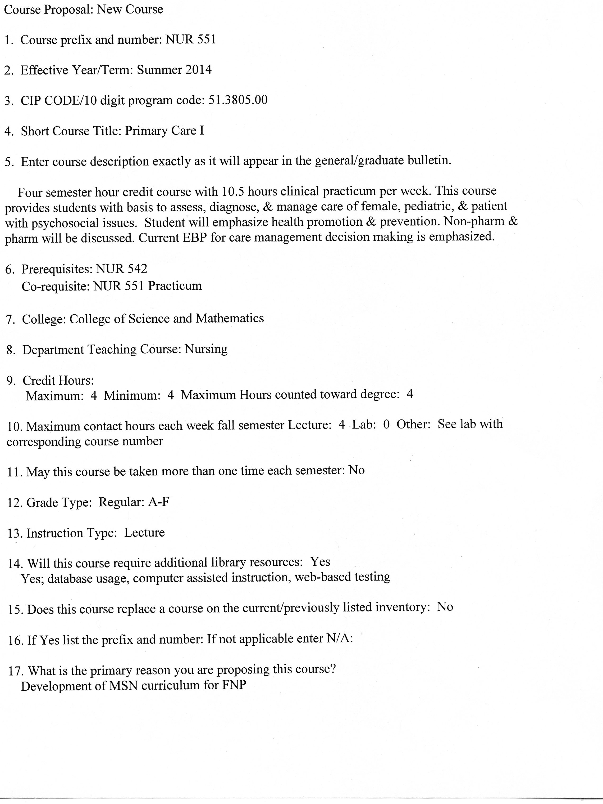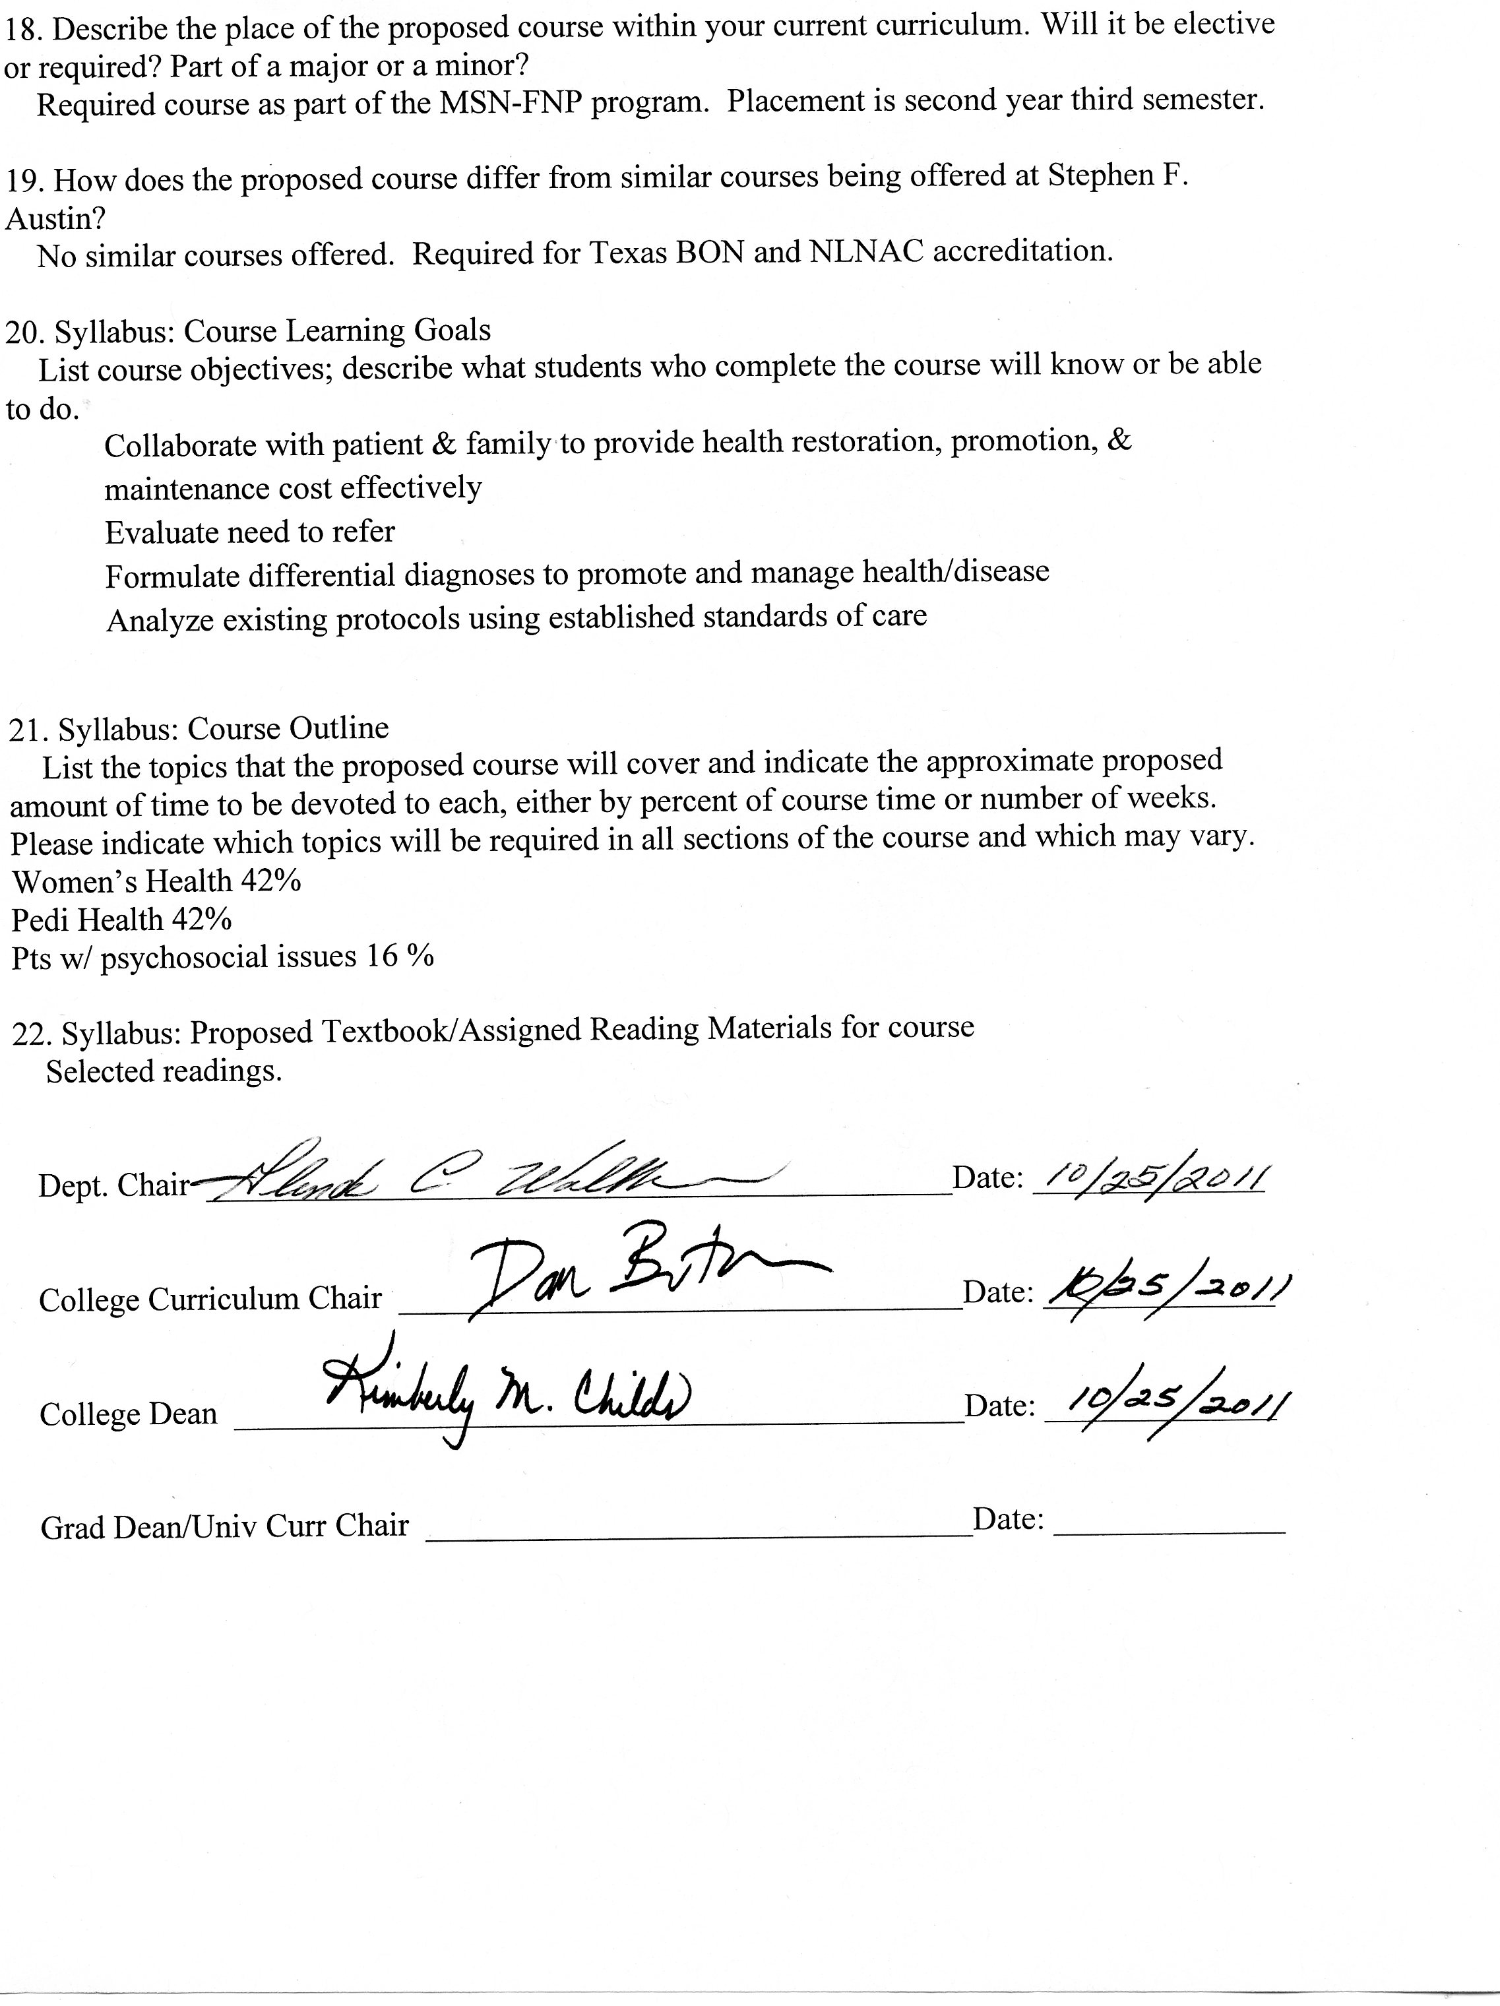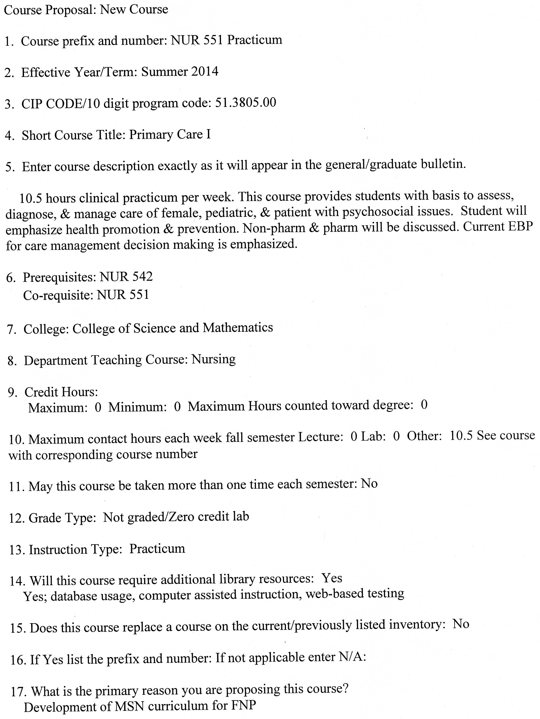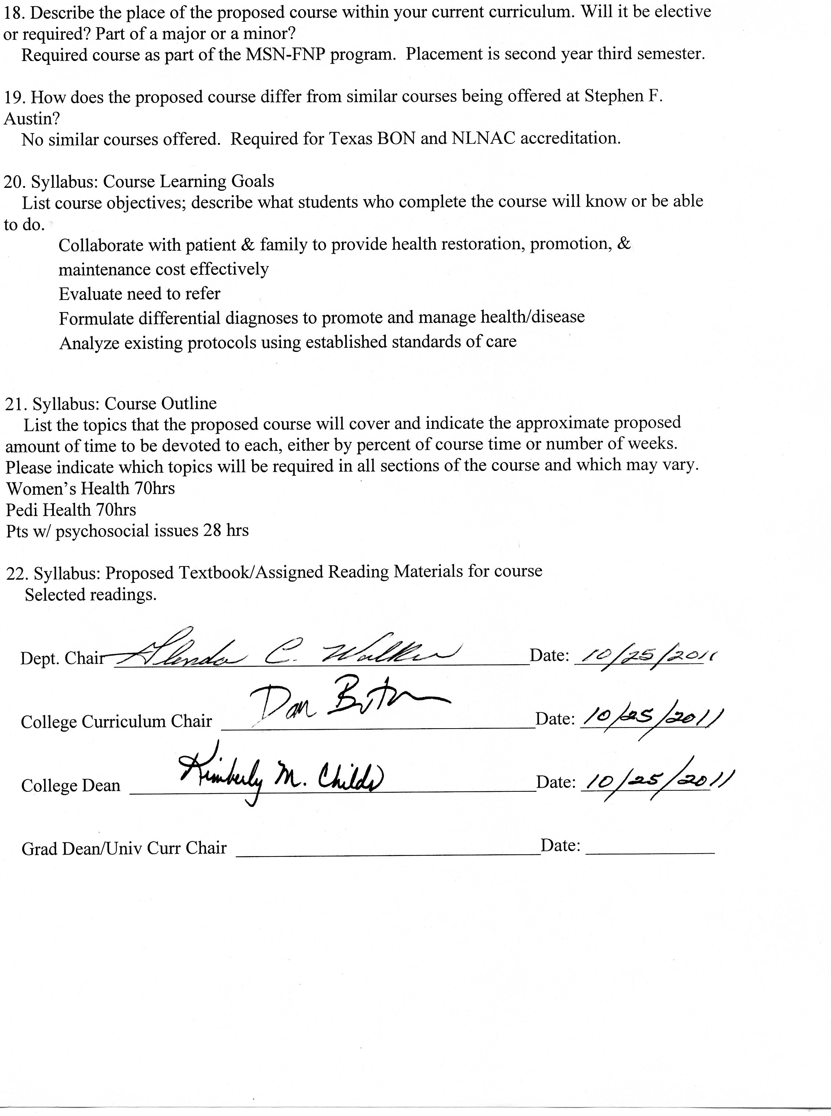

**Stephen F. Austin State University**

**DeWitt School of Nursing**

**Primary Care I**

**Course Number: NUR 551**

**ALL INFORMATION IN THIS SYLLABUS IS SUBJECT TO THE WRITTEN POLICIES AND PROCEDURES OF THE SCHOOL OF NURSING, STEPHEN F. AUSTIN STATE UNIVERSITY, NACOGDOCHES, TEXAS**

**IN THE CASE OF COMMISSION, OMISSION, AMBIGUITY, VAGUENESS, OR CONFLICT, THE POLICIES AND PROCEDURES OF THE SCHOOL OF NURSING SHALL CONTROL.**

**EACH STUDENT SHALL BE RESPONSIBLE FOR ACTUAL AND/OR CONSTRUCTIVE KNOWLEDGE OF THE POLICIES AND PROCEDURES OF THE SCHOOL OF NURSING AND FOR COMPLIANCE THEREWITH.**

**THE STUDENT IS RESPONSIBLE FOR ALL INFORMATION IN THIS SYLLABUS.**

***This syllabus is provided for information purposes only.***

**Faculty Information**

**Name:**

**Department: Nursing**

**Email:**

**Phone:**

**Office:**

**Office Hours:**

**Class Meeting Time and Place**

This course is taught in an online format.

|  |  |  |
| --- | --- | --- |
| Week | Date | Topic |
| 1 |  | Pre-pregnancy, antepartum |
| 2 |  | Menopausal/postmenopausal  Abuse, anxiety, situational stress |
| 3 |  | Anorexia/bulimia |
| 4 |  | Attention deficit disorders  Autism |
| 5 |  | Pediatric clients: Immunization/preventative care |
| 6 |  | Pediatric clients: Respiratory |
| 7 |  | Pediatric clients: Respiratory |
| 8 |  | Pediatric clients: ENT |
| 9 |  | Pediatric clients: Musculoskeletal |
| 10 |  | Pediatric clients: Dermatology |
| 11 |  | Pediatric clients: Cardiac |
| 12 |  | Pediatric clients: Gastrointestinal |
| 13 |  | Pediatric clients: Endocrine/obesity |
| 14 |  | Pediatric clients: Urology |
| 15 |  | Pediatric/Women’s Health Emergencies |
| 16 |  | Review and summary of course |

**Course Description**

This course provides students with the basis to assess, diagnose, and manage the care of the female patient, pediatric patient, and patient with psychosocial issues. The student will emphasize health promotion and disease prevention, as well as diagnosis and management of acute and chronic diseases. Culturally competent, holistic, ethical, age and gender specific care, as well as risk stratification will be discussed. Non-pharmacologic aspects of care will be addressed as well as the pharmacologic management designed to help clients achieve desired outcomes. Current evidence based practice as the basis for care management decision making is emphasized.

**Prerequisites:** NUR 542

**Co-requisite:** NUR 551 Practicum

**Credit Hour Distribution**

4 credit hours

168 clinical hours

**Course Objectives**

Upon completion of this course, the student will be able to:

1. Assemble concepts and principles of the arts, sciences, humanities, and nursing in order to make advanced practice nursing decisions in relation to women, children, and patients with psychosocial issues.

1. Collaborate with the interdisciplinary healthcare team respecting holistic, socio-economic, spiritual, and ethno-culturally diverse characteristics of clients.
2. Synthesize responsibility and accountability using consistent behavior patterns and professional communication.
3. Incorporate evidenced based practice into the provision of advanced practice nursing care.
4. Integrate moral, ethical, economic, and legal issues into the provision of advanced practice nursing care to women, children, and patients with psychosocial issues.
5. Collaborate with patient and family to provide for health restoration, promotion, and maintenance in a cost effective manner.
6. Evaluate the need to refer patients to other resources.
7. Formulate differential diagnoses to promote health, prevent disease, and manage acute/chronic illness in women, children, and patients with psychosocial issues through applying knowledge from related disciplines and nursing.
8. Analyze existing protocols using established standards of care for intervention with patients.

**Topics**

Pre-pregnancy

Antepartum

Menopausal/Postmenopausal

Abuse, anxiety, situational stress

Anorexia/bulimia

Attention deficit disorders

Autism

Pediatric clients

ENT

Respiratory

Endocrine, obesity

Cardiac

Musculoskeletal

Dermatology

Immunizations/preventative care

Urology

Gastrointestinal

**Instructional Methods**

Discussion board, PowerPoint presentations, case studies

**Teaching Strategies**

Online discussion, reading assignments, case studies, online lecture modules, exams, clinical experiences

**Required Textbooks**

Selected readings.

**Grades and Grading**

The student’s achievement of the course objectives is evaluated based on the following activities:

15% - Exam I 15% - Exam II 15% - Exam III 15% - Exam IV

8% - Pediatric Case Study: Evidence-Based Primary Care 8% - Complementary Alternative Care in Primary Care – Women’s Health 8% - Synthesis of Evidence-Based Practice: Women’s Health or Pedi 10% - Discussion Board

6% - Professional communication, participation attendance

Pass/Fail - Clinical Practice Hours (168 minimum) and Clinical Logs

A minimum average grade of 80% on the 4 exams must be achieved in order to pass the course. Even if the final course grade is 80% or more, the average grade on the 4 exams must be 80% or higher to pass the course. There is no provision for re-taking exams in the course.

**Grading Scale**

A 90-100

B 80-89

C 70-79

D 60-69

F <60

See current Stephen F. Austin State University Graduate Bulletin for probation, suspension, and readmission details.

**Exams**

All exams will be given online. Exams will be time limited. Exams will usually be objective items (multiple choice or matching), but may include questions requiring short answer or essay. In order to prepare for national board exams, only one question is displayed at time for answering and students MAY NOT go back to change their answer. Each of the 50 questions is given 1 ½ minutes. The exam will be available for 75 minutes.

Absolute integrity is expected from each student in all aspects of this course. Cheating on exams will not be tolerated. Students may be dismissed from the program for violation of academic integrity. Exams are not open-book. No notes, books, papers or aids are to be used during the exam. Students are also expected to work individually and submit the test within the allotted time frame.

**Scholarly Papers/Presentations**

1. **Pediatric Case Study: Evidence-Based Primary Care** For this assignment, students will present a pediatric patient seen in the clinical setting with a chief complaint consistent with one of the course module topics for this semester. Students will present the differential diagnoses and give a detailed account of how they ruled in the final diagnosis and ruled out the differentials. For example, if a patient has a chief complaint of an earache, the student would consider their top 3 differentials and discuss them. Students will apply an evidence-based guideline to the case. Compare and contrast (write how they are the same and/or different) and present an evidence-based treatment plan for the final selected diagnosis.
2. **Complementary Alternative Care in Primary Care – Women’s Health** For this assignment, students will present a women’s health patient seen in the clinical setting for a chronic complaint consistent with one of the course module topics for this semester. Students will explore CAM interventions for this chief complaint. The level of evidence for the CAM interventions should be given.
3. **Evidence-Based Practice Synthesis – Women’s Health or Pedi** In a group, students will determine a clinical question to which they want to find an answer and perform a web search to determine the best evidence available for the topic. The clinical question must be approved by the faculty. Students are expected to meet online in the workspace assigned for this purpose. The group’s final product will be a poster suitable for presentation at a professional conference.
4. **Discussion Board**

**Pediatric Case Study Grading Rubric**

|  |  |  |
| --- | --- | --- |
| **Criteria** | **Potential Points** | **Points Received** |
| **I. Presentation of the Case**  Present case to include demographic info, history, and physical exam findings. | **15** |  |
| **II. Presentation of Differential Diagnoses**  Present and discuss all possible differential diagnoses. Compare and contrast how the diagnoses are the same and different. Present differential diagnoses with detailed account of justification of how the final diagnosis was ruled in and the others were ruled out. | **50** |  |
| **III. Present an Evidence-Based Treatment Plan**  Must include researched based rationale for diagnostic tests ordered, medications, etc. | **25** |  |
| **IV. APA, Grammar & Spelling** | **10** |  |
| **Total** |  |  |
| **Comments** |  |  |
| **Evaluator** |  |  |

**Complementary Alternative Care in Primary Care Grading Rubric**

|  |  |  |
| --- | --- | --- |
| **Criteria** | **Potential Points** | **Points Received** |
| **I. Presentation of the Case**  Present case to include demographic info, history, and physical exam findings. | **15** |  |
| **II. Presentation of Differential Diagnoses with Rationale for selection**  . | **25** |  |
| **III. Presentation of CAM interventions**  Present and discuss all possible CAM interventions for the chief complaint. Level of evidence for the CAM interventions should be discussed | **50** |  |
| **IV. APA, Grammar & Spelling** | **10** |  |
| **Total** |  |  |
| **Comments** |  |  |
| **Evaluator** |  |  |

**Evidence-Based Practice Synthesis Grading Rubric**

|  |  |  |
| --- | --- | --- |
| **Criteria** | **Potential Points** | **Points Received** |
| **I. Presentation of the Identified Practice Problem**  Present a practice problem encountered during your clinical practicum. The practice problem should involve a women’s health or pediatric issue. | **10** |  |
| **II. Presentation of the Significance of the Problem** Provide evidence for why this problem should be addressed. What are the ramifications if the problem is not addressed? | **10** |  |
| **III. Clinical Question** State the clinical question in the proper format with a discussion of each part. | **10** |  |
| **IV. Research Evidence Supporting Practice Change** Present and discuss findings from research literature review which provide a basis for change. | **40** |  |
| **V. Present Recommendations for Practice Change** Recommendations should be based on your discussion of the research findings from your search of the literature. | **20** |  |
| **IV. Poster Presentation** Format, spelling, grammar, aesthetic quality. | **10** |  |
| **Total** |  |  |
| **Comments** |  |  |
| **Evaluator** |  |  |

**Stephen F. Austin State University**

**MSN-FNP Online Discussion Requirements and Grading Rubric**

*Background and Rational for Weekly Discussion Requirements and Grading*

For this online nursing course, you are completing 16 weeks of class room time (3 hours per week), course work and assignments online. It is important for online learners to understand that guidelines for online learning are given by the U.S. Department of Education and professional accrediting bodies through which Stephen F. Austin State University and the DeWitt School of Nursing are accredited. The following has been prepared to clarify weekly discussion requirements and grading for students participating in online nursing courses.

The purpose of the Weekly Discussions is to develop a scholarly and dynamic exchange between you, faculty, and other students in the course promoting an active and engaging online learning community. Your success and the success of your classmates in a positive learning environment is dependent on discussion participation and timely completion of assignments.

*Weekly Discussion Requirements*

* Students are expected to participate in weekly discussions on at **least three separate days out of seven** in the electronic week.
* The three weekly posts consist of ***one Main post and a minimum of two responses to peers. All will be posted on separate days.***
* The electronic week begins on Monday at 12:01 am CST and ends on Sunday at 12 midnight CST.
* There are no “make-ups” for not posting to the Weekly Discussions. If you need to be away or do not have computer access, you need to make alternative arrangements for participation and actively engaging in the course to meet weekly discussion requirements.
* Students must post a Main post to the Discussion board each week on or before Wednesday at 12 midnight CST.
* One point per day will be deducted for not having the Main post completed on or before Wednesday each week ensuring that all students have the opportunity for active learning and engagement with peers and course faculty.
* Students must read and respond to ***a minimum of two peer posts*** each week.
* Students ***must provide references in current APA format for all posts.***
* It is recommended that you prepare your weekly discussion posts in Microsoft Word and then cut and paste into the Blackboard discussion. This is because Blackboard ‘times out’.
* All discussions posted must reflect proficient writing standards.
* Posts must be in the correct Weekly Discussion board or no points will be awarded.
* Posts in other areas of the course do not count as discussion and no points are awarded for posts not in the Weekly Discussion on the Discussion board.

***Tips for postings***

* Avoid postings that are limited to 'I agree' or 'great idea', etc. If you agree (or disagree) with a posting then say why you agree by supporting your statement with concepts from the readings or by bringing in a related example or experience.
* Address the questions as much as possible
* Try to use quotes from the articles that support your postings. Include page numbers when you do that.
* Build on others responses to create threads.
* Bring in related prior knowledge (work experience, prior coursework, readings, etc.)
* Use proper etiquette (address your peer by name, proper language, typing, etc.)

*Discussion Rubric*

|  |  |  |  |  |  |
| --- | --- | --- | --- | --- | --- |
| Category | Exceeds  3 | Average  2 | Below  1 | Unacceptable  0 | POINTS |
| Main Post Discussion | Displays an outstanding integration of required reading and other scholarly works supporting the points and topics of discussion. | Displays some integration of required reading and other scholarly works supporting the points and topics of discussion. | Displays poor integration of required reading and other scholarly works supporting the points and topics of discussion. | No post. |  |
| Peer Response Discussion | Displays outstanding knowledge of concepts and issues presented in the courses as well as in their peers’ postings. | Displays some knowledge of concepts and issues presented in the course as well as in their peers’ postings. | Displays poor knowledge of concepts and issues presented in the course as well as their peers’ postings. | No post. |  |
| Scholarly Writing | Posts have no grammar, spelling, or current APA edition format mistakes. | Posts have few grammar, spelling, and/or current APA edition format mistakes. | Posts have multiple grammar, spelling, and/or current APA edition format mistakes. | No post. |  |

**Late Assignments**

Late papers will be assessed a 10% penalty daily including weekends. This applies to all papers and projects for this course. For pass/fail work, it is your faculty’s discretion whether to grant extensions on due dates. If you know you will need more time to complete an assignment, let your faculty know ahead of time.

**Clinical**  The student must complete a minimum of 168 clinical hours for the course, although faculty reserve the right to assign additional clinical hours if there is not sufficient evidence of adequate clinical performance. Because course faculty responsibilities are to guide, direct, and evaluate student learning in this course and in the program, the faculty will not hesitate to assign additional clinical hours when necessary. This provision is certainly not designed to be punitive, but to assure students the baseline competency necessary for continuing successfully in the program.

The minimum 168 hours should be hours spent in providing direct patient care in primary settings. For observational experiences in specialty clinics, these are allowed, but do not count toward the 168 hours of direct care.

All clinical rotations must be performed at an approved clinical site with an approved preceptor. If the student wishes to work with a preceptor/clinical site not included in the course list, arrangements must be made between the preceptor/clinical site and the School of Nursing prior to any student participation in clinical hours at that site. This requirement **must be met**, even for only one day of clinical and prior to any clinical hours performed or clinical hours will not be considered valid.

Policy 41 will be followed for obtaining preceptors.

Clinical schedules of proposed clinical activities for the semester must be submitted to clinical faculty early in the semester (see specific date on course calendar). Revisions of your clinical schedule must be submitted and approved by clinical faculty before changes can be made.

**Clinical Logs**

A clinical log will be kept by all students documenting their clinical experiences while practicing with preceptors. The clinical log will list each patient encountered and skills performed by the student. A clinical check list will also be included in the clinical log. Students must perform all skills on the check list with preceptor signing-off on those skills by the end of the semester.

Student must be checked-off on the attached Clinical Check-Off Skills List before the completion of the course. These skills will be completed with preceptors during the student’s clinical rotation. The Clinical Check-Off Skills List along with the clinical log will be submitted to course faculty by due date on course calendar.

Stephen F. Austin State University

**Richard and Lucille DeWitt School of Nursing**

**Clinical Evaluation Tool**

**NUR 551**

**Primary Care I**

**Student: ____________________________Date Fall/Spring: ________**

**Instructor(s)**: **__ __________________________________**

**Evaluation Criteria: S = Satisfactory U= Unsatisfactory**

**Ongoing clinical feedback will be provided in individual student-faculty conferences and with the weekly evaluation tool throughout the clinical rotation and will be documented on page 3.**

**Clinical objectives for evaluation are listed on page 2.**

**By the end of the clinical rotation, the student must satisfactorily demonstrate all behaviors described in the clinical objectives to pass the clinical portion of the course.**

|  |  |
| --- | --- |
| **Final Clinical Grade**:  **(Pass or Fail)**  **Instructor Signature**  **Student Signature**:  **Date: ____________________** | Final Instructor Comments **Final Student Comments** |

Stephen F. Austin State University

**Richard and Lucille DeWitt School of Nursing**

**Clinical Evaluation Tool**

**NUR 551**

**Primary Care I**

|  |  |
| --- | --- |
| **Clinical Outcomes** | **Final Grade**  **(S or U)** |
| ***The student will*:** |  |
| **A.** **Provider of Patient-Centered Care** |  |
| 1. Assemble concepts and principles of the arts, sciences, humanities, and nursing in order to make advanced practice nursing decisions in relation to women, children, and patients with psychosocial issues. (CO 1) |  |
| 1. Incorporate evidenced based practice into the provision of advanced practice nursing care. (CO 4) |  |
| 1. Integrate moral, ethical, economic, and legal issues into the provision of advanced practice nursing care to women, children, and patients with psychosocial issues. (CO 5) |  |
| 1. Collaborate with patient and family to provide for health restoration, promotion, and maintenance in a cost effective manner. (CO 6) |  |
| 1. Formulate differential diagnoses to promote health, prevent disease, and manage acute/chronic illness in women, children, and patients with psychosocial issues through applying knowledge from related disciplines and nursing. (CO 8) |  |
| 1. Analyze existing protocols using established standards of care for intervention with patients. (CO 9) |  |
| 1. Critically analyzes data and evidence for improving advanced nursing practice. (NONPF SFC 1) |  |
| 1. Integrates knowledge from the humanities and sciences within the context of nursing science. (NONPF SFC 2) |  |
| 1. Translates research and other forms of knowledge to improve practice processes and outcomes. (NONPF SFC 3) |  |
| 1. Develops new practice approaches based on the integration of research, theory, and practice knowledge (NONPF SFC 4) |  |
| 1. Uses best available evidence to continuously improve quality of clinical practice. (NONPF QC 1) |  |
| 1. Evaluates how organizational structure, care processes, financing, marketing and policy decisions impact the quality of health care. (NONPF QC 3) |  |
| 1. Applies skills in peer review to promote a culture of excellence. (NONPF QC 4) |  |
| 1. Anticipates variations in practice and is proactive in implementing interventions to ensure quality. (NONPF QC 5) |  |
| 1. Generates knowledge from clinical practice to improve practice and patient outcomes. (NONPF PIC 2) |  |
| 1. Applies clinical investigative skills to improve health outcomes. (NONPF PIC 3) |  |
| 1. Integrates appropriate technologies for knowledge management to improve health care. (NONPF TILC 1) |  |
| 1. Translates technical and scientific health information appropriate for various users’ needs. (NONPF TILC 2) |  |
| 1. Assesses the patient’s and caregiver’s educational needs to provide effective, personalized health care (NONPF TILC 2a) |  |
| 1. Coaches the patient and caregiver for positive behavioral change. (NONPF TILC 2b) |  |
| 1. Demonstrates information literacy skills in complex decision making. (NONPF TILC 3) |  |
| 1. Uses technology systems that capture data on variables for the evaluation of nursing care. (NONPF TILC 5) |  |
| 1. Evaluates the impact of healthcare delivery on patient’s, providers, other stakeholders, and the environment. (NONPF HDSC 5) |  |
| 1. Integrates ethical principles in decision making. (NONPF EC 1) |  |
| 1. Evaluates the ethical consequences of decisions. (NONPF EC 2) |  |
| 1. Provides the full spectrum of health care services to include health promotion, disease prevention, health protection, anticipatory guidance, counseling, disease management, palliative, and end of life care. (NONPF IPC 3a) |  |
| 1. Uses advanced health assessment skills to differentiate between normal, variations of normal and abnormal findings. (NONPF IPC 3b) |  |
| 1. Employs screening and diagnostic strategies in the development of diagnoses. (NONPF IPC 3c) |  |
| 1. Prescribes medications with scope of practice. (NONPF IPC 3d) |  |
| 1. Manages the health/illness status of patients and families over time. (NONPF IPC 3e) |  |
| 1. Works to establish a relationship with the patient characterized by mutual respect, empathy, and collaboration. (NONPF IPC 4a) |  |
| 1. Creates a climate of patient-centered care to include confidentiality, privacy, comfort, emotional support, mutual trust, and respect. (NONPF IPC 4b) |  |
| 1. Incorporates the patient’s cultural and spiritual preferences, values, and beliefs into health care. (NONPF IPC 4c) |  |
| 1. Preserves the patient’s control over decision making by negotiating a mutually acceptable plan of care. (NONPF IPC 4d) |  |
| **B. Member of Health Care Team** |  |
| 1. Collaborate with the interdisciplinary healthcare team respecting holistic, socio-economic, spiritual, and ethno-culturally diverse characteristics of clients. (CO2) |  |
| 1. Synthesize responsibility and accountability using consistent behavior patterns and professional communication. (CO 3) |  |
| 1. Evaluate the need to refer patients to other resources. (CO 7) |  |
| 1. Provides leadership to foster collaboration with multiple stakeholders (e.g. patients, community, integrated health care teams, and policy makers) to improve health care. (NONPF LC 2) |  |
| 1. Demonstrates leadership that uses critical and reflective thinking. (NONPF LC 3) |  |
| 1. Advocates for improved access, quality and cost effective health care. (NONPF LC 4) |  |
| 1. Communicates practice knowledge effectively both orally and in writing. (NONPF LC 6) |  |
| 1. Applies knowledge of organization practices and complex systems to improve health care delivery. (NONPF HDSC 1) |  |
| 1. Effects health care change using broad based skills including negotiating, consensus-building, and partnering. (NONPF HDSC 2) |  |
| 1. Facilitates the development of health care systems that address the needs of culturally diverse populations, providers, and other stakeholders. (NONPF HDSC 4) |  |
| 1. Evaluates the impact of health care delivery on patients, providers, other stakeholders, and the environment. (NONPF HDSC 5) |  |
| 1. Analyzes organizational structure, functions and resources to improve the delivery of care. (NONPF HDSC 6) |  |
| 1. Applies ethically sound solutions to complex issues related to individuals, populations and systems of care (NONPF EC 3) |  |
| **C**. **Member of the Profession** |  |
| 1. Provides leadership in the translation of new knowledge into practice. (NONPF PIC 1) |  |
| 1. Demonstrates an understanding of the interdependence of policy and practice. (NONPF PC 1) |  |
| 1. Analyzes ethical, legal, and social factors influencing policy development. (NONPF PC 3) |  |
| 1. Demonstrates the highest level of accountability for professional practice. (NONPF IPC 2) |  |
| **D. Patient Safety Advocate** |  |
| 1. Evaluates the relationship among access, cost, quality, and safety and their influence on health care. (NONPF QC 2) |  |
| 1. Advocates for ethical policies that promote access, equity, quality, and cost. (NONPF PC 2) |  |
| 1. Minimize risk to patients and providers at the individual and systems level. (NONPF HDSC 3) |  |