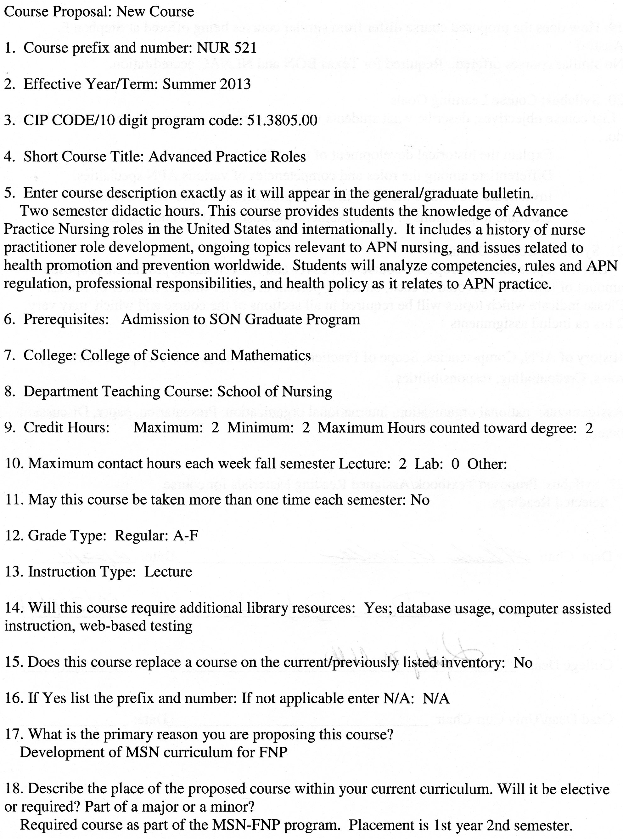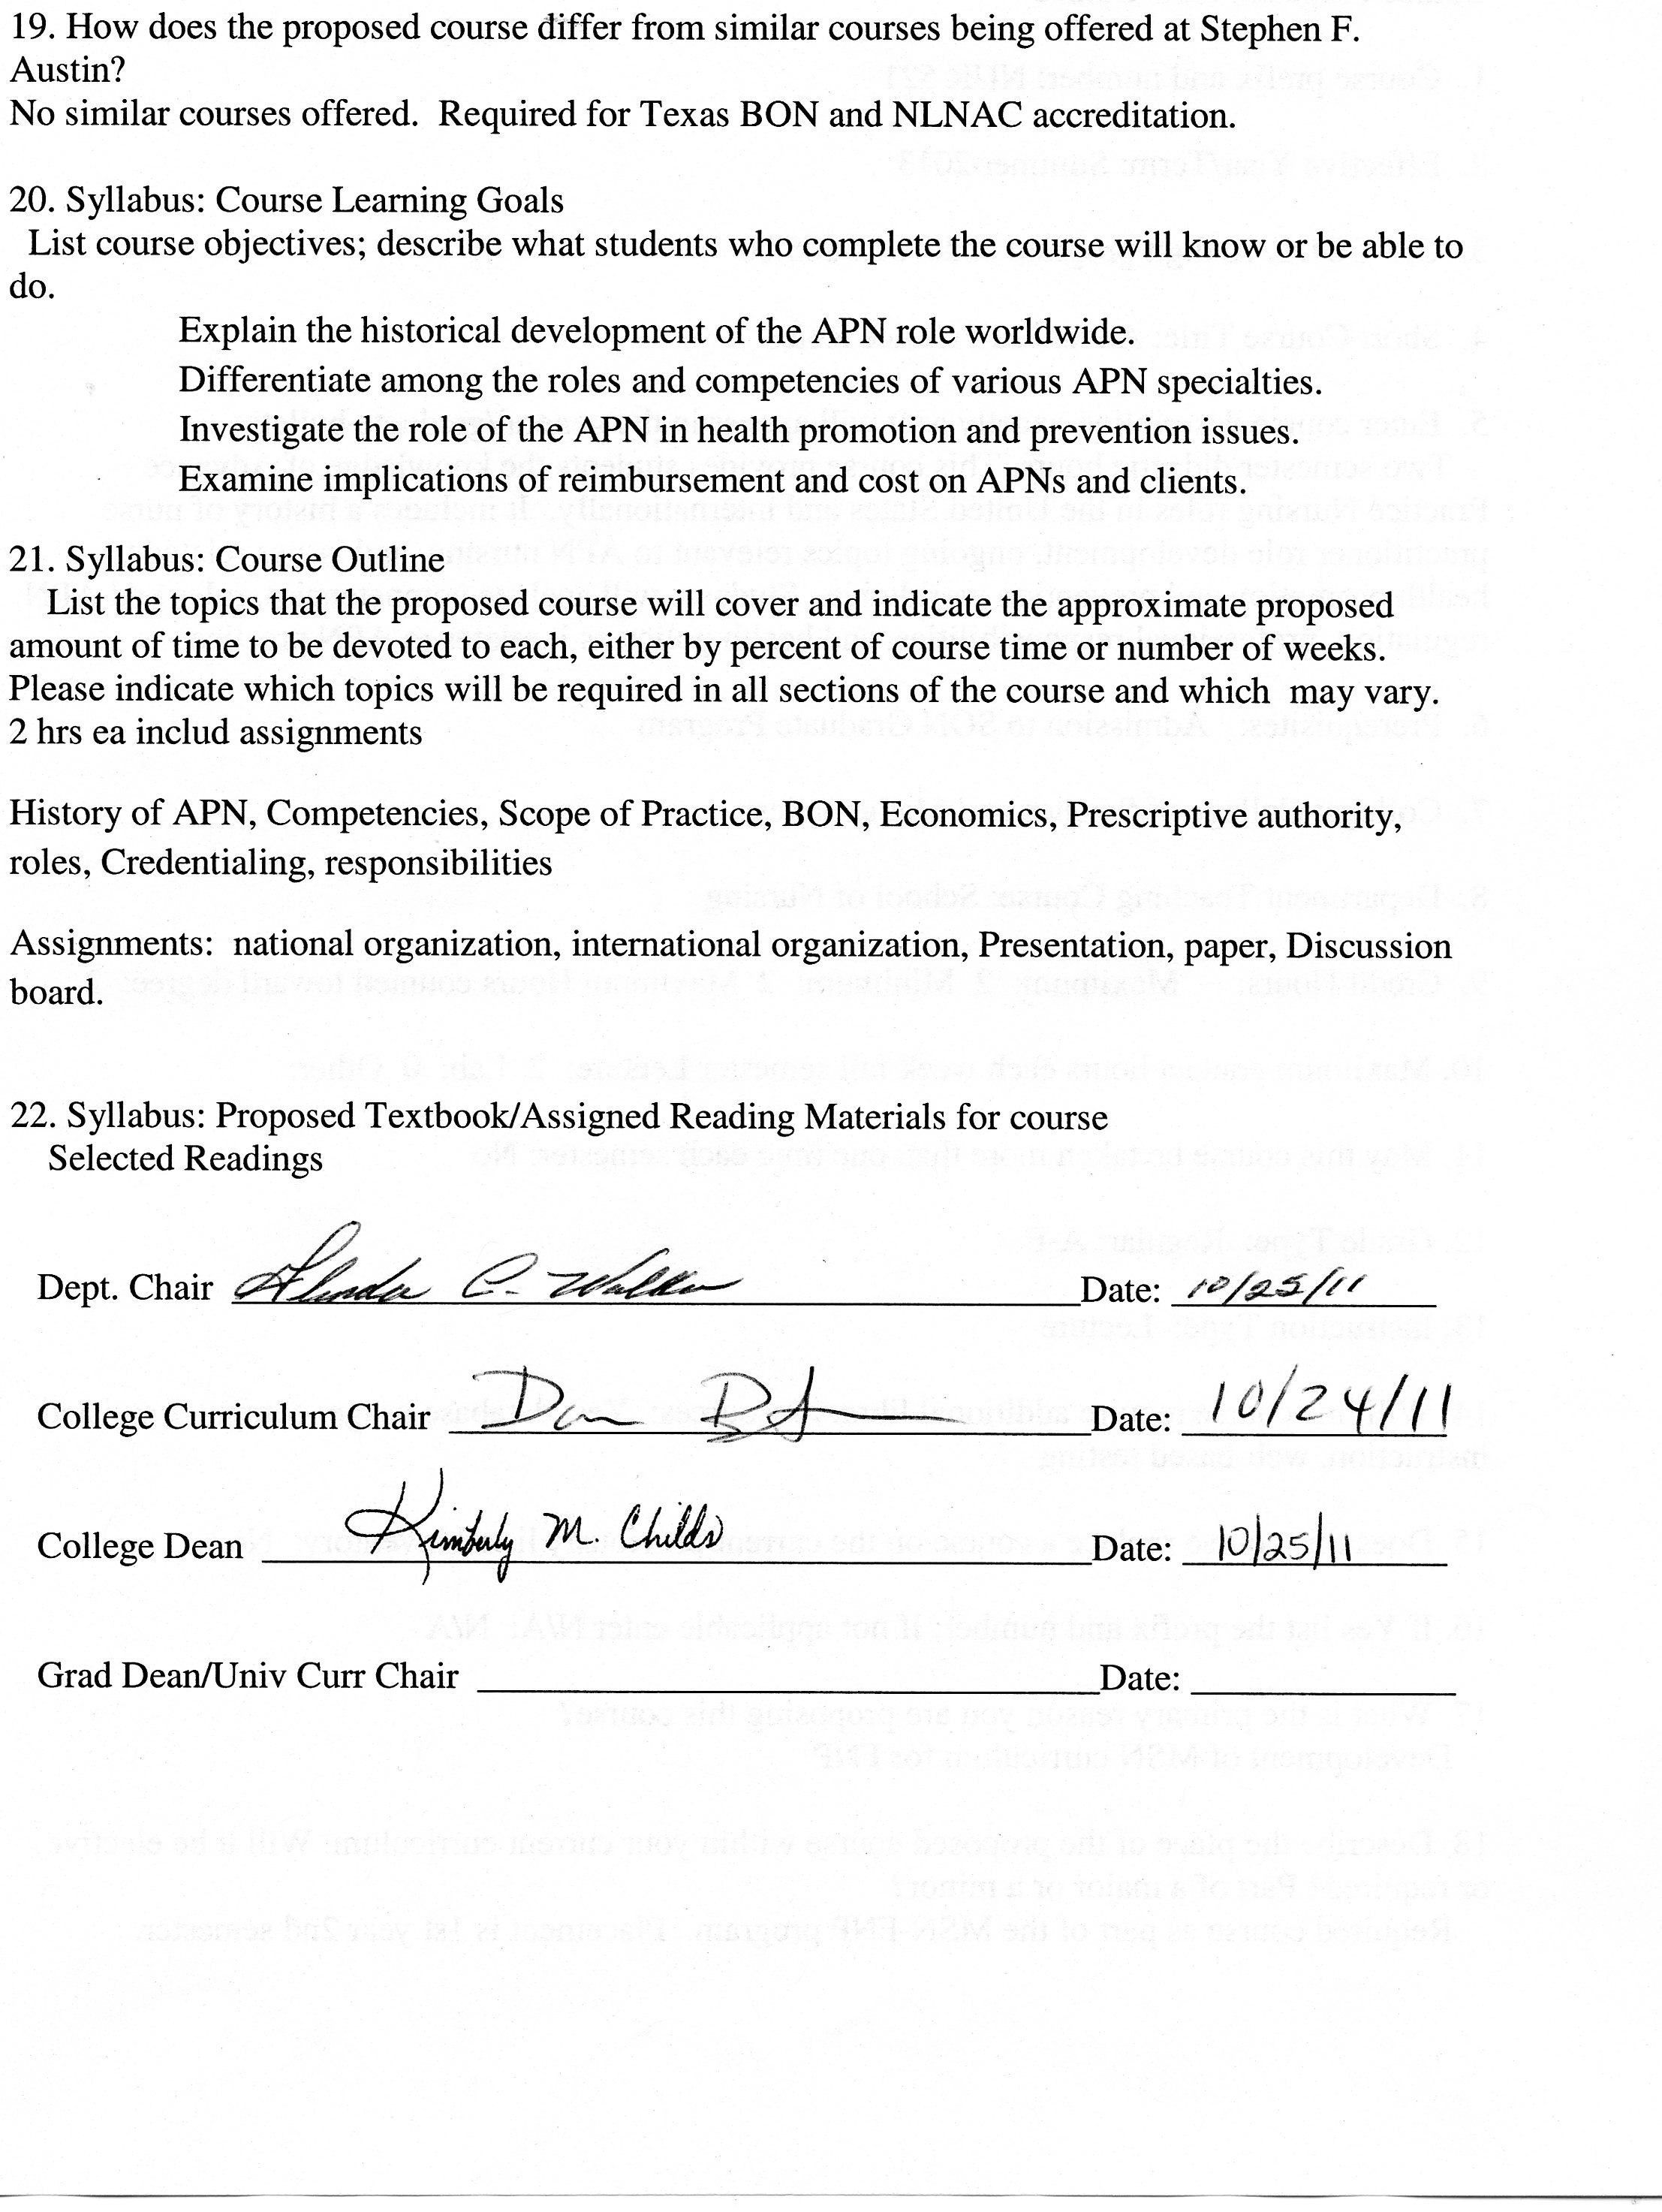

Stephen F. Austin State University
DeWitt School of Nursing
Advanced Practice Roles
Course Number: NUR 521

ALL INFORMATION IN THIS SYLLABUS IS SUBJECT TO THE WRITTEN POLICIES AND PROCEDURES OF THE SCHOOL OF NURSING, STEPHEN F. AUSTIN STATE UNIVERSITY, NACOGDOCHES, TEXAS

IN THE CASE OF COMMISSION, OMISSION, AMBIGUITY, VAGUENESS, OR CONFLICT, THE POLICIES AND PROCEDURES OF THE SCHOOL OF NURSING SHALL CONTROL.

EACH STUDENT SHALL BE RESPONSIBLE FOR ACTUAL AND/OR CONSTRUCTIVE KNOWLEDGE OF THE POLICIES AND PROCEDURES OF THE SCHOOL OF NURSING AND FOR COMPLIANCE THEREWITH.

THE STUDENT IS RESPONSIBLE FOR ALL INFORMATION IN THIS SYLLABUS.

This syllabus is provided for information purposes only.
Faculty Information

Name:
Department: Nursing
Email:
Phone:
Office:
Office Hours:

Class Meeting Time and Place: This course is taught in an online format.

Week | Date | Topic
1 |  | History of the role development of the APN
2 |  | Competencies of the APN
3 |  | Scope of practice of the APN
4 |  | BNE Rules
5 |  | Economic factors influencing the APN
6 |  | Economic factors influencing the APN
7 |  | Prescriptive authority
8 |  | NP roles
9 |  | NP roles - presentations
10 |  | NP roles - presentations
11 |  | NP roles - presentations
12 |  | Credentialing and titling issues
13 |  | Professional responsibilities
14 |  | Professional responsibilities
15 |  | NONPF Competencies
16 |  | Review and summary of course

Advanced Practice Roles
Course Description
This course provides students the knowledge of Advance Practice Nursing roles in the United States and internationally. It includes a history of nurse practitioner role development, ongoing topics relevant to APN nursing, and issues related to health promotion and prevention worldwide. Students will analyze competencies, rules and APN regulation, professional responsibilities, and health policy as it relates to APN practice.
Prerequisites Admission to the SON Graduate Program
Credit Hour Distribution 2 credit hours
Course Objectives
Upon completion of this course, students will:
- Explain the historical development of the APN role worldwide.
- Assemble concepts and principles of the arts, sciences, humanities, and nursing in order to utilize evidence based advanced practice nursing decisions within the APN’s scope of practice.
- Differentiate among the roles and competencies of various APN specialties.
- Investigate the role of the APN in health promotion and prevention issues.
- Examine implications of reimbursement and cost on APNs and clients.
- Evaluate responsibility and accountability using consistent behavior patterns and professional communication.
- Assess the role of the APN in collaboration with the interdisciplinary healthcare team respecting holistic, socio-economic, spiritual, and ethno-culturally diverse characteristics of clients.
Topics
- History of the role development of the APN.
- Competencies of the APN.
- Scope of Practice of the APN.
- BNE rules.
- Economic factors influencing the APN.
- Prescriptive authority.
- NP roles.
- Credentialing and titling issues.
- Professional responsibilities.
Instructional Methods

Discussion board, PowerPoint presentations, case studies

Teaching Strategies

Online discussion, reading assignments, case studies, online lecture modules, tests
Required Textbooks

Selected readings

Grades and Grading

Role Paper – 30%

Presentation on role of APN- 30%

Discussions – 20 %

Case Studies – 20%

Grading Scale

A 90-100
B 80-89
C 70-79
D 60-69
F <60

See current Stephen F. Austin State University Graduate Bulletin for probation, suspension, and readmission details.
Role Paper – Each student will submit a 15-20 page paper discussing the role of the
family nurse practitioner. See Role Paper Grading Rubric

Presentation on role of APN- Each student will present an online poster presentation on
the role of the family nurse practitioner utilizing information presented in the Role
Paper.

Discussions – Average of all Weekly Discussions. See Online Discussion Requirements and Grading Rubric

Case Studies – There will be a minimum of three case studies. See grading rubric.

Role Paper and Presentation Grading Rubric

 | 25 | 20 | 15 | 10 | 0 | POINTS
Quality of Content  (25 points) | Rich in content, full of thought, insight and synthesis with clear connections to previous or current content and/or to real life situations made with depth and detail. | Substantial information, thought, insight and analysis has taken place with some connection to previous or current content and/or to real life situations but lack of depth and detail. | Generally competent in summarizing learning, but information is thin and commonplace with limited connections and vague generalities. | Rudimentary and superficial regurgitation of content with no connections and/or completely off topic. | Not submitted or instructions not followed.
Relevance  (25 points) | The key issues within the prompt are indentified and answered. The discussion is consistently clear with few digressions. | The key issues within the prompt are identified but not all answered. The discussion is clear most of the time. | Some of the key issues within the prompt are identified but not answered. The discussion is not clear. | Confused, hard to follow and the key issues within the prompt are not identified or answered. | Not submitted or instructions not followed.
Reading and Resources  (25 points) | Readings and other resource materials are used to support comments. All references are documented according to current APA format. No APA format errors. | There is some reference to readings and other resource material. Most references are documented according to current APA format. Minimal APA format errors. | Little if any reference is made to readings. Major errors in references documented according to current APA format. Major APA format errors. | Readings and resources are not cited. No APA references. | Not submitted or instructions not followed.
Professionalism  (25 points) | Written in a professional manner, free of typos, spelling and mechanical errors. | Most writing in a professional manner, free of typos, spelling and mechanical errors. | Some writing written in a professional manner, free of typos, spelling and mechanical errors. | Most writing NOT written in a professional manner, free of typos, spelling and mechanical errors. | Not submitted or instructions not followed.

Stephen F. Austin State University
MSN-FNP Online Discussion Requirements and Grading Rubric

Background and Rational for Weekly Discussion Requirements and Grading

For this online nursing course, you are completing 16 weeks of class room time (2 hours per week), course work and assignments online. It is important for online learners to understand that guidelines for online learning are given by the U.S. Department of Education and professional accrediting bodies through which Stephen F. Austin State University and the DeWitt School of Nursing are accredited. The following has been prepared to clarify weekly discussion requirements and grading for students participating in online nursing courses.

The purpose of the Weekly Discussions is to develop a scholarly and dynamic exchange between you, faculty, and other students in the course promoting an active and engaging on-line learning community. Your success and the success of your classmates in a positive learning environment is dependent on discussion participation and timely completion of assignments.

Weekly Discussion Requirements

- Students are expected to participate in weekly discussions on at least three separate days out of seven in the electronic week.
- The three weekly posts consist of one Main post and a minimum of two responses to peers. All will be posted on separate days.
- The electronic week begins on Monday at 12:01 am CST and ends on Sunday at 12 midnight CST.
- There are no “make-ups” for not posting to the Weekly Discussions. If you need to be away or do not have computer access, you need to make alternative arrangements for participation and actively engaging in the course to meet weekly discussion requirements.
- Students must post a Main post to the Discussion board each week on or before Wednesday at 12 midnight CST.
- One point per day will be deducted for not having the Main post completed on or before Wednesday each week ensuring that all students have the opportunity for active learning and engagement with peers and course faculty.
- Students must read and respond to a minimum of two peer posts each week.
- Students must provide references in current APA format for all posts.
- It is recommended that you prepare your weekly discussion posts in Microsoft Word and then cut and paste into the Blackboard discussion. This is because Blackboard ‘times out’.
- All discussions posted must reflect proficient writing standards.
- Posts must be in the correct Weekly Discussion board or no points will be awarded.

Discussion Rubric

Category | Exceeds  3 | Average  2 | Below  1 | Unacceptable  0 | POINTS
Main Post Discussion | Displays an outstanding integration of required reading and other scholarly works supporting the points and topics of discussion. | Displays some integration of required reading and other scholarly works supporting the points and topics of discussion. | Displays poor integration of required reading and other scholarly works supporting the points and topics of discussion. | No post.
Peer Response Discussion | Displays outstanding knowledge of concepts and issues presented in the courses as well as in their peers’ postings. | Displays some knowledge of concepts and issues presented in the course as well as in their peers’ postings. | Displays poor knowledge of concepts and issues presented in the course as well as their peers’ postings. | No post.
Scholarly Writing | Posts have no grammar, spelling, or current APA edition format mistakes. | Posts have few grammar, spelling, and/or current APA edition format mistakes. | Posts have multiple grammar, spelling, and/or current APA edition format mistakes. | No post.

Case Study Grading Rubric

 | 25 | 20 | 15 | 10 | 0 | POINTS
Quality of Content  (25 points) | Rich in content, full of thought, insight and synthesis with clear connections to pervious or current content and/or to real life situations made with depth and detail. | Substantial information, thought, insight and analysis has taken place with some connection to previous or current content and/or to real life situations but lack of depth and detail. | Generally competent in summarizing learning, but information is thin and commonplace with limited connections and vague generalities. | Rudimentary and superficial regurgitation of content with no connections and/or completely off topic. | Not submitted or instructions not followed.
Relevance  (25 points) | The key issues within the prompt are indentified and answered. The discussion is consistently clear with few digressions. | The key issues within the prompt are identified but not all answered. The discussion is clear most of the time. | Some of the key issues within the prompt are identified but not answered. The discussion is not clear. | Confused, hard to follow and the key issues within the prompt are not identified or answered. | Not submitted or instructions not followed.
Reading and Resources  (25 points) | Readings and other resource materials are used to support comments. All references are documented according to current APA format. No APA format errors. | There is some reference to readings and other resource material. Most references are documented according to current APA format. Minimal APA format errors. | Little if any reference is made to readings. Major errors in references documented according to current APA format. Major APA format errors. | Readings and resources are not cited. No APA references. | Not submitted or instructions not followed.
Professionalism  (25 points) | Written in a professional manner, free of typos, spelling and mechanical errors. | Most writing in a professional manner, free of typos, spelling and mechanical errors. | Some writing written in a professional manner, free of typos, spelling and mechanical errors. | Most writing NOT written in a professional manner, free of typos, spelling and mechanical errors. | Not submitted or instructions not followed.

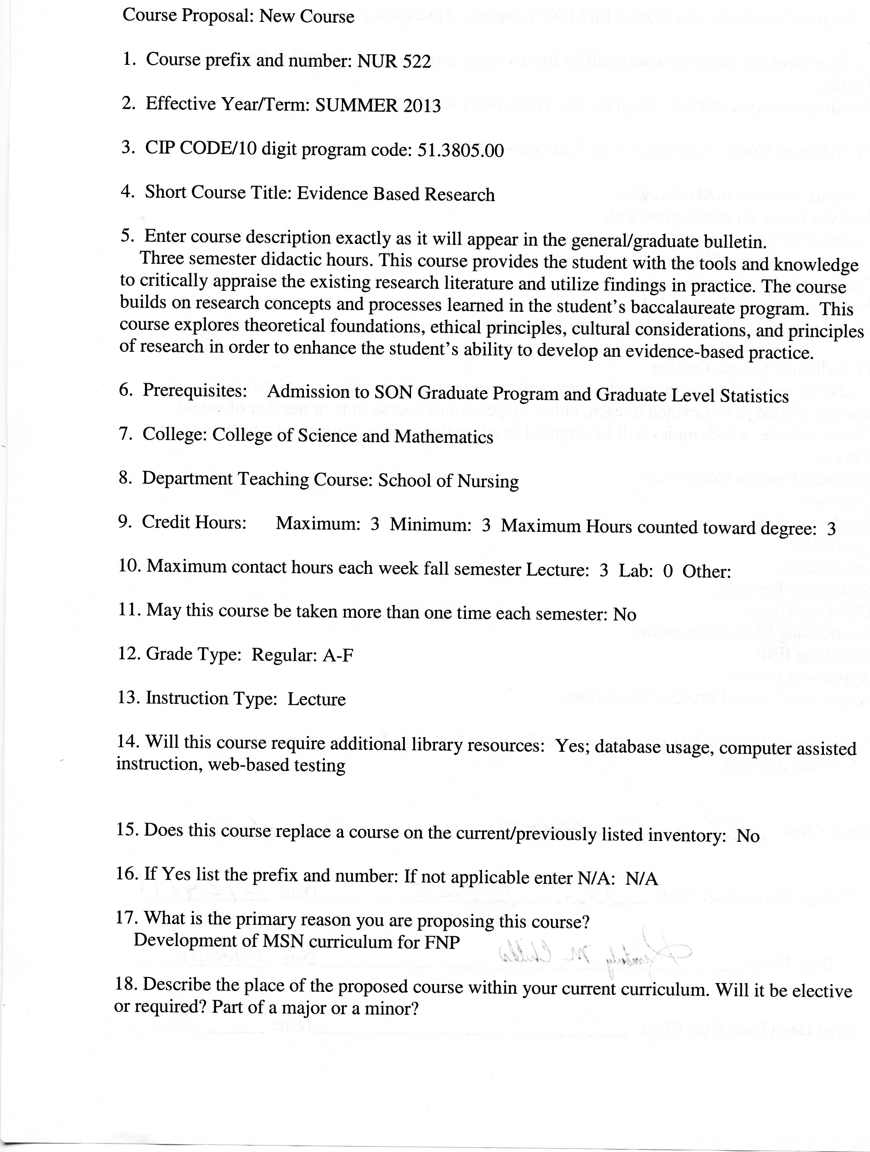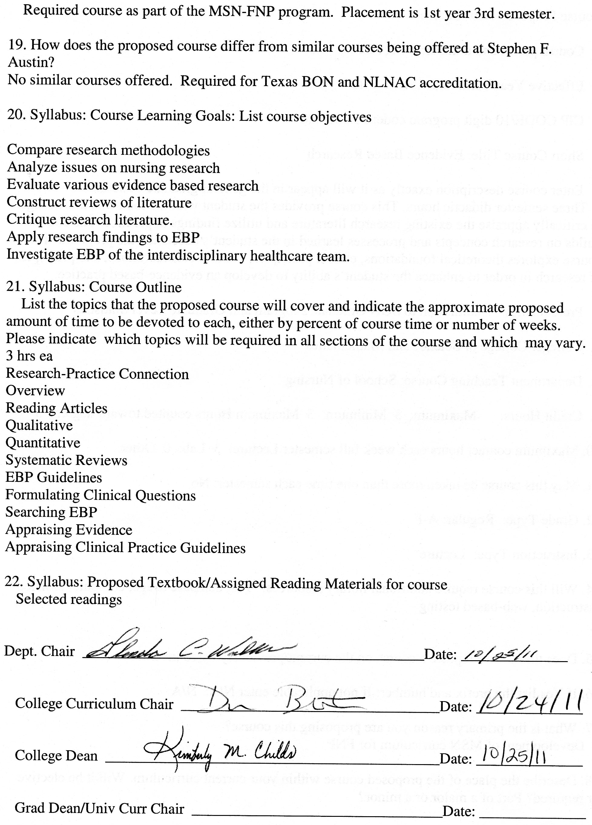

Stephen F. Austin State University
DeWitt School of Nursing
Evidence Based Research for the Advanced Practice Role
Course Number: NUR 522

ALL INFORMATION IN THIS SYLLABUS IS SUBJECT TO THE WRITTEN POLICIES AND PROCEDURES OF THE SCHOOL OF NURSING, STEPHEN F. AUSTIN STATE UNIVERSITY, NACOGDOCHES, TEXAS

IN THE CASE OF COMMISSION, OMISSION, AMBIGUITY, VAGUENESS, OR CONFLICT, THE POLICIES AND PROCEDURES OF THE SCHOOL OF NURSING SHALL CONTROL.

EACH STUDENT SHALL BE RESPONSIBLE FOR ACTUAL AND/OR CONSTRUCTIVE KNOWLEDGE OF THE POLICIES AND PROCEDURES OF THE SCHOOL OF NURSING AND FOR COMPLIANCE THEREWITH.

THE STUDENT IS RESPONSIBLE FOR ALL INFORMATION IN THIS SYLLABUS.

This syllabus is provided for information purposes only.
Faculty Information

Name:
Department: Nursing
Email:
Phone:
Office:
Office Hours:

Class Meeting Time and Place: This course is taught in an online format.

Week | Date | Topic
1 |  | Introductions  Review of Syllabus  Research-Practice Connection
2 |  | Overview of Research Methods
3 |  | Reading Research Articles
4 |  | Qualitative Research Methodology
5 |  | Quantitative Research Methodologies (descriptive, correlational, experimental, cohort)
6 |  | Systematic Reviews
7 |  | Evidence –Based Clinical Practice Guidelines
8 |  | Formulating Clinical Questions
9 |  | Searching for and Finding Clinical Evidence
10 |  | Appraising Research Evidence
11 |  | Appraising Clinical Practice Guidelines
12 |  | Appraising Conclusions of Integrative Research Reviews
13 |  | Appraising Findings of Original Studies
14 |  | Meta-analysis
15 |  | Presentation of Evidence Based Practice Findings
16 |  | Review and summary of course

Course Description
This course provides the student with the tools and knowledge to critically appraise the existing research literature and utilize findings in practice. The course builds on research concepts and processes learned in the student’s baccalaureate program. This course explores theoretical foundations, ethical principles, cultural considerations, and principles of research in order to enhance the student’s ability to develop an evidence-based practice.
Prerequisites: Admission to SON Graduate Program and Graduate Level Statistics
Credit Hour Distribution
3 credit hours
Course Objectives
Upon completion of this course, the student is expected to:

- Assemble concepts, principles, and research findings of the arts, sciences, humanities, and nursing in order to make evidence based advanced practice nursing decisions.
- Synthesize responsibility and accountability using consistent behavior patterns and professional communication.
- Compare qualitative and quantitative methodologies in research.
- Analyze the impact of ethical, legal, economic, and cultural issues on nursing research.
- Evaluate various theories, philosophies, frameworks, and process used in evidence based research.
- Construct reviews of literature using multiple databases and internet sources.
- Critique quantitative and qualitative research literature.
- Apply research findings to evidence based advanced nursing practice.
- Investigate the evidence based practices of the interdisciplinary healthcare team.
Topics
- Research-Practice Connection
- Overview of Research Methods
- Reading Research Articles
- Qualitative Research Methodology
- Quantitative Research Methodologies (descriptive, correlational, experimental, cohort)
- Systematic Reviews
- Evidence –Based Clinical Practice Guidelines
- Formulating Clinical Questions
- Searching for and Finding Clinical Evidence
- Appraising Research Evidence
- Appraising Clinical Practice Guidelines
- Appraising Conclusions of Integrative Research Reviews
- Appraising Findings of Original Studies
- Presentation of Evidence Based Practice Findings
Instructional Methods

Discussion board, PowerPoint presentations, case studies, module exams and projects as assigned.

Teaching Strategies

Online discussion, reading assignments, case studies, online lecture modules, online exams and student online presentations.

Required Textbooks

Selected readings

Grades and Grading

Powerpoint Presentation on Evidenced Based Research Clinical Practice Problem- 30%.

Database Searching and Website Analysis – 20%.
Discussion Average – 20 %
Quantitative and Qualitative Critiquing Group Assignment – 20%
Module Exams- 10%
Grading Scale

A 90-100
B 80-89
C 70-79
D 60-69
F <60

See current Stephen F. Austin State University Graduate Bulletin for probation, suspension, and readmission details.

PowerPoint Presentation on Evidenced Based Research Clinical Practice Problem-
16-20 slide PowerPoint Presentation which includes:
- Introduction to Clinical Problem
- Significance of problem to advanced nursing practice
- Statement of the research question
- Literature review in a table format
- Proposed evidence based solution to the advanced practice clinical problem with an emphasis on implementation
- APA format.
Database Searching and Website Analysis
Students will perform a search of 5 databases and 5 websites relevant to the topic they have chosen for their EBP poster presentation. The same search string will be used for all searches. Search worksheets will be provided. Students will then identify which database and which website is preferable for their topic and explain their decisions in written format in the assignment dropbox. Students will also submit (in current APA format), a list of 3 references from the databases and 2 from the web exploration that are applicable to their EBP poster topic.
Provided is the link to the website worksheet: http://www.lib.umd.edu/guides/webcheck.html
Discussions

See Online Discussion Requirements and Grading Rubric

Quantitative and Qualitative Critiquing Group Assignment
Students will work in small groups via the discussion or chat boards to critique both a quantitative and a qualitative research article (linked electronically by professors). See grading rubric for detailed criteria.
Critiques must include the following:
- Research Problem and Purpose
- Literature Review
- Theoretical/conceptual Framework
- Research Objectives, Questions, or Hypotheses
- Research Design
- Sample, Population, and Setting
- Measurements
- Scales and Questionnaires/Observation/Interviews/Physiologic Measures (choose the one that is applicable to your article)
- Data Collection
- Data Analysis
- Interpretation of Findings
- Evaluation: Recommendations for usefulness of the study in practice
- Assessment of References
- Credibility of the authors for this research study

Module Exams
Exams will be taken electronically at the conclusion of each module.
Stephen F. Austin State University
DeWitt School of Nursing
NURS 522: Evidence Based Research for the Advanced Practice Role

Guidelines and Scoring for Poster Presentation

The purpose of this project is to assist the student to demonstrate application of evidence-based practice in advanced practice clinical nursing.
The Poster Presentation (80 points)
- Introduction to the Clinical Problem (5 points)
Introduce the viewer to the problem by broadly addressing the topic
- Significance of the Problem to Advanced Practice Nursing (5 points)
Discuss significance of the problem to nursing practice and patient care. May need to address financial, physical, psychological, or organizational issues. Why is this problem important to you as a nurse? Your topic must have importance to the nurse at the bedside!
- Statement of the Research Question (5 points)
In one sentence, clearly state the question; what you hope to learn from the literature review. This should be in question format.
- Literature Review (20 points) – Must be presented in Table format
Review the literature and identify a minimum of 5 published research study articles from professional, peer reviewed journals. Each article must be a report of a single research study. Do not use integrated literature reviews, meta-analyses, or clinical guidelines or any other clinical research compilations. Each research study reviewed must include the following:
- Study design
- Human Rights/Informed Consent if applicable
- Sample and duration of study
- Objectives/questions/hypotheses
- Procedures for data collection
- Findings

- Presentation of the Evidence (10 points)
Synthesize the best evidence from the review of the literature. Identify similarities and differences in the findings of the studies and present the evidence which best supports and provides the basis for the proposed solution to the clinical problem.
- Proposed Evidence-Based Solution to the Clinical Problem (25 points)
Develop a proposal for an evidence-based solution to the clinical problem. Include in detail:
- Proposed solution and rationale for support.
- Strategies to implement the solution.
- Plan for implementation of the solution.
- Plan for evaluation after implementation.

- Summary and Conclusion (10 points)
Additional Criteria (20 points)
- Content is clear, well-organized, visually appealing, professional, and easy to read and is presented in PowerPoint poster format. (5 points)

- A list of the research articles used, in current APA format, is attached to the back to the presentation for your classmates to view. An electronic copy of each article in its entirety is available for faculty to review if requested.(5 points)

- Correct spelling and grammar (10 points)

Stephen F. Austin State University
DeWitt SON
NUR 522-Research
Evidence Based Poster Presentation
Database Search Worksheet (complete 1/database using identical search terms)
1. What is the topic you want to explore?
In priority order, list 2-3 central elements of the topic and their synonyms:
(1)__________________________________
(2)__________________________________
(3)__________________________________

2. What relational words will you use (and, or, not) and why?

Will you limit by years? _____ If yes, what years? _____________

3. 1st word or search string:
# of hits: # of hits that appear useful to you:

2nd word or search string:
# of hits: # of hits that appear useful to you:
Continue above format on a separate sheet until you feel that the majority of hits are useful in finding an article.
Final search string:
# of hits: # of hits that appear useful to you:

4. What factors influenced your choice of articles?

5. Was the article in our library? Online or hard copy?

If yes, how would you find it?

If no, how would you retrieve it?
Rubric for Grading Database Searching and Website Analysis
(5 database searches and 5 website analyses using same search string using forms attached to assignment instructions. All searches must be completed and forms submitted by date due)
 | 25 | 20 | 15 | 0 | POINTS
Data base search  (25 points) | All searches completed/forms submitted AND  discussion of why one database is preferable for your topic over the other four is clear and contains substantial detail. | All searches completed/forms submitted AND  discussion of why one database is preferable for your topic over the other four is  evident but lacks clarity and substantial detail. | All searches completed/forms submitted BUT  discussion of why one database is preferable for your topic over the other four is not evident. | Less than 5 databases searched using same search terms and/or all forms not submitted.
Website analysis  (25 points) | All analyses completed/forms submitted AND  discussion of why one website is preferable for your topic over the other four is clear and contains substantial detail. | All analyses completed/forms submitted AND  discussion of why one website is preferable for your topic over the other four is  evident but lacks of depth and substantial detail. | All analyses completed/forms submitted BUT  discussion of why one website is preferable for your topic over the other four is not evident. | Less than 5 websites searched using same search terms and/or all forms not submitted.
Resource selection documentation  (25 points) | 3 potential references for EBP poster and 2 explored websites are documented according to current APA format. No APA format errors. | 3 potential references for EBP poster and 2 explored websites are documented according to current APA format. Minimal APA format errors. | 3 potential references for EBP poster and 2 explored websites are documented according to current APA format. Major APA format errors. | Less than 3 potential references for EBP poster and/or < 2 websites are documented according to current APA format.
Professionalism  (25 points) | Assignment is written in a professional manner, free of typos, spelling and mechanical errors. | Most of assignment is written in a professional manner, free of typos, spelling and mechanical errors. | Some of assignment written in a professional manner, free of typos, spelling and mechanical errors. | Most of assignment is NOT written in a professional manner, free of typos, spelling and mechanical errors.
Stephen F. Austin State University
MSN-FNP Online Discussion Requirements and Grading Rubric

Background and Rational for Weekly Discussion Requirements and Grading

For this online nursing course, you are completing 16 weeks of class room time (3 hours per week), course work and assignments online. It is important for online learners to understand that guidelines for online learning are given by the U.S. Department of Education and professional accrediting bodies through which Stephen F. Austin State University and the DeWitt School of Nursing are accredited. The following has been prepared to clarify weekly discussion requirements and grading for students participating in online nursing courses.

The purpose of the Weekly Discussions is to develop a scholarly and dynamic exchange between you, faculty, and other students in the course promoting an active and engaging on-line learning community. Your success and the success of your classmates in a positive learning environment is dependent on discussion participation and timely completion of assignments.

Weekly Discussion Requirements

- Students are expected to participate in weekly discussions on at least three separate days out of seven in the electronic week.
- The three weekly posts consist of one Main post and a minimum of two responses to peers. All will be posted on separate days.
- The electronic week begins on Monday at 12:01 am CST and ends on Sunday at 12 midnight CST.
- There are no “make-ups” for not posting to the Weekly Discussions. If you need to be away or do not have computer access, you need to make alternative arrangements for participation and actively engaging in the course to meet weekly discussion requirements.
- Students must post a Main post to the Discussion board each week on or before Wednesday at 12 midnight CST.
- One point per day will be deducted for not having the Main post completed on or before Wednesday each week ensuring that all students have the opportunity for active learning and engagement with peers and course faculty.
- Students must read and respond to a minimum of two peer posts each week.
- Students must provide references in current APA format for all posts.
- It is recommended that you prepare your weekly discussion posts in Microsoft Word and then cut and paste into the Blackboard discussion. This is because Blackboard ‘times out’.
- All discussions posted must reflect proficient writing standards.
- Posts must be in the correct Weekly Discussion board or no points will be awarded.
Discussion Rubric

Category | Exceeds  3 | Average  2 | Below  1 | Unacceptable  0 | POINTS
Main Post Discussion | Displays an outstanding integration of required reading and other scholarly works supporting the points and topics of discussion. | Displays some integration of required reading and other scholarly works supporting the points and topics of discussion. | Displays poor integration of required reading and other scholarly works supporting the points and topics of discussion. | No post.
Peer Response Discussion | Displays outstanding knowledge of concepts and issues presented in the courses as well as in their peers’ postings. | Displays some knowledge of concepts and issues presented in the course as well as in their peers’ postings. | Displays poor knowledge of concepts and issues presented in the course as well as their peers’ postings. | No post.
Scholarly Writing | Posts have no grammar, spelling, or current APA edition format mistakes. | Posts have few grammar, spelling, and/or current APA edition format mistakes. | Posts have multiple grammar, spelling, and/or current APA edition format mistakes. | No post.

Grading Rubric for Quantitative and Qualitative Critiquing Group Assignment
 | 25 | 20 | 15 | 10 | 0 | POINTS
Quality of Content  (25 points) | Rich in content, full of thought, insight and synthesis with clear connections to previous or current content and/or to real life situations made with depth and detail. | Substantial information, thought, insight and analysis has taken place with some connection to previous or current content and/or to real life situations but lack of depth and detail. | Generally competent in summarizing learning, but information is thin and commonplace with limited connections and vague generalities. | Rudimentary and superficial regurgitation of content with no connections and/or completely off topic. | Not submitted or instructions not followed.
Relevance  (25 points) | The key issues within the prompt are indentified and answered. The discussion is consistently clear with few digressions. | The key issues within the prompt are identified but not all answered. The discussion is clear most of the time. | Some of the key issues within the prompt are identified but not answered. The discussion is not clear. | Confused, hard to follow and the key issues within the prompt are not identified or answered. | Not submitted or instructions not followed.
Reading and Resources  (25 points) | Readings and other resource materials are used to support comments. All references are documented according to current APA format. No APA format errors. | There is some reference to readings and other resource material. Most references are documented according to current APA format. Minimal APA format errors. | Little if any reference is made to readings. Major errors in references documented according to current APA format. Major APA format errors. | Readings and resources are not cited. No APA references. | Not submitted or instructions not followed.
Professionalism  (25 points) | Written in a professional manner, free of typos, spelling and mechanical errors. | Most writing in a professional manner, free of typos, spelling and mechanical errors. | Some writing written in a professional manner, free of typos, spelling and mechanical errors. | Most writing NOT written in a professional manner, free of typos, spelling and mechanical errors. | Not submitted or instructions not followed.

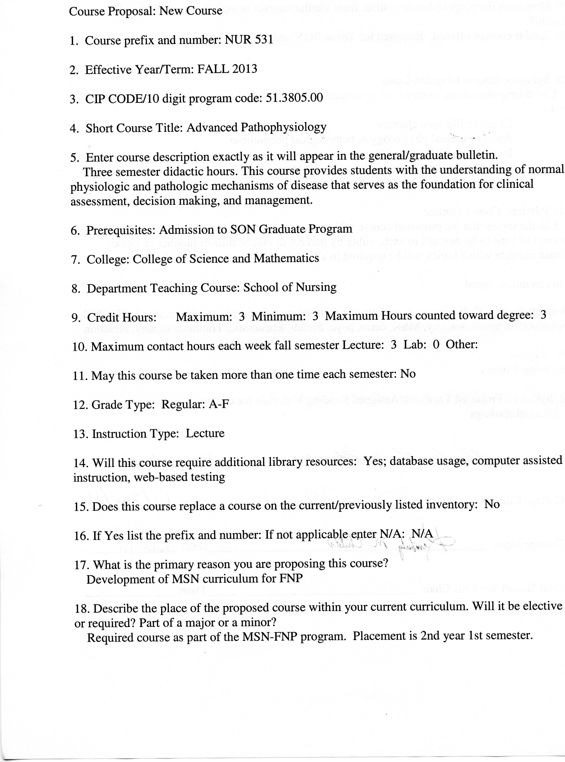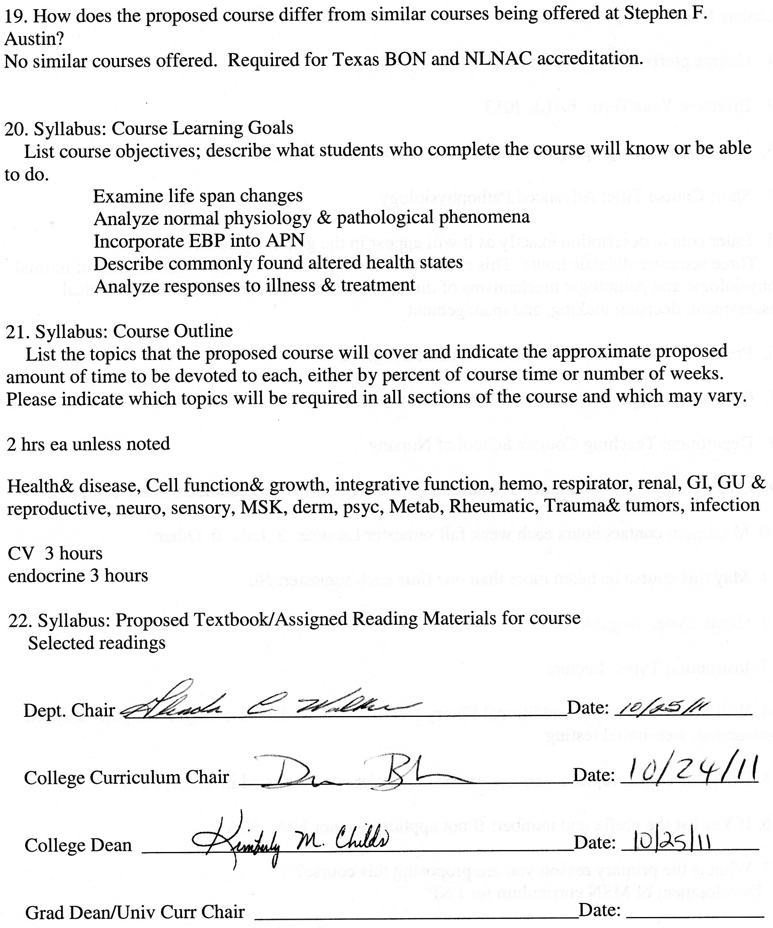

Stephen F. Austin State University
DeWitt School of Nursing
Advanced Pathophysiology
Course Number: NUR 531

ALL INFORMATION IN THIS SYLLABUS IS SUBJECT TO THE WRITTEN POLICIES AND PROCEDURES OF THE SCHOOL OF NURSING, STEPHEN F. AUSTIN STATE UNIVERSITY, NACOGDOCHES, TEXAS

IN THE CASE OF COMMISSION, OMISSION, AMBIGUITY, VAGUENESS, OR CONFLICT, THE POLICIES AND PROCEDURES OF THE SCHOOL OF NURSING SHALL CONTROL.

EACH STUDENT SHALL BE RESPONSIBLE FOR ACTUAL AND/OR CONSTRUCTIVE KNOWLEDGE OF THE POLICIES AND PROCEDURES OF THE SCHOOL OF NURSING AND FOR COMPLIANCE THEREWITH.

THE STUDENT IS RESPONSIBLE FOR ALL INFORMATION IN THIS SYLLABUS.

This syllabus is provided for information purposes only.
Faculty Information

Name:
Department: Nursing
Email:
Phone:
Office:
Office Hours:

Class Meeting Time and Place: This course is taught in an online format.

Week | Date | Topic
1 |  | Concepts of health and disease  Cell function and growth
2 |  | Disorders of integrative function  Disorders of hematopoietic system
3 |  | Infection, inflammation, and immunity
4 |  | Disorders of cardiovascular function
5 |  | Disorders of cardiovascular function
6 |  | Disorders of respiratory function
7 |  | Disorders of renal function and fluids and electrolytes
8 |  | Disorders of renal function and fluids and electrolytes
9 |  | Disorders of gastrointestinal function
10 |  | Disorders of endocrine function  Disorders of genitourinary and reproductive function
11 |  | Disorders of neural function
12 |  | Disorders of neurological function
13 |  | Disorders of sensory function
14 |  | Disorders of musculoskeletal and integumentary function
15 |  | Disorders of multisystem failure
16 |  | Review and summary of course

Advanced Pathophysiology
Course Description
This course provides students with the understanding of normal physiologic and pathologic mechanisms of disease that serves as the foundation for clinical assessment, decision making, and management.
Prerequisites Admission to the SON Graduate Program
Credit Hour Distribution
3 credit hours
Course Objectives
Upon completion of this course, the student is expected to:
- Examine physiologic changes over the life span.
- Analyze the relationship between normal physiology and pathological phenomena.
- Incorporate current evidence based practice regarding pathophysiology into advance practice nursing.
- Describe the developmental physiology, normal etiology, pathogenesis, and clinical manifestations of commonly found altered health states in various populations.
- Analyze physiological responses to illness and treatment modalities.
- Synthesize responsibility and accountability using consistent behavior patterns and professional communication.

Topics
Concepts of health and disease
Cell function and growth
Disorders of integrative function
Disorders of hematopoietic system
Infection, inflammation, and immunity
Disorders of cardiovascular function
Disorders of respiratory function
Disorders of renal function and fluids and electrolytes
Disorders of gastrointestinal function
Disorders of endocrine function
Disorders of genitourinary and reproductive function
Disorders of neurological function
Disorders of sensory function
Disorders of musculoskeletal and integumentary function
Disorders of skin integrity and function

Instructional Methods

Discussion board, PowerPoint presentations, case studies

Teaching Strategies

Online discussion, reading assignments, case studies, online lecture modules, tests

Required Textbooks

Selected readings

Grades and Grading (see grading rubrics)

Exam I 15%.

Exam II 15%.

Exam III 15%.

Exam IV 15%.

Discussion Average 20 %

Case Studies Average 20%.

Grading Scale

A 90-100
B 80-89
C 70-79
D 60-69
F <60

See current Stephen F. Austin State University Graduate Bulletin for probation, suspension, and readmission details.

Exams

Exam I - Concepts of health and disease, Disorders of integrative function, Disorders of hematopoietic system, Infection, inflammation, and immunity
Exam II - Disorders of cardiovascular function, Disorders of respiratory function,
Exam III - Disorders of renal function and fluids and electrolytes, Disorders of gastrointestinal function, Disorders of endocrine function
Exam IV - Disorders of neural function, Disorders of sensory function, Disorders of musculoskeletal and integumentary function
Discussions

Average of all Weekly Discussions. See Online Discussion Requirements and Grading Rubric.
Case Studies

Average of all Case Studies. Minimum of three case studies through the semester. Case studies may be assigned to group to be presented on the discussion board on an assigned date. See Case Study Grading Rubric.

Stephen F. Austin State University
MSN-FNP Online Discussion Requirements and Grading Rubric

Background and Rational for Weekly Discussion Requirements and Grading

For this online nursing course, you are completing 16 weeks of class room time (3 hours per week), course work and assignments online. It is important for online learners to understand that guidelines for online learning are given by the U.S. Department of Education and professional accrediting bodies through which Stephen F. Austin State University and the DeWitt School of Nursing are accredited. The following has been prepared to clarify weekly discussion requirements and grading for students participating in online nursing courses.

The purpose of the Weekly Discussions is to develop a scholarly and dynamic exchange between you, faculty, and other students in the course promoting an active and engaging online learning community. Your success and the success of your classmates in a positive learning environment is dependent on discussion participation and timely completion of assignments.

Weekly Discussion Requirements

- Students are expected to participate in weekly discussions on at least three separate days out of seven in the electronic week.
- The three weekly posts consist of one Main post and a minimum of two responses to peers. All will be posted on separate days.
- The electronic week begins on Monday at 12:01 am CST and ends on Sunday at 12 midnight CST.
- There are no “make-ups” for not posting to the Weekly Discussions. If you need to be away or do not have computer access, you need to make alternative arrangements for participation and actively engaging in the course to meet weekly discussion requirements.
- Students must post a Main post to the Discussion board each week on or before Wednesday at 12 midnight CST.
- One point per day will be deducted for not having the Main post completed on or before Wednesday each week ensuring that all students have the opportunity for active learning and engagement with peers and course faculty.
- Students must read and respond to a minimum of two peer posts each week.
- Students must provide references in current APA format for all posts.
- It is recommended that you prepare your weekly discussion posts in Microsoft Word and then cut and paste into the Blackboard discussion. This is because Blackboard ‘times out’.
- All discussions posted must reflect proficient writing standards.
Posts must be in the correct Weekly Discussion board or no points will be awarded.

Discussion Rubric

Category | Exceeds  3 | Average  2 | Below  1 | Unacceptable  0 | POINTS
Main Post Discussion | Displays an outstanding integration of required reading and other scholarly works supporting the points and topics of discussion. | Displays some integration of required reading and other scholarly works supporting the points and topics of discussion. | Displays poor integration of required reading and other scholarly works supporting the points and topics of discussion. | No post.
Peer Response Discussion | Displays outstanding knowledge of concepts and issues presented in the courses as well as in their peers’ postings. | Displays some knowledge of concepts and issues presented in the course as well as in their peers’ postings. | Displays poor knowledge of concepts and issues presented in the course as well as their peers’ postings. | No post.
Scholarly Writing | Posts have no grammar, spelling, or current APA edition format mistakes. | Posts have few grammar, spelling, and/or current APA edition format mistakes. | Posts have multiple grammar, spelling, and/or current APA edition format mistakes. | No post.

Case Study Grading Rubric

 | 25 | 20 | 15 | 10 | 0 | POINTS
Quality of Content  (25 points) | Rich in content, full of thought, insight and synthesis with clear connections to previous or current content and/or to real life situations made with depth and detail. | Substantial information, thought, insight and analysis has taken place with some connection to previous or current content and/or to real life situations but lack of depth and detail. | Generally competent in summarizing learning, but information is thin and commonplace with limited connections and vague generalities. | Rudimentary and superficial regurgitation of content with no connections and/or completely off topic. | Not submitted or instructions not followed.
Relevance  (25 points) | The key issues within the prompt are indentified and answered. The discussion is consistently clear with few digressions. | The key issues within the prompt are identified but not all answered. The discussion is clear most of the time. | Some of the key issues within the prompt are identified but not answered. The discussion is not clear. | Confused, hard to follow and the key issues within the prompt are not identified or answered. | Not submitted or instructions not followed.
Reading and Resources  (25 points) | Readings and other resource materials are used to support comments. All references are documented according to current APA format. No APA format errors. | There is some reference to readings and other resource material. Most references are documented according to current APA format. Minimal APA format errors. | Little if any reference is made to readings. Major errors in references documented according to current APA format. Major APA format errors. | Readings and resources are not cited. No APA references. | Not submitted or instructions not followed.
Professionalism  (25 points) | Written in a professional manner, free of typos, spelling and mechanical errors. | Most writing in a professional manner, free of typos, spelling and mechanical errors. | Some writing written in a professional manner, free of typos, spelling and mechanical errors. | Most writing NOT written in a professional manner, free of typos, spelling and mechanical errors. | Not submitted or instructions not followed.

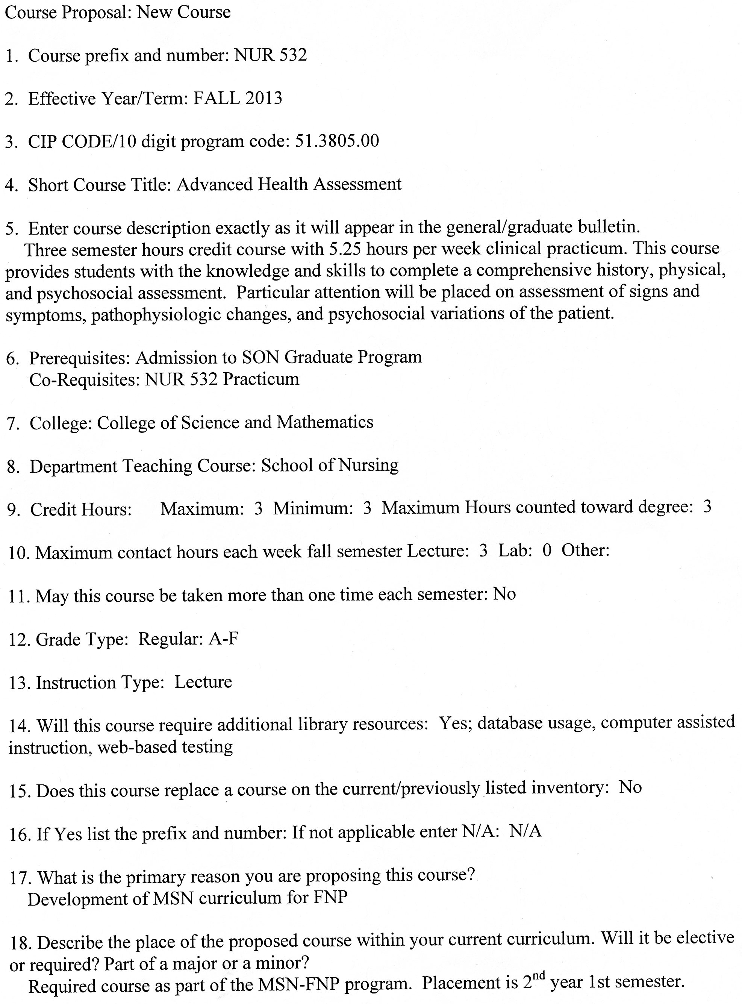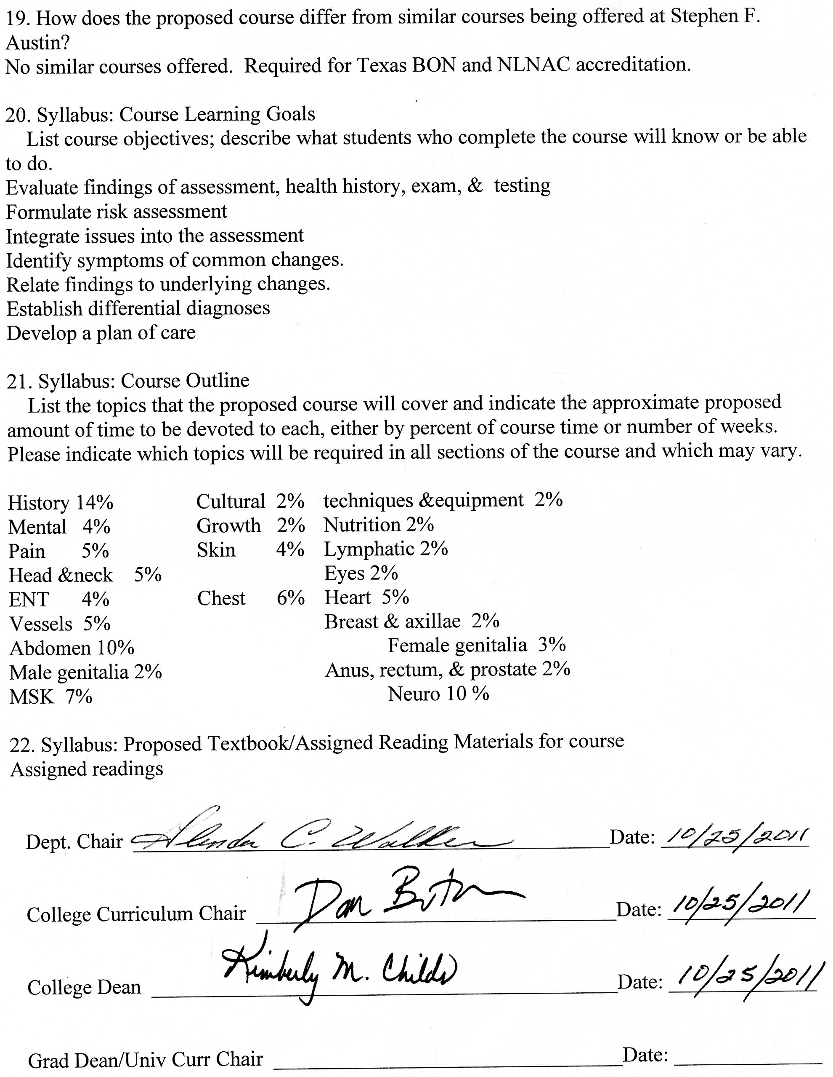
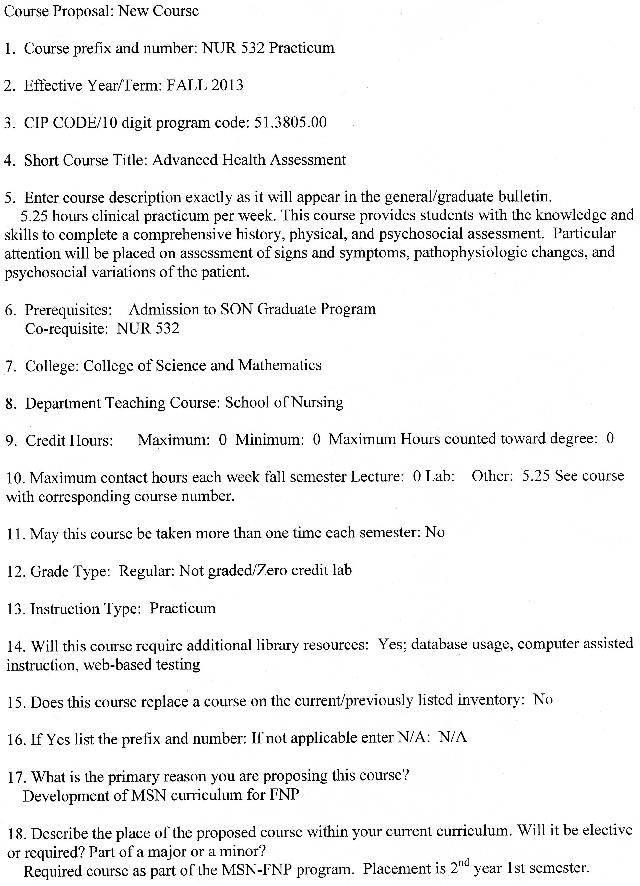
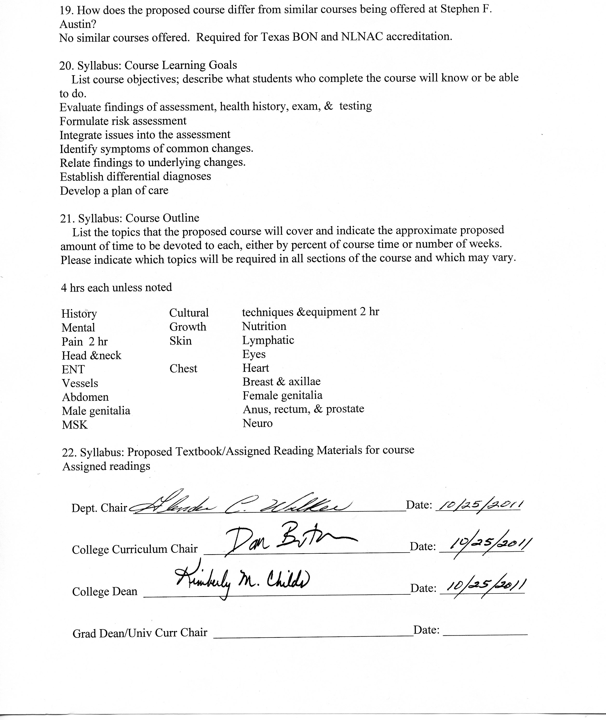

Stephen F. Austin State University
DeWitt School of Nursing
Advanced Health Assessment
Course Number: NUR 532

ALL INFORMATION IN THIS SYLLABUS IS SUBJECT TO THE WRITTEN POLICIES AND PROCEDURES OF THE SCHOOL OF NURSING, STEPHEN F. AUSTIN STATE UNIVERSITY, NACOGDOCHES, TEXAS

IN THE CASE OF COMMISSION, OMISSION, AMBIGUITY, VAGUENESS, OR CONFLICT, THE POLICIES AND PROCEDURES OF THE SCHOOL OF NURSING SHALL CONTROL.

EACH STUDENT SHALL BE RESPONSIBLE FOR ACTUAL AND/OR CONSTRUCTIVE KNOWLEDGE OF THE POLICIES AND PROCEDURES OF THE SCHOOL OF NURSING AND FOR COMPLIANCE THEREWITH.

THE STUDENT IS RESPONSIBLE FOR ALL INFORMATION IN THIS SYLLABUS.

This syllabus is provided for information purposes only.

Faculty Information

Name:
Department: Nursing
Email:
Phone:
Office:
Office Hours:

Class Meeting Time and Place

This course is taught in an online format.

Week | Date | Topic | Readings
1 |  | History, Interviewing, Exam Techniques & Equipment
2 |  | Growth, Measurement, Nutrition
3 |  | Risk Assessment & Pain Assessment
4 |  | Heart & Blood Vessels
5 |  | Chest & Lungs
6 |  | Male & Female Genitalia
7 |  | GI & GU
8 |  | Head, Neck, Lymph & Eyes
9 |  | Ears, Nose & Throat
10 |  | Musculoskeletal
11 |  | Neurological & Mental Status
12 |  | Skin, Hair & Nails
13 |  | Life Threatening/Emergency Issues
14 |  | Cultural Assessment
15 |  | On campus clinical
16 |  | Review and summary of course

Course Description
This course provides students with the knowledge and skills to complete a comprehensive history, physical, and psychosocial assessment. Particular attention will be placed on assessment of signs and symptoms, pathophysiologic changes, and psychosocial variations of the patient.
Prerequisites Admission to SON Graduate Program

Credit Hour Distribution
3 credit hours
84 hours clinical practicum
Course Objectives
Upon completion of this course, the student is expected to:

- Assemble concepts and principles of the arts, sciences, humanities, and nursing in order to make sound advanced practice nursing decisions.
- Evaluate findings of a complete assessment, health history, physical examination, and diagnostic testing.
- Formulate a risk assessment of the patient.
- Identify signs and symptoms of common psychosocial changes.
- Relate assessment findings to underlying pathology or physiologic changes.
- Establish differential diagnoses based on the assessment data.
- Develop a plan of care for the patient based on comprehensive assessment findings.
- Synthesize responsibility and accountability using consistent behavior patterns and professional communication.
- Incorporate evidenced based practice into the provision of advanced practice nursing care.
- Collaborate with the interdisciplinary healthcare team respecting holistic, socio-economic, spiritual, and ethno-culturally diverse characteristics of clients.
- Integrate moral, ethical, economic, and legal issues into the assessment of clients, families, and the global community.

Topics
- History and interviewing process
- Cultural awareness
- Examination techniques and equipment
- Mental status/psychosocial
- Risks
- Growth and measurement
- Nutrition
- Assessment of pain
- Skin, hair, and nails
- Lymphatic system
- Head and neck
- Eyes
- Ears, nose, and throat
- Chest and lungs
- Heart
- Blood vessels
- Breast and axillae
- Abdomen
- Female genitalia
- Male genitalia
- Anus, rectum, and prostate
- Musculoskeletal system
- Neurologic system
- Emergency Issues

Instructional Methods

Discussion board, Powerpoint presentations, case studies

Teaching Strategies

Online discussion, reading assignments, case studies, online lecture modules, exams, clinical experiences
Required Textbooks

Selected readings.

Grades and Grading
The student’s achievement of the course objectives is evaluated based on the following activities:

Exams
20% - Exam I 20% - Exam II A minimum average grade of 80% on the 2 exams must be achieved in order to pass the course. Even if the final course grade is 80% or more, the average grade on the 2 exams must be 80% or higher to pass the course. There is no provision for re-taking exams in the course.
Scholarly Papers/Presentations
10% - Audio Taped Interview & Write-up 10% - Episodic Exam & Write-up 20% - Comprehensive History & Physical 10% - Case Studies 10% - Discussion Board
Clinical
Pass/Fail - Clinical Practice Hours (84 minimum), Clinical Logs, and Clinical Skills Check-Off.
Grading Scale

A 90-100
B 80-89
C 70-79
D 60-69
F <60

See current Stephen F. Austin State University Graduate Bulletin for probation, suspension, and readmission details.

Exams
All exams will be given online. Exams will be time limited. Exams will usually be objective items (multiple choice or matching), but may include questions requiring short answer or essay. In order to prepare for national board exams, only one question is displayed at time for answering and students MAY NOT go back to change their answer. Each of the 50 questions is given 1 ½ minutes. The exam will be available for 75 minutes.
Absolute integrity is expected from each student in all aspect of this course. Cheating on exam will not be tolerated. Students may be dismissed from the program for violation of academic integrity. Exams are not open-book. No notes, books, papers or aids are to be used during the exam. Students are also expected to work individually and submit the test within the allotted time frame.
Scholarly Papers/Presentations
A. Audio Taped Interview and Write-up For this assignment each student will demonstrate proficiency in interviewing skills, via an audio taped interview with a patient. The student will be responsible for finding and interviewing a patient with a health problem. The patient will be considered as a new patient to the practice so the questions must be used to gather a baseline history. Questions will also need to be utilized that elicit pertinent information regarding the presenting problem or any red flags that may arise during the interview. You will be graded on your ability to appropriately follow a line of questioning, gather pertinent information, and redirect the patient when necessary. The student will be given 30 minutes to complete the interview. It is expected that the student will have practiced interviewing techniques prior to this taped interview.
In addition to the audiotape, the student will provide a health history for the encounter that reflects the findings from the interview. The history note must follow the format given in modules and according to the grading sheet provided in the syllabus. Only subjective information and risk factors will be documented. No objective information will be documented.
The student must receive a passing grade of 80 to progress in the course. Any student receiving a failing grade on the audiotape will be given one opportunity to repeat the interview. A maximum grade on the redo is 80.
The audiotape can be in the form of an MP3 file or digital recording. Failure by the student to provide a clear audible recording will result in a 50% point reduction.
Audio Taped Interview Grading Rubric
Criteria | Potential Points | Points Received
Chief Complaint | 5
History of Present Illness | 20
Past Medical History: Immunizations, LMP, last physical exam, screening exams, birth control method, hospitalizations, surgeries, chronic diseases | 15
Allergies | 5
Medications: Prescriptions, OTC, vitamins, supplements, etc. | 5
Genogram | 10
Personal/Social History: Living conditions, lifestyle habits, ADL’s, occupation, nutrition, exercises, etc. | 10
ROS | 10
Grammar, Spelling and Formatting | 10
Communication Effectiveness | 10
Total | 100
Comments

Evaluator

B. Episodic Exam and Write-up Each student will be evaluated on his/her ability to complete a history and physical examination from an episodic complaint. The complaint will not be known to the student until the patient is first encountered. The purpose of this evaluation is to assess the student’s ability to implement the skills of history taking and physical examination in an impromptu setting. Faculty will evaluate the student’s systematic approach to a patient that includes full exploration of the patient’s pertinent history, ROS, and risk factors associated with the chief complaint. The ability to arrive at a list of potential differential diagnoses is an important aspect of this exercise.
This activity will take place during a two day on campus clinical experience. The student will be provided a patient with a common chief complaint found in a primary care setting. The student will have 20 minutes to complete the episodic history and physical and may utilize one side of a 5X7 index card with whatever references or notes desired during the exam. (Please be aware, points will be deducted if you use your card too much). The student may take notes on their findings during the physical exam on a single sheet of paper. The student will then be given an additional 20 minutes to write a SOAP note from the encounter utilizing the information given to him/her by the patient. During the write up of the SOAP note, the student may only use the notes taken during the exam; no other references or notes will be available. The student will receive only one opportunity for this graded exam, there will be no repeats and the grade that the student receives is the grade that stands.
Episodic Exam Grading Rubric
Criteria | Potential Points | Points Received
Chief Complaint | 5
History of Present Illness | 30
Physical Examination | 30
Soap Note | 15
Communication Effectiveness | 15
Grammar, Spelling & Formatting | 5
Total | 100
Comments

Evaluator

C. Comprehensive History & Physical The student will complete a comprehensive history and physical exam on a patient provided during the two day on campus clinical experience. The student will need to arrive 15 minutes prior to their scheduled time to prepare their equipment. The student may take notes on their findings during the physical exam on a single sheet of paper. The student may also use one side of a 5X7 index card with whatever references or notes desired during the exam. (Please be aware, points will be deducted if you use your card too much). The student will have one hour to complete the head-to-toe physical exam and an additional hour to write-up the exam in the proper format. No reference materials will be allowed for the write-up, but the student may take their single sheet of notes from the exam (not their 5X7 index card).
The student must receive a passing grade of 80 to progress in the course. Any student receiving a failing grade on the comprehensive history, physical, and write-up will be given one opportunity to repeat the interview. A maximum grade on the redo is 80.
Comprehensive History and Physical Grading Rubric
Criteria | Potential Points | Points Received
Biographical Data | 2
Chief Complaint | 4
History of Present Illness | 6
Past Medical History | 10
Family History | 8
Personal/Social History | 10
ROS | 10
Physical Exam | 20
Exam Techniques | 10
Interview Structure | 4
Communication Style | 6
General Documentation | 10
Total | 100
Comments

Evaluator

D. Case Studies
Two case studies will be posted during the semester. These case studies will provide a context in which the student can apply assessment skills. The case studies are designed to allow the student to differentiate normal from abnormal findings and to utilize critical thinking in the formulation of a diagnosis and treatment plan. The student will be provided a patient history and findings from a physical examination. They will utilize this information to complete critical thinking questions.
E. Discussion Board
For this online nursing course, you are completing 16 weeks of class room time (3 hours per week), course work and assignments online. It is important for online learners to understand that guidelines for online learning are given by the U.S. Department of Education and professional accrediting bodies through which Stephen F. Austin State University and the DeWitt School of Nursing are accredited. The following has been prepared to clarify weekly discussion requirements and grading for students participating in online nursing courses.

The purpose of the Weekly Discussions is to develop a scholarly and dynamic exchange between you, faculty, and other students in the course promoting an active and engaging online learning community. Your success and the success of your classmates in a positive learning environment is dependent on discussion participation and timely completion of assignments.

Weekly Discussion Requirements

- Students are expected to participate in weekly discussions on at least three separate days out of seven in the electronic week.
- The three weekly posts consist of one Main post and a minimum of two responses to peers. All will be posted on separate days.
- The electronic week begins on Monday at 12:01 am CST and ends on Sunday at 12 midnight CST.
- There are no “make-ups” for not posting to the Weekly Discussions. If you need to be away or do not have computer access, you need to make alternative arrangements for participation and actively engaging in the course to meet weekly discussion requirements.
- Students must post a Main post to the Discussion board each week on or before Wednesday at 12 midnight CST.
- One point per day will be deducted for not having the Main post completed on or before Wednesday each week ensuring that all students have the opportunity for active learning and engagement with peers and course faculty.
- Students must read and respond to a minimum of two peer posts each week.
- Students must provide references in current APA format for all posts.
- It is recommended that you prepare your weekly discussion posts in Microsoft Word and then cut and paste into the online discussion. This is because the online system ‘times out’.
- All discussions posted must reflect proficient writing standards.
- Posts must be in the correct Weekly Discussion board or no points will be awarded.

Tips for postings
- Avoid postings that are limited to 'I agree' or 'great idea', etc. If you agree (or disagree) with a posting then say why you agree by supporting your statement with concepts from the readings or by bringing in a related example or experience.
- Address the questions as much as possible
- Try to use quotes from the articles that support your postings. Include page numbers when you do that.
- Build on others responses to create threads.
- Bring in related prior knowledge (work experience, prior coursework, readings, etc.)
- Use proper etiquette (address your peer by name, proper language, typing, etc.)

Discussion Rubric

Category | Exceeds  3 | Average  2 | Below  1 | Unacceptable  0 | POINTS
Main Post Discussion | Displays an outstanding integration of required reading and other scholarly works supporting the points and topics of discussion. | Displays some integration of required reading and other scholarly works supporting the points and topics of discussion. | Displays poor integration of required reading and other scholarly works supporting the points and topics of discussion. | No post.
Peer Response Discussion | Displays outstanding knowledge of concepts and issues presented in the courses as well as in their peers’ postings. | Displays some knowledge of concepts and issues presented in the course as well as in their peers’ postings. | Displays poor knowledge of concepts and issues presented in the course as well as their peers’ postings. | No post.
Scholarly Writing | Posts have no grammar, spelling, or current APA edition format mistakes. | Posts have few grammar, spelling, and/or current APA edition format mistakes. | Posts have multiple grammar, spelling, and/or current APA edition format mistakes. | No post.
Late Assignments
Late papers will be assessed 10% penalty daily including weekends. This applied to all papers and projects for this course. For pass/fail work, it is your faculty’s discretion whether to grant extensions on due dates. If you know you will need more time to complete an assignment, let your faculty know ahead of time.
Clinical

The student must complete a minimum of 84 clinical hours for the course, although faculty reserve the right to assign additional clinical hours if there is not sufficient evidence of adequate clinical performance. Because course faculty responsibilities are to guide, direct, and evaluate student learning in this course and in the program, the faculty will not hesitate to assign additional clinical hours when necessary. This provision is certainly not designed to be punitive, but to assure students the baseline competency necessary for continuing successfully in the program.

The minimum 52 hours should be hours spent in primary settings practicing assessment skills. Observational experiences in specialty clinics are allowed, but do not count toward the 84 hours of direct care. An additional 16 hours will be set aside to focus on assessment of the female patient. A two day (16 hours) on campus clinical experience will also be scheduled for completion of the episodic and head-to-toe assessment activity. The 52 hours of primary care assessment, 16 hours of assessment of the female and the 16 hours of on campus clinical all go together to make up the required 84 hours of clinical.
All clinical rotations must be performed at an approved clinical site with an approved preceptor. If the student wishes to work with a preceptor/clinical site not included in the course list, arrangements must be made between the preceptor/clinical site and the School of Nursing prior to any student participation in clinical hours at that site. This requirement must be met, even for only one day of clinical and prior to any clinical hours performed or clinical hours will not be considered valid.
Clinical schedules of proposed clinical activities for the semester must be submitted to clinical faculty early in the semester (see specific date on course calendar). Revisions of your clinical schedule must be submitted and approved by clinical faculty before changes can be made.
Clinical Logs
A clinical log will be kept by all students documenting their clinical experiences while practicing with preceptors. The clinical log will list each patient encountered and skills performed by the student. A clinical check list will also be included in the clinical log. Students must perform all skills on the check list with preceptor signing-off on those skills by the end of the semester.
Student must be checked-off on the Clinical Check-Off Skills List before the completion of the course. These skills will be completed with preceptors during the student’s clinical rotation. The Clinical Check-Off Skills List along with the clinical log will be submitted to course faculty by due date on the course calendar.

Stephen F. Austin State University
Richard and Lucille DeWitt School of Nursing
Clinical Evaluation Tool
NUR 532
Advanced Health Assessment

Student: ____________________________Date Fall/Spring: ________
Instructor(s): __ __________________________________

Evaluation Criteria: S = Satisfactory U= Unsatisfactory

Ongoing clinical feedback will be provided in individual student-faculty conferences and with the weekly evaluation tool throughout the clinical rotation and will be documented on page 3.

Clinical objectives for evaluation are listed on page 2.

By the end of the clinical rotation, the student must satisfactorily demonstrate all behaviors described in the clinical objectives to pass the clinical portion of the course.

Final Clinical Grade:  (Pass or Fail)  Instructor Signature  Student Signature:  Date: ____________________ | Final Instructor Comments  Final Student Comments

Stephen F. Austin State University
Richard and Lucille DeWitt School of Nursing
Clinical Evaluation Tool
NUR 532
Advanced Health Assessment

Clinical Outcomes | Final Grade  (S or U)
The student will:
A. Provider of Patient-Centered Care
- Assemble concepts and principles of the arts, sciences, humanities, and nursing in order to make sound advanced practice nursing decisions. (CO 1)
- Evaluate findings of a complete assessment, health history, physical examination, and diagnostic testing. (CO 2)
- Identify signs and symptoms of common psychosocial changes. (CO 4)
- Relate assessment findings to underlying pathology or physiologic changes. (CO5)
- Establish differential diagnoses based on the assessment date. (CO6)
- Develop a plan of care for the patient based on comprehensive assessment findings. (CO7)
- Incorporate evidenced based practice into the provision of advanced practice nursing care. (CO 9)
- Integrate moral, ethical, economic, and legal issues into the assessment of clients, families, and the global community. (CO 11)
- Critically analyzes data and evidence for improving advanced nursing practice. (NONPF SFC 1)
- Integrates knowledge from the humanities and sciences within the context of nursing science. (NONPF SFC 2)
- Translates research and other forms of knowledge to improve practice processes and outcomes. (NONPF SFC 3)
- Develops new practice approaches based on the integration of research, theory, and practice knowledge (NONPF SFC 4)
- Uses best available evidence to continuously improve quality of clinical practice. (NONPF QC 1)
- Applies skills in peer review to promote a culture of excellence. (NONPF QC 4)
- Anticipates variations in practice and is proactive in implementing interventions to ensure quality. (NONPF QC 5)
- Generates knowledge from clinical practice to improve practice and patient outcomes. (NONPF PIC 2)
- Applies clinical investigative skills to improve health outcomes. (NONPF PIC 3)
- Integrates appropriate technologies for knowledge management to improve health care. (NONPF TILC 1)
- Translates technical and scientific health information appropriate for various users’ needs. (NONPF TILC 2)
- Assesses the patient’s and caregiver’s educational needs to provide effective, personalized health care (NONPF TILC 2a)
- Integrates ethical principles in decision making. (NONPF EC 1)
- Evaluates the ethical consequences of decisions. (NONPF EC 2)
- Uses advanced health assessment skills to differentiate between normal, variations of normal and abnormal findings. (NONPF IPC 3b)
- Employs screening and diagnostic strategies in the development of diagnoses. (NONPF IPC 3c)
- Works to establish a relationship with the patient characterized by mutual respect, empathy, and collaboration. (NONPF IPC 4a)
- Creates a climate of patient-centered care to include confidentiality, privacy, comfort, emotional support, mutual trust, and respect. (NONPF IPC 4b)
- Incorporates the patient’s cultural and spiritual preferences, values, and beliefs into health care. (NONPF IPC 4c)
- Preserves the patient’s control over decision making by negotiating a mutually acceptable plan of care. (NONPF IPC 4d)
B. Member of Health Care Team
- Synthesize responsibility and accountability using consistent behavior patterns and professional communication.(CO 8)
- Collaborate with the interdisciplinary healthcare team respecting holistic, socioeconomic, spiritual, and ethno-culturally diverse characteristics of clients. (CO 10)
- Communicates practice knowledge effectively both orally and in writing. (NONPF LC 6)
- Applies ethically sound solutions to complex issues related to individuals, populations and systems of care (NONPF EC 3)
C. Member of the Profession
D. Patient Safety Advocate
- Formulate a risk assessment of the patient. (CO 3)
- Minimize risk to patients and providers at the individual and systems level. (NONPF HDSC 3)

Stephen F. Austin State University
School of Nursing
Richard and Lucille DeWitt School of Nursing
Clinical Evaluation Tool
NUR 532
Advanced Health Assessment
Feedback Page

The instructor will provide individual feedback to the student about clinical performance throughout the clinical rotation.
Date and Clinical Site: | Instructor Feedback: | Student Response: | Recommendations: | Student & Faculty Initials

