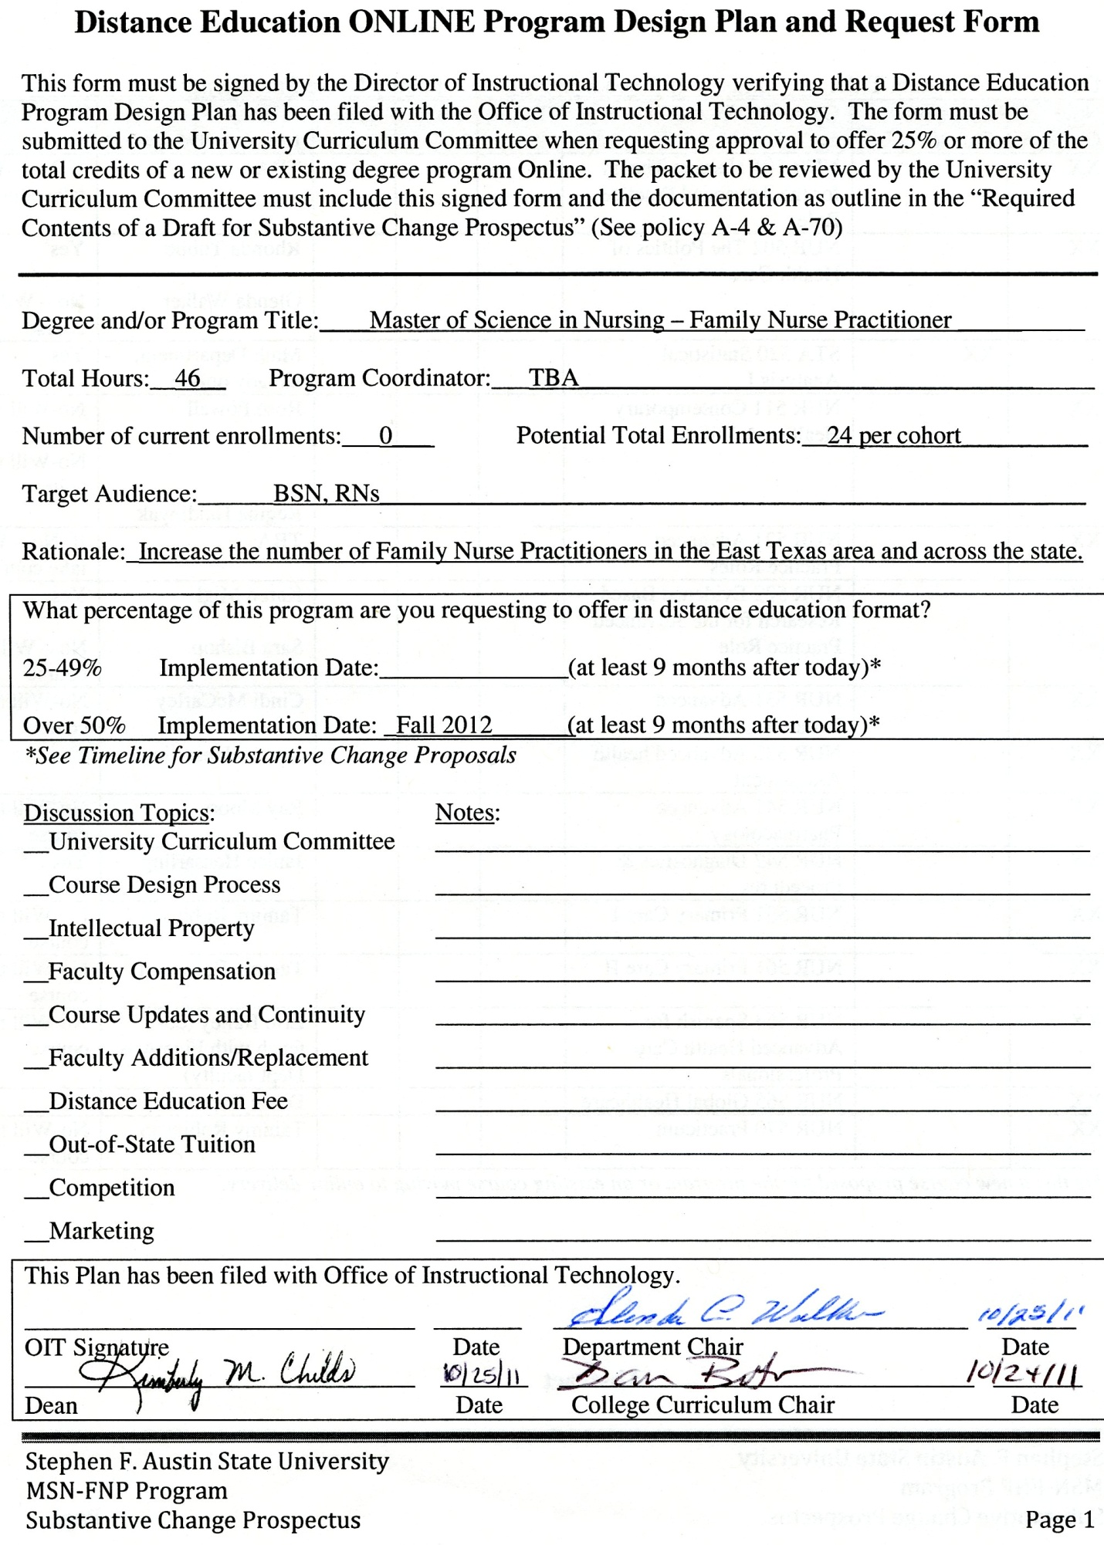 **New Program Request Form**

This form must be completed when any new program is proposed. Submit the form with the appropriate Substantive Change Prospectus to the University Curriculum Committee when seeking approval to offer a new degree program (or other new program described in policy A-4). The form must also be accompanied by documentation as outlined in the attached “Required Contents of a Draft for a Substantive Change Prospectus” (*See policy A-4 & A-70*). Please consult the Timeline for Substantive Change proposals when selecting an implementation date.

Degree and/or Program Title: ___Master of Science in Nursing – Family Nurse Practitioner____

Total Hours: 46 Program Coordinator: TBA

Implementation Date ­ Fall 2012______ Projected Enrollment 24 per cohort

Target Audience: BSN, RNs

Rationale: Increase the number of Family Nurse Practitioners in the East Texas area and across the state.

Briefly describe the new program. See abstract on page 4

Complete the course list on page 3.

Include a brief approval letter from the Dean of your college or school.

Include a cover letter explaining the program proposal.

This plan has been recommended by the department and college curriculum committee.

__________ _____________________________ __________________________

Date Dean Signature Department Chair

Degree and/Program Title:_____Master of Science in Nursing – Family Nurse Practitioner____________

|  |  |  |  |  |  |  |  |
| --- | --- | --- | --- | --- | --- | --- | --- |
| New Course* | Existing Course | Course Prefix and Title | Target | Plan | Done | Primary Instructor/Designer | COI-Certified Online Instructor |
| XX |  | NUR 501 Nursing Theory for the Advanced Practice Role |  |  |  | TBA | If No – Will take course |
| XX |  | NUR 502 The Politics of Health Care |  |  |  | Rhonda Tubbe  Glenda Walker | Yes  No – Will take course |
|  | XX | STA 520 Statistical Analysis I |  |  |  | Math Department, already online | Yes |
| XX |  | NUR 511 Contemporary Healthcare Ethics |  |  |  | Rose Powell  Regina Haidinyak | No-Will take course  No-Will take course |
| XX |  | NUR 521 Advanced Practice Roles |  |  |  | TBA | If No – Will take course |
| XX |  | NUR 522 Evidence Based Research for the Advanced Practice Role |  |  |  | Karen Migl  Sara Bishop | Yes  No – Will take course |
| XX |  | NUR 531 Advanced Pathophysiology |  |  |  | Cindi McCarley | No-Will take course |
| XX |  | NUR 532 Advanced health Assessment |  |  |  | Janice Hensarling | Yes |
| XX |  | NUR 541 Advanced Pharmacology |  |  |  | Ray Moore | No-Will take course |
| XX |  | NUR 542 Diagnostics & Procedures |  |  |  | Janice Hensarling | Yes |
| XX |  | NUR 551 Primary Care I |  |  |  | Tammy Robinson | No-Will take course |
| XX |  | NUR 561 Primary Care II |  |  |  | Tammy Robinson | No-Will take course |
| XX |  | NUR 564 Spanish for Advanced Health Care Professionals |  |  |  | Erin Bailey (co-teach with Fine Arts Dept faculty) | No-Will take course |
| XX |  | NUR 565 Global Healthcare |  |  |  | Dawn Barnes | Yes |
| XX |  | NUR 570 Practicum |  |  |  | Tammy Robinson | No-Will take course |

\**Is this a new course proposed for the program or an existing course moving to online delivery?*

**Abstract**

The DeWitt School of Nursing (SON) at Stephen F. Austin State University (SFASU), located in Nacogdoches, Texas, seeks approval to implement a Master of Science in Nursing (MSN) degree program with a focus on the Family Nurse Practitioner (FNP) role. The FNP program will have a focus on global health and cultural competencies for underserved individuals. These threads will be integrated throughout the curriculum and elective courses will be available in these areas. The SON projects enrolling 24 students beginning fall 2012. Ongoing cohorts of 24 students maximum will begin the curriculum each consecutive fall. The program will be a part time 46 semester hour curriculum, which can be completed in three years. Students will take approximately 6 hours per semester. All of the didactic portion of the course will be delivered online and students will be assigned to preceptors in approved clinical sites for the practicum courses. The primary target audience is registered nurses who have a Bachelor of Science in Nursing.

**Background Information**

The DeWitt School of Nursing (SON) at Stephen F. Austin State University (SFASU), located in Nacogdoches, Texas, seeks approval to implement a Master of Science in Nursing (MSN) degree program with a focus on the Family Nurse Practitioner (FNP) role.

**Mission and Strategic Plan**

The mission of SFASU is as follows: ‘Stephen F. Austin State University is a comprehensive institution dedicated to excellence in teaching, research, scholarship, creative work, and service. Through the personal attention of our faculty and staff, we engage our students in a learner-centered environment and offer opportunities to prepare for the challenges of living in the global community.”

**SFASU’s Strategic Plan 2013: Preparing for the Future**

The Strategic Plan 2013 has six initiatives. The initiatives and strategies that the Graduate Program addresses are:

***Initiative 1:*** Enhance excellence in teaching and learning, research, scholarship, creative

work and service.

*Strategy 5:* Increase the number of opportunities for research and creative work.

***Initiative 3:*** Increase undergraduate and graduate enrollment.

*Strategy 7:* Develop degree programs and certificate programs with potential for

substantial enrollment.

***Initiative 4:*** Develop a learner-centered environment.

*Strategy 2:* Increase enrollment in online courses by 500 percent by 2013.

The SON Graduate Program will meet the mission of preparing students for living and working in a global community. The Graduate Program will provide students with the skills and expertise to provide advanced level nursing to patients from diverse cultures. The global health component will be integrated throughout the curriculum and clinical experiences will be available for work on mission trips and exchanges with health care providers throughout the world. The focus on research based practice will address Initiative 1. The online delivery method addresses Initiative 4. Based upon the critical need for nurse practitioners to provide care in the region and state, the program has the potential to generate substantial enrollment in the future. The Texas Board of Nursing draft application has been submitted and the preliminary review is scheduled for November 10, 2011. Application to the Texas Higher Education Coordinating Board will be submitted later this year.

The DeWitt SON has a Bachelor of Science in Nursing (BSN) program which admits 120 to 160 students a year. The SON offers a totally online RN to BSN Transition program and admits approximately 25 students per year. From 1993 to 2000, the SON collaborated with the University of Texas Medical Branch (UTMB) at Galveston to offer the MSN program focusing on the FNP track at the DeWitt School of Nursing. During the duration of the collaborative program, approximately 46 students graduated from the program. Approximately 45 of those graduates have remained and continue to practice in the East Texas area. The majority of those graduates are employed in practice and as faculty in nursing programs. The program was discontinued due to budget cuts at UTMB. Currently, there is not a graduate nursing program offered at SFASU.

**Assessment of Need and Program Planning/Approval**

Stephen F. Austin State University (SFASU) is located in East Texas which is a non-border, non-metropolitan area. Counties in the East Texas area include: [Angelina](http://en.wikipedia.org/wiki/Angelina_County,_Texas), Cherokee, [Houston](http://en.wikipedia.org/wiki/Houston_County,_Texas), [Jasper](http://en.wikipedia.org/wiki/Jasper_County,_Texas), [Nacogdoches](http://en.wikipedia.org/wiki/Nacogdoches_County,_Texas), [Newton](http://en.wikipedia.org/wiki/Newton_County,_Texas), Panola, [Polk](http://en.wikipedia.org/wiki/Polk_County,_Texas), Rusk, [Sabine](http://en.wikipedia.org/wiki/Sabine_County,_Texas), [San Augustine](http://en.wikipedia.org/wiki/San_Augustine_County,_Texas), [San Jacinto](http://en.wikipedia.org/wiki/San_Jacinto_County,_Texas), [Shelby](http://en.wikipedia.org/wiki/Shelby_County,_Texas), [Trinity](http://en.wikipedia.org/wiki/Trinity_County,_Texas), and [Tyler](http://en.wikipedia.org/wiki/Tyler_County,_Texas). The following tables provide a picture of selected demographics and health care status of residents in Nacogdoches County and selected counties in East Texas. While these are selected statistics, they are applicable to the other counties in the East Texas region. East Texas has a higher percentage of older individuals, a lower per capita income, more individuals living in poverty, a higher percentage of single mothers, and a higher death rate from all causes1.

In addition, Appendix A *Table 1* illustrates that a majority of counties in East Texas has a higher population to primary care physician ratio than the state level for the designation of underserved, which is 3,500 to 1.

**National Data**

At the American Association of Retired Persons (AARP) Health Solutions Forum on June 12, 2011, Dr. Mary Wakefield, Administrator of Health Resources and Services Administration, stated that one-fifth of Americans are living in rural areas and that their health care status is poorer than urban individuals2. One-third of the individuals in rural America receive food stamps. The number of citizens receiving CHIPS, Medicaid, and Medicare or who have no insurance, and reside in rural areas, is greater than urban residents with the same scenario. Rural citizens experience higher rates of substance abuse, including methamphetamine, alcohol and tobacco use, increased rate of death due to traumatic injury, increased rates of hypertension, obesity, and dental diseases than urban residents. More individuals are being seen in tertiary care facilities due to preventable illnesses. One of the primary needs in the rural community is for health education, disease management, and promotion of healthy lifestyles, all of which are primary roles for nurse practitioners.

In 2008, 13.2 percent of the nation’s registered nurses held either a master’s or doctoral degree as their highest educational degree.4 The American Association of Colleges of Nursing (AACN, 2009) data shows that enrollment in master’s and doctoral degree nursing programs has increased3. Nursing schools with master’s programs reported a 9.6 percent increase in enrollment and a 10.5 percent increase in graduations in 2009. In 2009, AACN found 8,491 qualified applicants were turned away from master’s programs. The primary reason for not accepting all qualified applicants was a shortage of faculty4. According to Dr. Raines, “moving more nursing students into graduate programs is a top priority for the profession given the growing demand for more nurses to serve as teachers and researchers, as well as specialty and primary care providers.”3 According to the National Advisory Council on Nurse Education and Practice, to meet the more complex demands of today’s health care environment, two-thirds of the nursing workforce needs to hold a baccalaureate or higher degree by 20104. The Institute of Medicine (IOM) study, Nursing: Leading Change, Advancing Health recommends that at least ten percent of baccalaureate program graduates enter master’s or doctoral degree programs within five years of graduation5. According to a survey published in the Journal of the American Medical Association (JAMA) in September 2008, only two percent (2%) of fourth year medical students plan to work in primary care after graduation, despite a need for a 40 percent increase by 20206. When the above data is linked to the medical school data and the health reform estimate that 30 million individuals will be added to the health care system, the national need for nurse practitioners is profound.

It must also be remembered that many master’s prepared nurse practitioners fill the role of faculty in nursing programs. According to the 2009-2010 AACN survey, the average ages for master’s prepared faculty for professors, associate professors and assistant professors were 56.9, 55.7 and 50.6 years, respectively.4 It is projected that 220-280 master’s prepared nurse faculty will retire each year between 2012 and 2018.4

**Texas Nurse Practitioner Data**

In 2009, there were 5,745 active nurse practitioners (NPs) in Texas.7 The supply ratios of NPs per 100,000 population in Texas has lagged behind the national average. According to the Kaiser Foundation, the national average of APNs per 100,000 is 54. For the state of Texas, the NP ratio per 100,000 is 34. Appendix A *Table 2* illustrates the provider per 100,000 population for urban versus rural.7

Appendix A *Table 3* lists the number of providers in the East Texas counties per 100,000 and the rank of the county out of the 254 counties in the state of Texas.8 When the numbers of NPs who function as faculty in all levels of 11 nursing programs in East Texas are taken away from the above numbers of providers, then the number of NPs to provide direct patient care becomes more profound.

In 2010, the Texas Board of Nursing (BON) collected data on the admissions, enrollment, and graduation trends for advanced practice nursing programs. First year enrollment in nurse practitioner programs was 1,215. However, 1,796 individuals applied to NP programs, 1487 were qualified and 309 (17.2%) were not admitted.9 The advanced practice nursing student population is predominantly female (81.8%), age 30-49 (60.3%), and white (57.6%). While Hispanics comprise 38.2% of the Texas population, Hispanics are considerably underrepresented as advanced practice nursing students (12.4%).9

According to the BON survey, there are 22 schools offering advanced practice nursing education programs in Texas.9 There are no programs in non metropolitan non border counties. There are 18 Family Nurse Practitioner (FNP) programs in Texas. Of the 22 schools offering advanced practice programs, five schools (22.7%) offer the entire program online.9

**Region Data Related to Family Nurse Practitioners**

The University of Texas at Tyler (UTT) is located 76.2 miles from Nacogdoches and is the closest FNP program. For fall 2011, UTT admitted 25 students and had 200 applications for the 25 positions.

**Local Supply and Demand Data**

The DeWitt SON conducted the following surveys to assess supply and demand data for the program. Surveys were sent to all clinical agencies for the SON asking them to identify if they were willing to be a clinical site for an FNP student and if they had a FNP or physician who was willing to be a preceptor. The same survey was sent to the local association of advanced nurse practitioners and to all physicians practicing at the four major hospitals in the area. A significant number of nurse practitioners teach in the 11 nursing programs in Region 4 and the majority of that faculty will be retiring in the next five to ten years. Therefore, a survey was developed for the Deans and Directors to determine their projected need for nurse practitioners as faculty. (*See Appendix B for survey tools.)* Approximately 60 physicians responded they would be interested in serving as preceptors for FNP students.

A task force that involved the School of Nursing faculty and doctoral prepared nurses from the community was appointed to develop the curriculum for the FNP program. Members of the task force included Anita D. Barnes, DNP, RN, FNP-BC (faculty), Janice Hensarling, PhD, RN, FNP-BC (faculty), Carla Hairston, PhD, RN, FNP-BC (community member), Rhonda Tubbe, Ph.D., RN (community member/adjunct faculty), Glenda Walker, DSN, RN (director), Tammy Harris, MSN, RN, FNP-BC (faculty), Sara Bishop, Ph.D., RNC-OB (faculty), Gina Haidinyak, JD, MSN, RN (faculty), Cindi McCarley, DSN, RN (faculty). The task force developed the terminal objectives and the course syllabi. The task force worked closely with the curriculum committee for the School of Nursing. In addition, the School of Nursing has utilized Susan Yarborough, Ph.D., Associate Dean for Graduate Programs at The University of Texas at Tyler, as a curriculum consultant.

The reference list for ‘Assessment of Need and Program Planning/Approval’ is available in Appendix C.

**Description of the Change**

The DeWitt SON is seeking approval for a Graduate Program in Nursing, specifically the Family Nurse Practitioner (FNP) program. The FNP program will have a focus on global health and cultural competencies for underserved individuals. These threads will be integrated throughout the curriculum and elective courses will be available in these areas, as will elective courses in education. The program will be a part time 46 semester hour curriculum, which can be completed in three years. Students will take approximately 6 hours per semester. All of the didactic portion of the course will be delivered online and students will be assigned to preceptors in approved clinical sites for the practicum courses.

Appendix D *Table 4* illustrates the curriculum for cohort 1, followed by the syllabus for

each course. The program learning objectives are as follows:

1. Integrate nursing science with knowledge from ethics, the biophysical, psychosocial, analytical, and organizational sciences as the basis for the advanced level of nursing practice.
2. Implement and evaluation effective strategies for managing the ethical and legal dilemmas inherent in patient care, the healthcare organization, and research.
3. Employ effective communication and collaborative skills in interdisciplinary teams for the purpose of creating change in the global healthcare arena.
4. Synthesize concepts, including psychosocial dimensions and cultural diversity, related to clinical prevention and population health by implementing and evaluating interventions to address global health promotion/disease prevention efforts, improve health status/access patterns, and/or address gaps in care of individuals, aggregates, or populations.
5. Promote and evaluate use of health care information systems and patient care technology, including consumer health information sources.
6. Demonstrate leadership in the development and implementation of institutional, local, state, federal, and/ global health policy.
7. Critically appraise existing literature from nursing and other disciplines using advanced levels of clinical judgment, systems thinking, and accountability to determine and implement the best evidence for practice.
8. Advocate for the advanced practice role within the policy and healthcare communities.
9. Demonstrate continuing competence, growth, and development in the profession.

The Graduate Program terminal program learning objectives flow from the DeWitt SON mission and core values. Appendix E *Table 5* compares the DeWitt SON mission, core values of the SON, undergraduate terminal program objectives, and the Graduate Program terminal program learning objectives.

Dr. Glenda Walker will provide the administrative leadership for the Graduate Program. Dr. Walker has extensive leadership and teaching experience in graduate level programs. Dr. Walker has a MSN and DSN from the University of Alabama in Birmingham. Her clinical specialty area is psychiatric/mental health nursing. Dr. Walker has over thirty-three years experience in nursing education administration and Dr. Walker’s education administration includes experience in private universities, public universities, and a health science center. Dr. Walker was the Interim Director of the Graduate Mental Health Major at Vanderbilt University and, in that position, developed the first specialty track in the nation for family violence. While at Vanderbilt University, Dr. Walker taught the psychiatric content for the FNP program. Dr. Walker was the Associate Dean of Academic Affairs and the Director of Graduate Nursing Programs at the University of North Dakota (UND). At UND, she developed a graduate program in rural health nursing and served as the director for the other graduate programs: nurse anesthesia and adult health.

In 1987, Dr. Walker moved to an administration position at the University of Texas Health Science Center (UTHSC) in Houston. While at UTHSC, Dr. Walker taught graduate courses in psychiatric nursing theory, and nursing research. She was the Associate Dean of Clinical and Community Affairs and the Director of Nursing Research at the Harris County Psychiatric Hospital at Houston. Dr. Walker developed and implemented the University of Texas Nursing Service Center while serving as Associate Dean of the School of Nursing in Houston.

Dr. Walker has an extensive research and scholarship record. She received a National Institute of Nursing Research grant in 1991, which focused on sexual abuse. Dr. Walker has over thirty published articles. She has an extensive track record in grant writing and has generated over $3 million in grants and gifts. Dr. Walker has been a federal grant reviewer for the Office for the Advancement of Telemedicine. She was recognized for her service contributions to Nacogdoches when, in 2004, she was elected to the Nacogdoches Women’s Hall of Fame. Dr. Walker is an alumnus of Leadership Texas and was a past President of the Texas Association of Deans and Directors.

A coordinator for the program will be hired as faculty or a consultant. The qualified person for the position will meet the qualifications as set forth by the Texas Board of Nursing. Those qualifications include:

1. Hold a current, valid, unencumbered license or privilege to practice as a registered nurse in the State of Texas;
2. Hold a minimum of a master’s degree in nursing or the equivalent thereof as determined by the Board;
3. Be authorized to practice as an advanced practice nurse in a role and specialty appropriate to the type of program;
4. Have a minimum of three years teaching experience in a program appropriately related to the type of program being administered; and
5. Have demonstrated knowledge, skills, and abilities in administration within graduate level advanced practice nursing educational programs.

**Faculty**

Currently, the DeWitt SON at SFASU employs 30 faculty members in the BSN program. Some faculty members hold multiple degrees and certifications. Of the faculty available to teach in the FNP program, there are four who are Ph.D. prepared, two DSN prepared, one JD prepared, one DNP prepared, four Family Nurse Practitioner, two Women’s Health Nurse Practitioners, one Pediatric Nurse practitioner, two Clinical Nurse Specialists, one, Certified Registered Nurse Anesthetist, one Adult Nurse Practitioner, and one Psychiatric Nurse Practitioner. By May 2012, there will be two additional Ph.D. prepared faculty and two DNP prepared faculty members who are scheduled to graduate in December 2011. In addition to these, three other faculty members are enrolled in DNP programs and two faculty members are enrolled in Ph.D. programs. Ray Moore, PharmD, has agreed to teach the Advanced Pharmacology course.  
 The SON plans to utilize the existing expertise of the Advanced Practice Nurses (APN) and doctoral prepared faculty in the SON. The Faculty Roster Form and CVs, see Appendices F and G, respectively, demonstrate the depth and breadth of expertise in the area of Advanced Practice Nursing. The SON has a sufficient number of Ph.D. faculty to teach the theoretical and research component. In addition, the SON has 11 APNs to teach the clinical courses and provide supervision of clinical preceptors. The current faculty will teach the didactic portion and provide clinical supervision of all preceptors in the FNP program. The current faculty will be reassigned from undergraduate teaching assignments in order to implement the program. Additional undergraduate faculty will be hired and/or adjunct faculty to handle the workload of reassigned faculty. To fully implement the FNP program, three faculty who are currently employed in the SON will be reassigned at 100% FTE to the graduate program staggered over a 3 year period. One of the three FTE will assume the coordinator position. To date, the SON has not experienced difficulty in hiring faculty. The SON averages approximately six application for every position. There are sufficient funds to hire part-time and/or adjunct faculty to release the Graduate Program faculty.

**Library and Learning Resources**

SON faculty developing the Graduate Program met with the Director of the Steen Library to discuss the adequacy of the library holdings, in relation to the MSN program. After an assessment of the holdings by library representatives and SON faculty, it was determined that additional holdings would need to be added to support the MSN program. Consequently $25,708 was added to the first two-year budget to purchase additional library resources. The following paragraphs describe the current Steen Library resources for the MSN program.

Research by faculty and students is made more convenient today with the availability of full-text electronic databases accessible from the Steen Library website. The selection of the databases includes titles which contribute crossover research in sociology, leadership, chemistry, psychology, and business. Electronic resources specific to nursing and allied health fields are as follows:

[Alternative Health Watch](http://steenproxy.sfasu.edu:2048/login?url=http://search.ebscohost.com/login.aspx?authtype=ip,uid&profile=ehost&defaultdb=awh) (EBSCO) focuses on the many perspectives of complementary, holistic and integrated approaches to health care and wellness. It offers libraries full text articles for more than 180 international and often peer-reviewed journals and reports. In addition, there are hundreds of pamphlets, booklets, special reports, original research and book excerpts. **Access through TexShare.**

[CINAHL Plus with full-text](http://steenproxy.sfasu.edu:2048/login?url=http://search.ebscohost.com/login.aspx?authtype=ip,uid&profile=ehost&defaultdb=rzh) (EBSCO) is the world's most comprehensive source of full text for nursing & allied health journals, providing full-text for more than 770 journals indexed in CINAHL. **$1,142 Annual Subscription Cost.**

[Consumer Health Complete](http://steenproxy.sfasu.edu:2048/login?url=http://search.ebscohost.com/login.aspx?authtype=ip,uid&profile=c9h) (EBSCO) is a comprehensive resource for consumer-oriented health content, designed to support the information needs of patients, and to foster an overall understanding of health-related topics. **Access through TexShare.**

[Health Source: Consumer Edition](http://steenproxy.sfasu.edu:2048/login?url=http://search.ebscohost.com/login.aspx?authtype=ip,uid&profile=ehost&defaultdb=hxh) (EBSCO) the richest collection of consumer health information available to libraries worldwide, providing information on many health topics including the medical sciences, food sciences and nutrition, childcare, sports medicine and general health. **Access through TexShare.**

[Health Source: Nursing/Academic edition](http://steenproxy.sfasu.edu:2048/login?url=http://search.ebscohost.com/login.aspx?authtype=ip,uid&profile=ehost&defaultdb=hch) (EBSCO) provides full-text access to articles in scholarly journals focusing on nursing and allied health professions. **Access through TexShare.**

[Medic Latina](http://steenproxy.sfasu.edu:2048/login?url=http://search.ebscohost.com/login.aspx?authtype=ip,uid&profile=ehost&defaultdb=lth) (EBSCO) is a full-text Spanish language collection of medical research and investigative journals published by Latin American medical publishers. **Access through TexShare.**

[Medline](http://steenproxy.sfasu.edu:2048/login?url=http://search.ebscohost.com/login.aspx?authtype=ip,uid&profile=ehost&defaultdb=cmedm) (EBSCO) is a database that was created by the National Library of Medicine which covers all areas of medicine, including dentistry and nursing. There is no full-text access, but most records include substantial abstracts. **Access through TexShare.**

[Mental Measurements Yearbook with Tests in Print](http://steenproxy.sfasu.edu:2048/login?url=http://search.ebscohost.com/login.asp?profile=ehost&defaultdb=mmt) (EBSCO) provides users with a comprehensive guide to over 2,000 contemporary testing instruments. The series contains information essential for a complete evaluation of test products, within such diverse areas as psychology, education, business, and leadership. **$3,105 annual subscription cost.**

[Nursing Resource Center](http://steenproxy.sfasu.edu:2048/login?url=http://infotrac.galegroup.com/itweb/txshracd2557?db=NRC) (Gale Cengage Learning) is a comprehensive collection of reference, periodical, and multi-media content that correlates to college nursing programs. **$1,486.20, annual subscription.**

[PubMed](http://steenproxy.sfasu.edu:2048/login?url=http://www.ncbi.nlm.nih.gov/entrez/query.fcgi?otool=txufuglib) Central is a free digital archive of biomedical and life sciences journal literature at the U.S. National Institutes of Health (NIH) developed and managed by NIH's National Center for Biotechnology Information (NCBI) in the National Library of Medicine (NLM). **Free resource.**

[SciFinder](https://scifinder.cas.org) is an access point to several Chemical Abstracts databases, providing chemical literature from over 10,000 journals, 1907-present, including organic and inorganic substance information (CAS registry), patents, structure diagrams, and more. **$10,400 annual subscription/3 simultaneous users.**

[Scirus](http://www.scirus.com/) searches more than 150 million science-related Web sites, along with 11 journal databases, with full-text articles often included. **Free resources.**

[SpringerLink Journals](http://steenproxy.sfasu.edu:2048/login?url=http://journals.kluweronline.com) is the most comprehensive online collection of scientific, technological, and medical journals; some are available full-text and are clearly marked as such. **$48,023.73 annual subscription.**

[Stat!Ref](http://steenproxy.sfasu.edu:2048/login?url=http://online.statref.com/default.asp?grpalias=TEX) is a full-text collection of 35 medical and drug reference titles, including the Merck Manual, and the Stedman's Medical Dictionary**. $2,793 collaborative purchase through TexShare.**

[Taylor](http://steenproxy.sfasu.edu:2048/login?url=http://www3.interscience.wiley.com/cgi-bin/home) & Francis Journal collection provides access to an interdisciplinary collection of full-text, peer-reviewed research journals from a leading academic publisher. **$75,000 annual subscription.**

**Holdings in R and RT (Medicine and Nursing) Library of Congress Classifications**

The following table includes primarily books at Steen Library relevant to the Library of Congress classification for medicine and nursing.

|  |  |
| --- | --- |
| **LC classification books includes some E-Books** | **# titles** |
| R (medicine) | 18,465 |
| RT (Nursing) | 1,738 |

|  |  |
| --- | --- |
| **LC classification journals includes some E-Journals** | **# titles** |
| R (medicine) | 381 |
| RT (Nursing) | 60 |

**Total Library Holdings for all Library of Congress Classifications**

The following table includes totals for all the collections in the library by type.

|  |  |
| --- | --- |
| **All Library of Congress Classifications** | **# titles** |
| Books | 484,460 |
| Serials | 7,844 |
| Documents | 247,071 |
| E-Books | 25,581 |
| E-Journals | 22,639 |
| E-Documents | 42,373 |

Faculty may [Suggest a Purchase](http://libweb.sfasu.edu/proser/ris/collectiondevelopment.html) to be added to the collection and request to be contacted upon receipt of the material.

The library regularly participates in trials of electronic resources that are being considered for purchase. Faculty and students are invited to participate in the review of the trialed resources.

**Collection Development Statements for Medicine and Nursing and Medicine**

Library of Congress subjects and classification numbers included in this statement for physical books and journals follow:

R Medicine

RT 1 - 120..................................................Nursing

RT 89 - 120...............................................Specialties in nursing

RZ ………………………………………Other systems of medicine

**Student Support Services**

SFASU and the SON are committed to providing students with a positive learning environment. Key student support services include: 1) orientation to web-based courses administered by OIT; 2) Counseling and Career Services; 3) student technology help desk; and, 4) Disability Services. As noted earlier, OIT requires students enrolled in online courses to complete an orientation program which helps them learn how to navigate online courses at SFASU. In addition, OIT and IT both provide troubleshooting services for students when they encounter problems with either computers or accessing the online courses. Counseling and Career Services provides Licensed Professional Counselors (LPC’s) to help students handle personal problems. Substance abuse counseling, educational programs and referrals are available. In addition, Counseling and Career Services administers the following tests: ACT, GRE, MAT, LSAT, MCAT, ExCET, GMAT, THEA, ACCUPLACER, TOFEL, CLEP, and GED.

Disabled students are integrated into the University community. Students obtain special accommodations and services by completion of an application which may be obtained through Disability Services, in compliance with the Rehabilitation Act of 1973, as amended, and the Americans with Disabilities Act of 1990.

**Physical Resources**

Stephen F. Austin State University’s (SFASU) Richard and Lucille DeWitt School of Nursing moved from the SFASU campus to the new $13 million state-of-the-art academic facility in January, 2010. The entire nursing program is located in the new facility.

The 17-acre site for the new building was donated to SFASU in 2006 by Lucille DeWitt of Nacogdoches and her late husband, Richard DeWitt. The site formerly served as a distribution center for the Kentucky Fried Chicken restaurants owned by the couple. The year following the site donation, the Texas Legislature passed House Bill 1775 authorizing the construction of the nursing facility on the donated property. The building is 41,000 square feet, including a 9,000 square-foot simulation laboratory. There are three wings to the SON: the education wing, the simulation wing, and the administrative wing. The simulation lab is designed like a hospital and includes an emergency room with ambulance bay, an intensive care unit, a pediatric area, and a neonatal intensive care unit. The simulation laboratory features nine of the most advanced patient mannequins available for nursing education. The computerized Sim Man 3G mannequins can simulate almost any patient condition. The conditions are manipulated remotely to be filmed as students treat the ‘patients’. The video can be streamed into classrooms or recorded for later review.

There are 10 medical-surgical beds in the simulation lab with one unit being an ICU area. There is an OB-Pedi area with three beds and a nursery unit which converts to a neonatal ICU. There is a 10-bed health assessment unit, a fundamental’s skills area, and an ER with an ambulance bay. There are two fully equipped nurses’ stations and two medication Pyxis units. The Ed and Gwen Cole simulation Lab also has a massive control room where faculty operate the computers that change the parameters on the patient simulations that are being run in the simulation lab. A virtual tour of the SON is located at [www.nursing.sfasu.edu](http://www.nursing.sfasu.edu).

In 2010, the Ed & Gwen Cole Simulation Laboratory became a Laerdal Simulation Center of Excellence. There are only 23 simulation Centers of Excellence in the nation. The SFASU Center is the only Center located in a rural area. In order to achieve this designation, a simulation program must demonstrate best practices in simulation design and implementation throughout the curriculum. In addition, the simulation center must demonstrate community partnerships to improve patient care in the area.

The education wing has four classrooms which will seat 100 students. One of the classrooms is a computer testing center with 100 computers built into the desks. If students are taking tests or conducting web-based activities, the computer can be raised. After use, the computer can then be placed back in the desk for lecture activities. There is one divided classroom which can be set up to accommodate two classes of 60 and 40 students. There is a student computer café with 29 computers and a printer to which the students have access from 7 a.m. to 5 p.m., Monday through Friday. The student lounge has a kitchen with a refrigerator, three microwaves, coffeepots, and vending machines. There is an outdoor patio with picnic benches and ceiling fans. There are handicap accessible bathrooms for both men and women in the education wing.

The administrative wing has a main lobby with a reception area which is staffed by work study students. There are 34 faculty offices and offices for the senior secretary, the nursing advisor, the director’s administrative assistant, and the director. The administrative wing has a large workroom with a copy machine, fax machine, faculty mailboxes, and a supply and storage room. There is a conference room which seats twelve. The faculty lounge has a kitchen with two microwaves, a refrigerator, and seating for approximately sixteen. There is a secure file room where students records are kept.

All faculty have an individual office with new furniture and fixtures. Each office has a desk, bookcase, credenza, computer, printer, and telephone. Currently, there are five vacant offices. This will be sufficient for the one FTE secretary for the Graduate Program and for adjunct faculty who will be used to release currently faculty from undergraduate clinical to teach in the MSN program. The administrative wing has male and female handicap accessible restrooms. There will not be any new construction or remodeling projects for this program.

**Financial Support**

The University is fully committed to successful development of a Graduate Program at SFASU. Regarding economic outlook, the Financial Report ending August 31, 2010 states:

Management is not aware of any facts, decisions, or conditions that are expected to have a material effect on the financial position or results of operations during the fiscal year 2011. Enrollment trends continue to remain positive (see Appendix H).

*Table 6* presents the first year budget for the Graduate Program.

|  |
| --- |
| ***Table 6. MSN-FNP First Year Budget.*** |
| **Year 1 (2012-2013)** |
| **Personnel**  Coordinator - $100,000 base for 12 months + $28,000 fringe  Adjunct faculty:  (1 ea. Sem) $5,355 x 3 = $16,065  Secretarial support (1 FTE) for 12 months - $30,000 base + $8,400 fringe |
| Library - $12,854 for book and journal subscriptions and access to electronic databases |
| O&M - $5,000 – phone, copying, office supplies, webinars |
| Total for Year 1: $200,319 |

The three major sources of funding for the program include: 1) formula funding, 2) tuition and fees, and 3) general revenues. As *Table 7* indicates, formula funding and tuition and fees will generate $74,943. Since the cost of the program for the first year is $200,319, the remaining funds will be covered by general revenue funds from the University.

|  |  |
| --- | --- |
| ***Table 7. Projected Revenue Sources for the First Year*** | |
| Formula Funding | Year 1: $0 |
| Tuition and Fees | Year 1: $76,650 |
| General Revenue (Provided by University) | Year 1: $123,669 |

**Evaluation and Assessment**

The SON has an extensive and robust evaluation plan. SFASU purchased an evaluation tracking system called TracDat in 2009 for the purpose of tracking evaluation components for programs. TracDat is an online system which has two major categories: PLO’s and Support Unit. The PLO part of the system requires that the PLO’s (terminal objectives) for each program (BSN, RN-BSN, and MSN) be evaluated yearly. Each PLO must have two methods for assessing achievement and each method must have a criterion benchmark. Data is then entered to document achievement and, if not met, an action plan is required. The support unit section focuses on the SON’s assessment of the following goals:

1. Provide high quality teaching/learning experience for students;
2. Provide relevant 21st Century curriculum to meet healthcare needs of clients;
3. Provide high quality services and experiences for students;
4. Maintain adequate resources;
5. Provide health related public service;
6. Maintain quality relationships with SON alumni/nursing graduates
7. Faculty will advance the science of nursing by engaging in research, scholarly activities, and faculty development.

As with the PLO’s, two methods for assessing achievement and criterion benchmarks must be delineated. Data is entered to document achievement and, if not met, an action plan is required. The system also requires that supporting documentation be linked to each PLO and support unit goal. *Appendix I* provides the support unit goals and PLO evaluation forms for the SON. The Evaluation Committee is developing the assessment methods and criteria for the MSN.

TracDat is the online system that provides a universal template for all departments in the University to document program outcomes and the achievement of goals related to the organizational functioning of each department. Supporting documentation for each goal is provided in the form of aggregate tables. However, the program does not have the capacity to trend data over time and compare/contrast changes in the criterion scores. The SON is in the process of purchasing a robust evaluation system called Typhon. This program will allow the school to manage and maintain data specific to:

1. accreditation and performance standards,
2. electronic curriculum management system which allows for the mapping of competencies and outcomes,
3. extensive reporting capability, including trending data over time,
4. web-based with full mobile compatibility (allows students and preceptors convenient and reliable access to the evaluation system via stationary or mobile devices).

Currently, the graduate program at the University of Texas at Tyler is using the system to evaluate and monitor evaluation components for their MSN program and have been very pleased with its functionality.

The SON uses the NLNAC standards to organize the SON Master Schedule for Program Evaluation (see Appendix J *Table 8*). Appendix J *Table 8* presents the NLNAC standards, while Appendix J *Table 9* presents the specific evaluation plan for the SON’s Graduate Program.

Appendix A

|  |  |
| --- | --- |
| ***Table 1*. Population to Primary Care Physician Ratio** | |
| County | Ratio of Uninsured/Medicaid Population* to Medicaid-Accepting Primary Care Physician # |
| Nacogdoches | 4667:1 |
| Angelina | 4868:1 |
| Cherokee | 5548:1 |
| Sabine | 4313:1 |
| San Augustine | 4457:1 |
| Shelby | 5790:1 |
| Underserved Level | 3500:1 |
| *2005 Selected Health Facts | |

*Texas Medicaid and Healthcare Partnership* Provider (<http://www.tmhp.com/Pages/default.aspx>)

|  |  |
| --- | --- |
| ***Table 2.* Nurse Practitioner Providers per 100,000 population for Texas** | |
| Border Metropolitan | 17 |
| Non Border Metropolitan | 25.1 |
| Border Non Metropolitan | 8.3 |
| Non Border Non Metropolitan | 15.5 |

|  |  |  |  |
| --- | --- | --- | --- |
| ***Table 3.* East Texas Nurse Practitioner Provider Status** | | | |
| County | Number of Nurse Practitioner Providers | Providers per 100,000 population | Rank out of 254 counties in Texas |
| Angelina | 21 | 24.8 | 54 |
| Cherokee | 7 | 14.1 | 124 |
| Houston | 3 | 12.3 | 134 |
| Jasper | 9 | 25.1 | 53 |
| Nacogdoches | 10 | 15.7 | 110 |
| Newton | 0 | 0 | -- |
| Panola | 1 | 4.2 | 190 |
| Polk | 7 | 14.3 | 122 |
| Rusk | 8 | 16.1 | 105 |
| Sabine | 2 | 18.15 | 90 |
| San Augustine | 2 | 21 | 73 |
| San Jacinto | 1 | 3.6 | 193 |
| Shelby | 5 | 18.9 | 88 |
| Trinity | 1 | 6.6 | 178 |
| Tyler | 3 | 13.6 | 126 |

Appendix B

*Survey 1*

July 15, 2011

Dear Health Care Provider:

The Richard & Lucille DeWitt School of Nursing at Stephen F. Austin State University is seeking approval from the Texas Broad of Nursing and the Texas Higher Education Coordinating Board for a Master of Science in Nursing – Family Nurse Practitioner program. You are being contacted to assess your willingness to have your clinical facility serve as a practice site for FNP students and to assess your willingness to serve as a preceptor. The School of Nursing would greatly appreciate you completing the following short survey and returning it to the School of Nursing by August 10, 2011.

Please identify the name of your

facility_________________________________________________________________

Address of your

facility_________________________________________________________________

Contact Person (if additional information is needed)

_____________________________________________________________________

Phone number of contact person

___________________________________________________________________

Approximate number of patient seen per day and type of patient (i.e. pediatric, adult,

women’s health, geriatric)?______________________________________________

Would you be willing to have the facility serve as a clinical site for FNP students? (circle one)

Yes No

Would you be willing to serve as a preceptor or have a person in your facility serve as a preceptor? (circle one)

Yes No

How many FNP students would you be willing to have in your facility per week?_________

Please identify the name and credentials of the individual who would serve in the preceptor role?_____________________________________________________________________

Have you had experience working with FNPs? (circle one) Yes No

Please attach a brief CV/Resume of the provider willing to serve as a preceptor.

**Return to:**

DeWitt School of Nursing

SFASU

P.O. Box 6156

SFA Station

Nacogdoches, TX 75962

Thank you for taking the time to complete this survey. Should you have additional questions, please feel free to contact Dr. Glenda Walker at 936-468-7704 or [gwarler@sfasu.edu](mailto:gwarler@sfasu.edu)

Sincerely,

Glenda Walker, DSN, RN

DeWitt School of Nursing Director

Stephen F. Austin University

*Survey 2*

July 15, 2011

Dear Health Care Provider:

The Richard & Lucille DeWitt School of Nursing at Stephen F. Austin State University is seeking approval from the Texas Broad of Nursing and the Texas Higher Education Coordinating Board for a Master of Science in Nursing – Family Nurse Practitioner program. You are being contacted to assess your willingness to have your clinical facility serve as a practice site for FNP students and to assess your willingness to serve as a preceptor. The School of Nursing would greatly appreciate you completing the following short survey and returning it to the School of Nursing by August 10, 2011.

Please identify the name of your

facility_________________________________________________________________

Address of your

facility_________________________________________________________________

Contact Person (if additional information is needed)

_____________________________________________________________________

Phone number of contact person

___________________________________________________________________

In the past 5 years, have you employed a nurse practitioner(s)? (circle one)

Yes No Please identify number if more than one:______________

If yes, what type of nurse practitioner were they (i.e. Family, geriatric, adult, pediatric, etc.)

____________________________________________________________________

How satisfied are you with the carte the nurse practitioner delivered? (circle one)

Very satisfied Satisfied Not satisfied

If no, are you currently searching for an advanced practice nurse to employee? (circle one)

Yes No

How long have you been searching? (circle one)

Not Applicable 1-3 months 4-6 months 6-9 months 10-12 months >1 year

Does your practice see patients with: (circle all that apply)

Medicare Medicaid Private Insurance No insurance/self-pay

**Return to:**

DeWitt School of Nursing

SFASU

P.O. Box 6156

SFA Station

Nacogdoches, TX 75962

Thank you for taking the time to complete this survey. Should you have additional questions, please feel free to contact Dr. Glenda Walker at 936-468-7704 or [gwarler@sfasu.edu](mailto:gwarler@sfasu.edu)

Sincerely,

Glenda Walker, DSN, RN

DeWitt School of Nursing Director

Stephen F. Austin University

*Survey 3*

July 15, 2011

Dear Dean/Director:

The Richard & Lucille DeWitt School of Nursing at Stephen F. Austin State University is seeking approval from the Texas Broad of Nursing and the Texas Higher Education Coordinating Board for a Master of Science in Nursing – Family Nurse Practitioner program. You are being contacted to assess your willingness to have your clinical facility serve as a practice site for FNP students and to assess your willingness to serve as a preceptor. The School of Nursing would greatly appreciate you completing the following short survey and returning it to the School of Nursing by August 10, 2011.

Please identify the name of your institution

_____________________________________________________________________

Address of your institution

_____________________________________________________________________

Contact Person (if additional information is needed)

_____________________________________________________________________

Phone number of contact person

_____________________________________________________________________

Number of faculty you currently employee in your school of nursing_______________

How many faculty you employee are nurse practitioners________________________

Are you satisfied with the level of teaching performed by nurse practitioners? (circle one)

Yes No

Do you have current faculty positions available? (circle one)

Yes No

If yes, how many positions?_________________________________________________

Would you hire an MSN who is a nursing practitioner? (circle one) Yes No

**Return to:**

DeWitt School of Nursing

SFASU

P.O. Box 6156

SFA Station

Nacogdoches, TX 75962

Thank you for taking the time to complete this survey. Should you have additional questions, please feel free to contact Dr. Glenda Walker at 936-468-7704 or [gwarler@sfasu.edu](mailto:gwarler@sfasu.edu)

Sincerely,

Glenda Walker, DSN, RN

DeWitt School of Nursing Director

Stephen F. Austin University

Appendix C

**References**

1. The Texas Department of State Health Services Center for Health Statistics. (2010). Selected Health Facts 2008. Retrieved on July 15, 2011, from http:www.dshs.state.tx.us/chs/.
2. Mary Wakefield. (June 12, 2011). American Association of Retired Persons Health

Solutions Forum.

1. American Association of Colleges of Nursing. (2009). Student Enrollment Expands at U.S. Nursing Colleges and Universities for the 9th Year Despite Financial Challenges and Capacity Restraints. Retrieved on December 22, 2010, from http://www.aacn.nche.edu/Media/NewsReleases/2009/StudentEnrollment.html.
2. American Association of Colleges of Nursing. (2010). Nursing Faculty Shortage. Retrieved on December 22, 2010, from http://www.aacn.nche.edu/Media/FactSheets/FacultyShortage.htm.
3. Institute of Medicine. (2011). Nursing: Leading Change, Advancing Health.
4. American Association of Colleges of Nursing. (2010). Talking Points. Retrieved on December 22, 2010, from http://www.aacn.nche.edu./Media/pdf/Economy.pdf
5. Kaiser Foundation (2010). Texas: Non-Physician Providers. Retrieved on August 9, 2011, from http://www.statehealthfacts.org.
6. Texas Center for Nursing Workforce Studies. (2010). Nursing Workforce In Texas – 2009; Demographics and Trends.
7. Texas Center for Nursing Workforce Studies. (2011). Advance Practice Nursing Education Program Characteristics. Retrieved on July 15, 2011, from www.dshs.state.tx.us/chs/cnws/

Appendix D

|  |  |  |  |  |  |
| --- | --- | --- | --- | --- | --- |
| ***Table 4:* *Curriculum (consists of 696 clinical hours); Electives (consists of 3 hours)*** | | | | | |
| **Year** | **Semester** | **Schedule** | **Course Name** | **No. of Hours** | **Course Number** |
| **2012-2013** |  |  |  |  |  |
| 1 | I | Fall 2012 | Nursing Theory for the Advanced Practice Role | 3 | NUR 501 |
| 1 | I | Fall 2012 | The Politics of Health Care | 3 | NUR 502 |
| 1 | II | Spr 2013 | Statistical Analysis I | 3 |  |
| 1 | II | Spr 2013 | Contemporary Health Care Ethics | 3 | NUR 511 |
| 1 | III | Sum 2013 | Advanced Practice Roles | 2 | NUR 521 |
| 1 | III | Sum 2013 | Evidence Based Research for the Advanced Practice Role | 3 | NUR 522 |
| **2013-2014** |  |  |  |  |  |
| 2 | IV | Fall 2013 | Advanced  Pathophysiology | 3 | NUR 531 |
| 2 | IV | Fall 2013 | Advanced Health Assessment | 3 (84 Hours) | NUR 532 |
| 2 | V | Spr 2014 | Advanced Pharmacology | 3 | NUR 541 |
| 2 | V | Spr 2014 | Diagnostics and Procedures | 3 (98 Hours) | NUR 542 |
| 2 | VI | Sum 2014 | Primary Care I | 4 (168 Hours) | NUR 551 |
| **2014-2015** |  |  |  |  |  |
| 3 | VII | Fall 2014 | Primary Care II | 4 (168 Hours) | NUR 561 |
| 3 | VII | Fall 2014 (Electives) | Spanish for Advanced Health Care Professionals | 3 | NUR 564 |
| 3 | VII | Fall 2014 (Electives) | Global Health Care | 3 | NUR 565 |
| 3 | VIII | Spr 2015 | Practicum | 6 (336 Hours) | NUR 570 |
|  |  | **Total Hours** |  | **46 Hours** |  |

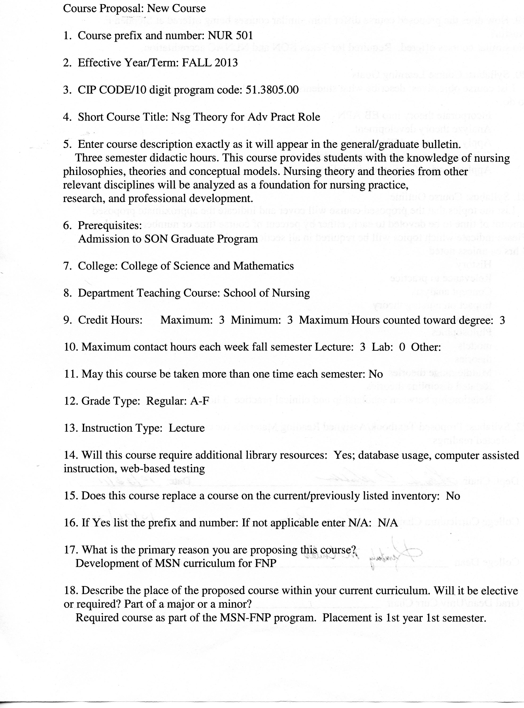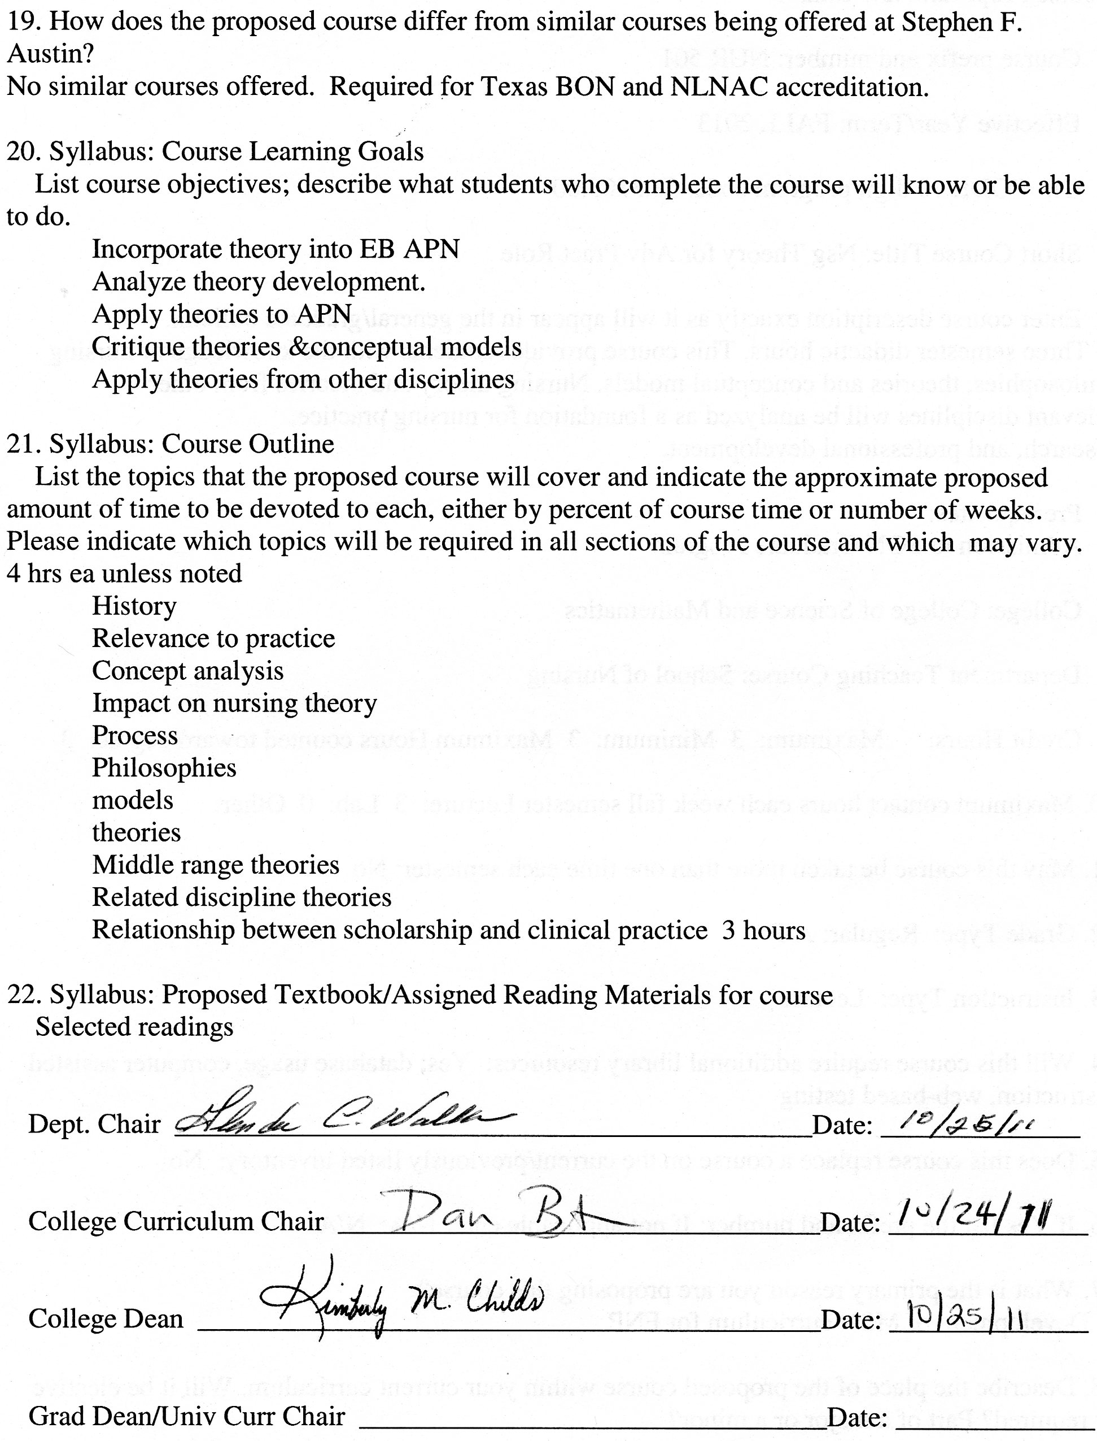

**Stephen F. Austin State University**

**DeWitt School of Nursing**

**Nursing Theory for the Advanced Practice Role**

**Course Number: NUR 501**

**All INFORMATION IN THIS SYLLABUS IS SUBJECT TO THER WRITTEN POLICIES AND PROCEDURES OF THE SCHOOL OF NURSING, STEPHEN F. AUSTIN STATE UNIVERISTY, NACODOCHES, TEXAS.**

**IN THE CASE OF COMMISSION, OMISSION, AMBIGUITY, VAGUENESS, OR CONFLICT, THE POLICIES AND PROCEDURES OF THE SCHOOL OF NURSING SHALL CONTROL.**

**EACH STUDENT SHALL BE RESPONSIBLE FOR ACTUAL AND/OR CONSTRUCTIVE KNOWEDGE OF THE POLICIES AND PROCEDURES OF THE SCHOOL OF NURSING AND FOR COMPLIANCE THEREWITH.**

**THE STUDENT IS RESPONSIBE FOR ALL INFORMATION IN THIS SYLLABLUS.**

**This syllabus is provided for information purposes only.**

**Faculty Information**

**Name:**

**Department: Nursing**

**Email:**

**Phone:**

**Office:**

**Office Hours:**

**Class Meeting Time and Place:** This course is taught in an online format.

|  |  |  |
| --- | --- | --- |
| **Week** | **Date** | **Topic** |
| 1 |  | History and overview of the structure of contemporary nursing knowledge |
| 2 |  | Relevance of contemporary nursing knowledge to clinical practice and nursing education |
| 3 |  | Concept analysis |
| 4 |  | Impact of concepts and propositions on nursing theory |
| 5 |  | Process of theory development |
| 6 |  | Philosophies of nursing |
| 7 |  | Nursing models |
| 8 |  | Nursing models continued |
| 9 |  | Nursing theories |
| 10 |  | Nursing theories continued |
| 11 |  | Middle range theories |
| 12 |  | Middle range theories continued |
| 13 |  | Related discipline theories |
| 14 |  | Relationship between scholarship and clinical practice |
| 15 |  | Case study analysis of client problem using middle range theories |
| 16 |  | Review and summary of course |

**Nursing Theory for the Advanced Practice Role**

**Course description:**

This course provides students with the knowledge of nursing philosophies, theories and conceptual models. Nursing theory and theories from other relevant disciplines will be analyzed as a foundation for nursing practice, research, and professional development.

**Prerequisites:** Admission to SON Graduate Program

**Credit hours:** 3 hours

**Course objectives:**

Upon completion of this course, the student will be able to:

1. Synthesize responsibility and accountability using consistent behavior patterns and professional communication.
2. Describe the history of contemporary nursing knowledge.
3. Examine the relationship of concepts, philosophies, conceptual models, theories, and empirical indicators to contemporary nursing knowledge.
4. Incorporate the components of theory into evidence based advanced nursing practice and research.
5. Analyze theory development.
6. Apply theories to advanced practice nursing.
7. Critique selected theories and conceptual models for nursing.
8. Apply theories from other disciplines to advanced clinical practice.

**Topics:**

1. History and overview of the structure of contemporary nursing knowledge
2. Relevance of contemporary nursing knowledge to clinical practice and nursing education
3. Concept analysis
4. Impact of concepts and propositions on nursing theory
5. Process of theory development
6. Philosophies of nursing
7. Nursing models
8. Nursing theories
9. Middle range theories
10. Related discipline theories
11. Relationship between scholarship and clinical practice

**Instructional Methods**

Discussion board, PowerPoint presentations

**Teaching Strategies**

Online discussion, reading assignments, online lecture modules

**Required Textbooks**

Selected readings

**Grades and Grading**

Concept analysis paper 30%

Middle Range theory paper 30%

Weekly Discussion board assignment 20%

Weekly online quizzes 20%

**Total 100%**

**Grading Scale**

A 90-100

B 80-89

C 70-79

D 60-69

F <60

See current Stephen F. Austin State University Graduate Bulletin for probation, suspension, and readmission details.

**Concept Analysis Paper**

The concept analysis paper is designed to assist students in the application of knowledge about the basic components of theory. Each student will select a concept relative to their nursing practice or area of interest. The student should consult with the nursing faculty prior to making the final discussion regarding the concept that will be investigated. The concept analysis paper should include the following sections:

1. Select a concept and explain why the concept is relative to nursing practice.
2. Determine the aims or purposes of analysis.
3. Identify all uses of the concept that you can discover.
4. Determine the defining attributes.
5. Identify a model case.
6. Identify borderline, related, contrary, invented, and illegitimate cases.
7. Identify antecedents and consequences.
8. Define empirical referents.

**Middle Range Theory Paper**

The theory paper will demonstrate the student’s ability to apply a middle range theory to the practice of nursing. The student will select a middle range theory pertinent to their area of practice and apply the theory to an interesting case from their own experience as a nurse.

The student will:

* Select a case from their area of practice.
* Find a mid-range theory that demonstrates the metaparadigm elements demonstrated in the case. If the theory does not identify metaparadigm elements the student should discuss the major concepts of the theory.
* Discuss the theory and the case with the faculty prior to writing the paper.

Paper guidelines:

* The emphasis of the paper will be on an in-depth review of the literature related to the theory.
* Paper organization.
  + Introduction
  + Overview of the theory
  + A model case
  + Relation of the case to metaparadigm elements
  + Use of the theory to nursing practice
  + Use of the theory in research

**Weekly discussion Board**

Students are expected to participate in the online discussion board weekly. Criteria for the assignment and instructions are found below.

**Weekly Online Quizzes**

A 10 question quiz will be taken at the end of each module.

**Stephen F. Austin State University**

**MSN-FNP Online Discussion Requirements and Grading Rubric**

*Background and Rational for Weekly Discussion Requirements and Grading*

For this online nursing course, you are completing 16 weeks of class room time (3 hours per week), course work and assignments online. It is important for online learners to understand that guidelines for online learning are given by the U.S. Department of Education and professional accrediting bodies through which Stephen F. Austin State University and the DeWitt School of Nursing are accredited. The following has been prepared to clarify weekly discussion requirements and grading for students participating in online nursing courses.

The purpose of the Weekly Discussions is to develop a scholarly and dynamic exchange between you, faculty, and other students in the course promoting an active and engaging online learning community. Your success and the success of your classmates in a positive learning environment is dependent on discussion participation and timely completion of assignments.

*Weekly Discussion Requirements*

* Students are expected to participate in weekly discussions on at **least three separate days out of seven** in the electronic week.
* The three weekly posts consist of ***one Main post and a minimum of two responses to peers. All will be posted on separate days.***
* The electronic week begins on Monday at 12:01 am CST and ends on Sunday at 12 midnight CST.
* There are no “make-ups” for not posting to the Weekly Discussions. If you need to be away or do not have computer access, you need to make alternative arrangements for participation and actively engaging in the course to meet weekly discussion requirements.
* Students must post a Main post to the Discussion board each week on or before Wednesday at 12 midnight CST.
* One point per day will be deducted for not having the Main post completed on or before Wednesday each week ensuring that all students have the opportunity for active learning and engagement with peers and course faculty.
* Students must read and respond to ***a minimum of two peer posts*** each week.
* Students ***must provide references in current APA format for all posts.***
* It is recommended that you prepare your weekly discussion posts in Microsoft Word and then cut and paste into the Blackboard discussion. This is because Blackboard ‘times out’.
* All discussions posted must reflect proficient writing standards.
* Posts must be in the correct Weekly Discussion board or no points will be awarded.

*Discussion Rubric*

|  |  |  |  |  |  |
| --- | --- | --- | --- | --- | --- |
| Category | Exceeds  3 | Average  2 | Below  1 | Unacceptable  0 | POINTS |
| Main Post Discussion | Displays an outstanding integration of required reading and other scholarly works supporting the points and topics of discussion. | Displays some integration of required reading and other scholarly works supporting the points and topics of discussion. | Displays poor integration of required reading and other scholarly works supporting the points and topics of discussion. | No post. |  |
| Peer Response Discussion | Displays outstanding knowledge of concepts and issues presented in the courses as well as in their peers’ postings. | Displays some knowledge of concepts and issues presented in the course as well as in their peers’ postings. | Displays poor knowledge of concepts and issues presented in the course as well as their peers’ postings. | No post. |  |
| Scholarly Writing | Posts have no grammar, spelling, or current APA edition format mistakes. | Posts have few grammar, spelling, and/or current APA edition format mistakes. | Posts have multiple grammar, spelling, and/or current APA edition format mistakes. | No post. |  |

**Grading Rubric for: Concept Analysis Paper and Middle Range Theory Paper**

|  |  |  |  |  |  |  |
| --- | --- | --- | --- | --- | --- | --- |
|  | 25 | 20 | 15 | 10 | 0 | POINTS |
| Quality of Content  (25 points) | Rich in content, full of thought, insight and synthesis with clear connections to previous or current content and/or to real life situations made with depth and detail. | Substantial information, thought, insight and analysis has taken place with some connection to previous or current content and/or to real life situations but lack of depth and detail. | Generally competent in summarizing learning, but information is thin and commonplace with limited connections and vague generalities. | Rudimentary and superficial regurgitation of content with no connections and/or completely off topic. | Not submitted or instructions not followed. |  |
| Relevance  (25 points) | The key issues within the prompt are indentified and answered. The discussion is consistently clear with few digressions. | The key issues within the prompt are identified but not all answered. The discussion is clear most of the time. | Some of the key issues within the prompt are identified but not answered. The discussion is not clear. | Confused, hard to follow and the key issues within the prompt are not identified or answered. | Not submitted or instructions not followed. |  |
| Reading and Resources  (25 points) | Readings and other resource materials are used to support comments. All references are documented according to current APA format. No APA format errors. | There is some reference to readings and other resource material. Most references are documented according to current APA format. Minimal APA format errors. | Little if any reference is made to readings. Major errors in references documented according to current APA format. Major APA format errors. | Readings and resources are not mentioned. No APA references. | Not submitted or instructions not followed. |  |
| Professionalism  (25 points) | Written in a professional manner, free of typos, spelling and mechanical errors. | Most writing in a professional manner, free of typos, spelling and mechanical errors. | Some writing written in a professional manner, free of typos, spelling and mechanical errors. | Most writing NOT written in a professional manner, free of typos, spelling and mechanical errors. | Not submitted or instructions not followed. |  |

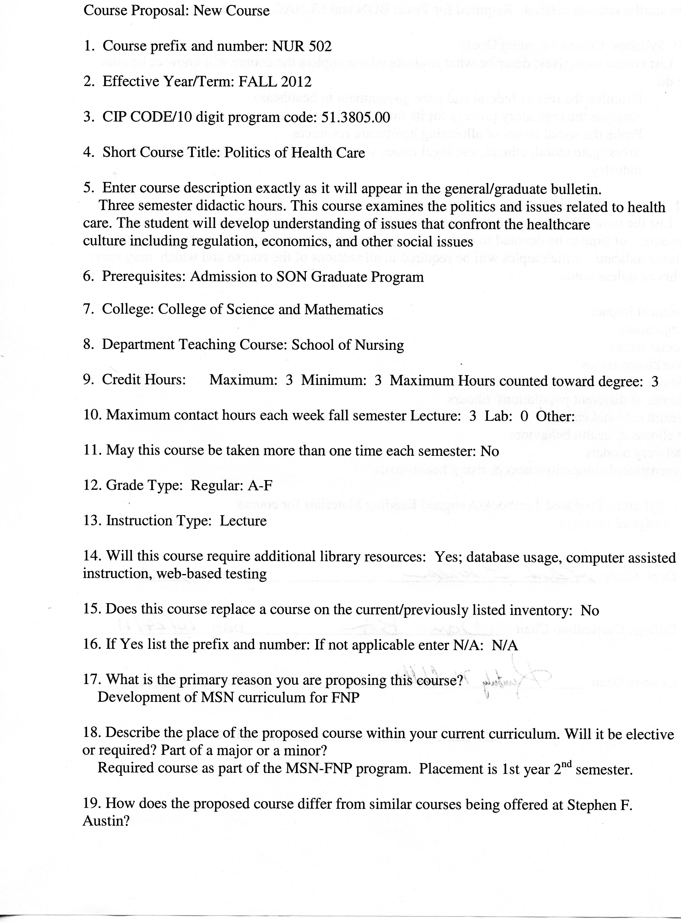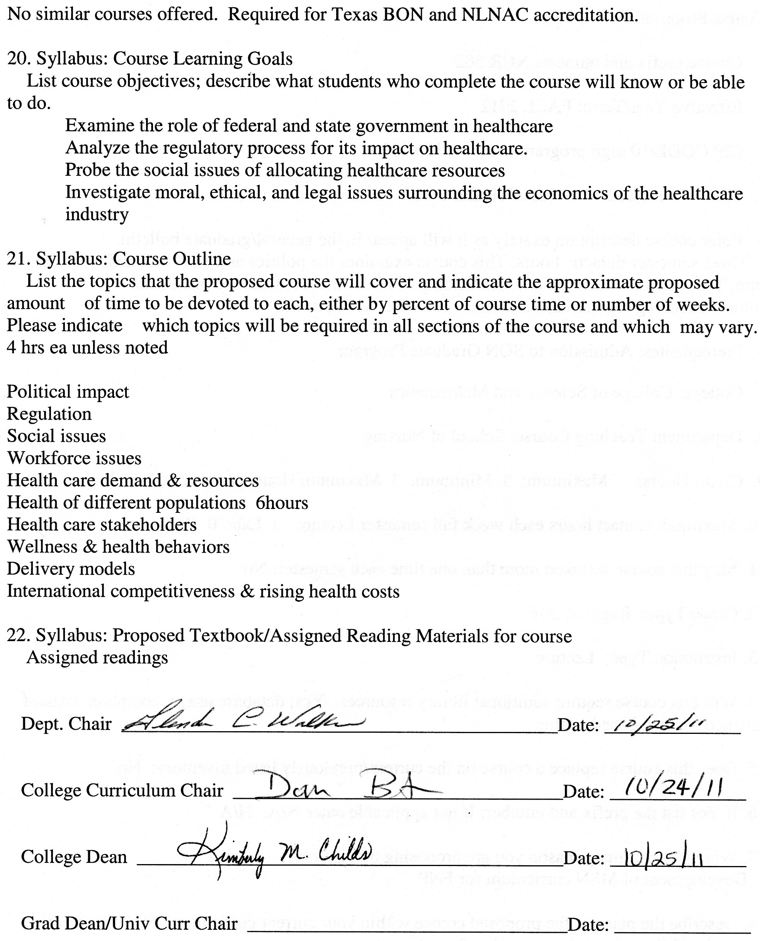

**Stephen F. Austin State University**

**DeWitt School of Nursing**

**The Politics of Healthcare**

**Course Number: NUR 502**

**ALL INFORMATION IN THIS SYLLABUS IS SUBJECT TO THE WRITTEN POLICIES AND PROCEDURES OF THE SCHOOL OF NURSING, STEPHEN F. AUSTIN STATE UNIVERSITY, NACOGDOCHES, TEXAS**

**IN THE CASE OF COMMISSION, OMISSION, AMBIGUITY, VAGUENESS, OR CONFLICT, THE POLICIES AND PROCEDURES OF THE SCHOOL OF NURSING SHALL CONTROL.**

**EACH STUDENT SHALL BE RESPONSIBLE FOR ACTUAL AND/OR CONSTRUCTIVE KNOWLEDGE OF THE POLICIES AND PROCEDURES OF THE SCHOOL OF NURSING AND FOR COMPLIANCE THEREWITH.**

**THE STUDENT IS RESPONSIBLE FOR ALL INFORMATION IN THIS SYLLABUS.**

***This syllabus is provided for information purposes only.***

**Faculty Information**

**Name:**

**Department:**

**Email:**

**Phone:**

**Office:**

**Office Hours:**

**Class Meeting Time and Place:** This course is taught in an online format.

|  |  |  |
| --- | --- | --- |
| Week | Date | Topic |
| 1 |  | Introductions  Review of Syllabus |
| 2 |  | Political impact on health care |
| 3 |  | Regulation awareness and influences |
| 4 |  | Social issues related to demographic trends, delivery of healthcare, and cultural awareness |
| 5 |  | Social issues related to demographic trends, delivery of healthcare, and cultural awareness |
| 6 |  | Workforce issues |
| 7 |  | Healthcare demand and resources |
| 8 |  | Health and healthcare of different populations |
| 9 |  | Health and healthcare of different populations |
| 10 |  | Healthcare stakeholders; the patient, payors, and providers |
| 11 |  | Wellness and health behaviors |
| 12 |  | Continuation of wellness and health behaviors |
| 13 |  | Healthcare delivery models |
| 14 |  | International competitiveness and rising health costs |
| 15 |  | Analysis of current proposed nursing regulations as requested by legislative staff for local political representative |
| 16 |  | Review and summary of course |

The Politics of Healthcare

**Course Description**

This course examines the politics and issues related to healthcare. The student will develop understanding of issues that confront the healthcare culture including regulation, economics, and other social issues.

**Prerequisites** Admission to SON Graduate Program

**Credit Hour Distribution**

3 credit hours

**Course Objectives**

Upon completion of this course, the student is expected to:

1. Examine the role of federal and state government in healthcare
2. Analyze the regulatory process for its impact on healthcare.
3. Probe the social issues of allocating healthcare resources.
4. Investigate moral, ethical, and legal issues surrounding the economics of the healthcare industry.
5. Assemble concepts and principles of the arts, sciences, humanities, and nursing in order to make advanced practice nursing decisions concerning issues related to policy, economics, and resource allocation.
6. Synthesize responsibility and accountability using consistent behavior patterns and professional communication.
7. Evaluate the role of evidence based practice in healthcare policy.

**Topics**

1. Political impact on healthcare

2. Regulation awareness and influences

3. Social issues related to demographic trends, delivery of healthcare, and cultural awareness

4. Workforce issues

5. Healthcare demand and resources

6. Health and healthcare of different populations

7. Healthcare stakeholders; the patient, payors, and providers

8. Wellness and health behaviors

9. Healthcare delivery models

10. International competitiveness and rising health costs

**Instructional Methods**

Discussion board, PowerPoint presentations, case studies

**Teaching Strategies**

Online discussion, reading assignments, case studies, online lecture modules, tests

**Required Textbooks**

Selected readings

**Grades and Grading (see grading rubrics)**

*PowerPoint Presentation on Healthcare Delivery Models*- 30%.

*Wellness and Healthcare Behaviors Paper* – 30%.

*Discussion Average*– 20 %

*Case Study Average*– 20%

**Grading Scale**

A 90-100

B 80-89

C 70-79

D 60-69

F <60

See current Stephen F. Austin State University Graduate Bulletin for probation, suspension, and readmission details.

**PowerPoint Presentation on Healthcare Delivery Models**

20-slide PowerPoint Presentation which includes:

* Introduction
* Desired outcomes
* Pros/Cons of the plan
* Financial Implications
* Short-term/Long-term ramifications
* Unintentional outcomes
* Impact on providers/patient
* Access/payor sources
* Summary
* References

Topics may include: local, state, US or international healthcare plans

All slides MUST include notes, expect references.

Minimum of 6 peer-reviewed articles as references.

See grading rubric.

**Wellness and Healthcare Behavior Paper**

Each student will submit a 15-20 page paper on a healthcare behavior and its affect on wellness. The objective of this assignment is to understand the impact of wellness on politics of healthcare related to economics, end of life issues, access to healthcare, impairments, etc.

The components of the essay will include the following elements in current APA format:

* 1. Definition of the healthcare behavior and its relationship to wellness
  2. Relationship of topic to politics
  3. 15-20 pages not including references
  4. Minimum of six(6) peer reviewed resources

**Case Studies**

There will be a minimum of three case studies. See grading rubric.

*PowerPoint Presentation on Healthcare Delivery Models Grading Rubric*

|  |  |  |  |  |  |  |
| --- | --- | --- | --- | --- | --- | --- |
|  | 25 | 20 | 15 | 10 | 0 | POINTS |
| Quality of Content  (25 points) | Rich in content, full of thought, insight and synthesis with clear connections to previous or current content and/or to real life situations made with depth and detail. | Substantial information, thought, insight and analysis has taken place with some connection to previous or current content and/or to real life situations but lack of depth and detail. | Generally competent in summarizing learning, but information is thin and commonplace with limited connections and vague generalities. | Rudimentary and superficial regurgitation of content with no connections and/or completely off topic. | Not submitted or instructions not followed. |  |
| Relevance  (25 points) | The key issues within the prompt are indentified and answered. The discussion is consistently clear with few digressions. | The key issues within the prompt are identified but not all answered. The discussion is clear most of the time. | Some of the key issues within the prompt are identified but not answered. The discussion is not clear. | Confused, hard to follow and the key issues within the prompt are not identified or answered. | Not submitted or instructions not followed. |  |
| Reading and Resources  (25 points) | Readings and other resource materials are used to support comments. All references are documented according to current APA format. No APA format errors. | There is some reference to readings and other resource material. Most references are documented according to current APA format. Minimal APA format errors. | Little if any reference is made to readings. Major errors in references documented according to current APA format. Major APA format errors. | Readings and resources are not cited. No APA references. | Not submitted or instructions not followed. |  |
| Professionalism  (25 points) | Written in a professional manner, free of typos, spelling and mechanical errors. | Most writing in a professional manner, free of typos, spelling and mechanical errors. | Some writing written in a professional manner, free of typos, spelling and mechanical errors. | Most writing NOT written in a professional manner, free of typos, spelling and mechanical errors. | Not submitted or instructions not followed. |  |

*Wellness and Healthcare Behaviors Paper* *Grading Rubric*

|  |  |  |  |  |  |  |
| --- | --- | --- | --- | --- | --- | --- |
|  | 25 | 20 | 15 | 10 | 0 | POINTS |
| Quality of Content  (25 points) | Rich in content, full of thought, insight and synthesis with clear connections to previous or current content and/or to real life situations made with depth and detail. | Substantial information, thought, insight and analysis has taken place with some connection to previous or current content and/or to real life situations but lack of depth and detail. | Generally competent in summarizing learning, but information is thin and commonplace with limited connections and vague generalities. | Rudimentary and superficial regurgitation of content with no connections and/or completely off topic. | Not submitted or instructions not followed. |  |
| Relevance  (25 points) | The key issues within the prompt are indentified and answered. The discussion is consistently clear with few digressions. | The key issues within the prompt are identified but not all answered. The discussion is clear most of the time. | Some of the key issues within the prompt are identified but not answered. The discussion is not clear. | Confused, hard to follow and the key issues within the prompt are not identified or answered. | Not submitted or instructions not followed. |  |
| Reading and Resources  (25 points) | Readings and other resource materials are used to support comments. All references are documented according to current APA format. No APA format errors. | There is some reference to readings and other resource material. Most references are documented according to current APA format. Minimal APA format errors. | Little if any reference is made to readings. Major errors in references documented according to current APA format. Major APA format errors. | Readings and resources are not cited. No APA references. | Not submitted or instructions not followed. |  |
| Professionalism  (25 points) | Written in a professional manner, free of typos, spelling and mechanical errors. | Most writing in a professional manner, free of typos, spelling and mechanical errors. | Some writing written in a professional manner, free of typos, spelling and mechanical errors. | Most writing NOT written in a professional manner, free of typos, spelling and mechanical errors. | Not submitted or instructions not followed. |  |

**Stephen F. Austin State University**

**MSN-FNP Online Discussion Requirements and Grading Rubric**

*Background and Rational for Weekly Discussion Requirements and Grading*

For this online nursing course, you are completing 16 weeks of class room time (3 hours per week), course work and assignments online. It is important for online learners to understand that guidelines for online learning are given by the U.S. Department of Education and professional accrediting bodies through which Stephen F. Austin State University and the DeWitt School of Nursing are accredited. The following has been prepared to clarify weekly discussion requirements and grading for students participating in online nursing courses.

The purpose of the Weekly Discussions is to develop a scholarly and dynamic exchange between you, faculty, and other students in the course promoting an active and engaging online learning community. Your success and the success of your classmates in a positive learning environment is dependent on discussion participation and timely completion of assignments.

*Weekly Discussion Requirements*

* Students are expected to participate in weekly discussions on at **least three separate days out of seven** in the electronic week.
* The three weekly posts consist of ***one Main post and a minimum of two responses to peers. All will be posted on separate days.***
* The electronic week begins on Monday at 12:01 am CST and ends on Sunday at 12 midnight CST.
* There are no “make-ups” for not posting to the Weekly Discussions. If you need to be away or do not have computer access, you need to make alternative arrangements for participation and actively engaging in the course to meet weekly discussion requirements.
* Students must post a Main post to the Discussion board each week on or before Wednesday at 12 midnight CST.
* One point per day will be deducted for not having the Main post completed on or before Wednesday each week ensuring that all students have the opportunity for active learning and engagement with peers and course faculty.
* Students must read and respond to ***a minimum of two peer posts*** each week.
* Students ***must provide references in current APA format for all posts.***
* It is recommended that you prepare your weekly discussion posts in Microsoft Word and then cut and paste into the Blackboard discussion. This is because Blackboard ‘times out’.
* All discussions posted must reflect proficient writing standards.
* Posts must be in the correct Weekly Discussion board or no points will be awarded.

*Discussion Rubric*

|  |  |  |  |  |  |
| --- | --- | --- | --- | --- | --- |
| Category | Exceeds  3 | Average  2 | Below  1 | Unacceptable  0 | POINTS |
| Main Post Discussion | Displays an outstanding integration of required reading and other scholarly works supporting the points and topics of discussion. | Displays some integration of required reading and other scholarly works supporting the points and topics of discussion. | Displays poor integration of required reading and other scholarly works supporting the points and topics of discussion. | No post. |  |
| Peer Response Discussion | Displays outstanding knowledge of concepts and issues presented in the courses as well as in their peers’ postings. | Displays some knowledge of concepts and issues presented in the course as well as in their peers’ postings. | Displays poor knowledge of concepts and issues presented in the course as well as their peers’ postings. | No post. |  |
| Scholarly Writing | Posts have no grammar, spelling, or current APA edition format mistakes. | Posts have few grammar, spelling, and/or current APA edition format mistakes. | Posts have multiple grammar, spelling, and/or current APA edition format mistakes. | No post. |  |

*Case Study Grading Rubric*

|  |  |  |  |  |  |  |
| --- | --- | --- | --- | --- | --- | --- |
|  | 25 | 20 | 15 | 10 | 0 | POINTS |
| Quality of Content  (25 points) | Rich in content, full of thought, insight and synthesis with clear connections to previous or current content and/or to real life situations made with depth and detail. | Substantial information, thought, insight and analysis has taken place with some connection to previous or current content and/or to real life situations but lack of depth and detail. | Generally competent in summarizing learning, but information is thin and commonplace with limited connections and vague generalities. | Rudimentary and superficial regurgitation of content with no connections and/or completely off topic. | Not submitted or instructions not followed. |  |
| Relevance  (25 points) | The key issues within the prompt are indentified and answered. The discussion is consistently clear with few digressions. | The key issues within the prompt are identified but not all answered. The discussion is clear most of the time. | Some of the key issues within the prompt are identified but not answered. The discussion is not clear. | Confused, hard to follow and the key issues within the prompt are not identified or answered. | Not submitted or instructions not followed. |  |
| Reading and Resources  (25 points) | Readings and other resource materials are used to support comments. All references are documented according to current APA format. No APA format errors. | There is some reference to readings and other resource material. Most references are documented according to current APA format. Minimal APA format errors. | Little if any reference is made to readings. Major errors in references documented according to current APA format. Major APA format errors. | Readings and resources are not cited. No APA references. | Not submitted or instructions not followed. |  |
| Professionalism  (25 points) | Written in a professional manner, free of typos, spelling and mechanical errors. | Most writing in a professional manner, free of typos, spelling and mechanical errors. | Some writing written in a professional manner, free of typos, spelling and mechanical errors. | Most writing NOT written in a professional manner, free of typos, spelling and mechanical errors. | Not submitted or instructions not followed. |  |

**S T E P H E N F. A U S T I N S T A T E U N I V E R S I T Y** __________________________________________________________

**Department of Mathematics and Statistics** www.sfasu.edu

**STA 520 – Statistical Analysis I**

**Course Syllabus**

**Course description:** Probability, statistical inference, rank tests, chi-square tests, linear regression and correlation, analysis of variance, multiple regression.

**Credit hours:** 3

**Course Prerequisites and Corequisites:** MTH 220 or equivalent

**Course outline:** Approximate time spent

**Descriptive Statistics** 5%

o Graphical Methods

o Measures of Central Tendency

o Measures of Variability

**Probability** 15%

o Probability Laws

o Conditional Probability and Independence

o Probability Distributions for Random Variables:

▪ Discrete

▪ Continuous

o Random Sampling

o Sampling Distributions

**Statistical Inference (Estimation and Hypothesis Tests)** 15%

o Inferences about a single population parameter

o Inference comparing parameters of two populations

**Statistical Inference Comparing Parameters forMore Than Two Populations** 25%

o Analysis of Variance (ANOVA)

o Kruskal-Wallis Test

**Multiple Comparisons** 10%

o Fisher's Least Significant Difference Test

o Tukey's Test

o Student-Newman-Keuls Test

o Duncan's Test

o Dunnett's Test

o Scheffe's Test

**Chi-Square Tests** 10%

o Goodness-of-Fit Test

o Tests for Independence and Homogeneity

**Regression** 20%

o Correlation and Simple Linear Regression

o Multiple Regression

STA 520 – Statistical Analysis I

Syllabus continuation

**Student Learning Outcomes (SLO):** At the end of STA 520, a student who has studied and learned the material should be able to:

1. Solve problems encountered in research projects and make decisions based on data and life experiences beyond the classroom and university setting. [PLO: 2,3,4,5]

2. Investigate the nature of independence and/or dependence among several variables. [PLO: 1]

3. Formulate statistical hypotheses in terms of the parameters of populations. [PLO: 1,2]

4. Test hypotheses using appropriate test statistics. [PLO: 3,4,5]

**Program Learning Outcomes (PLO):**

Students graduating from SFASU with an M.S. degree and a major in statistics will demonstrate:

1. A command of core probability and statistical concepts through major definitions and theorems. **[*Concepts*]** (Probability and Statistical Inference)

2. Strategic competence in formulating a standard probabilistic/statistical model for a given problem. **[*Modeling*]** (Model Choice and Model Interpretation)

3. Skill in using statistical software in order to process and interpret data. **[*Data Processing*]**

(Computational Skills and Model Validation)

4. The ability to independently apply principles of probability and statistics to model and solve new or non-standard problems. **[*Independent Thinking and Application*]** (Existing Literature Comprehension, Independent Progression, Resourcefulness)

5. Proficiency in communicating probability and statistics in a format appropriate to expected audiences. **[*Communication*]** (Written Communication, Oral Communication)

*Date of document: 04/01/2009*

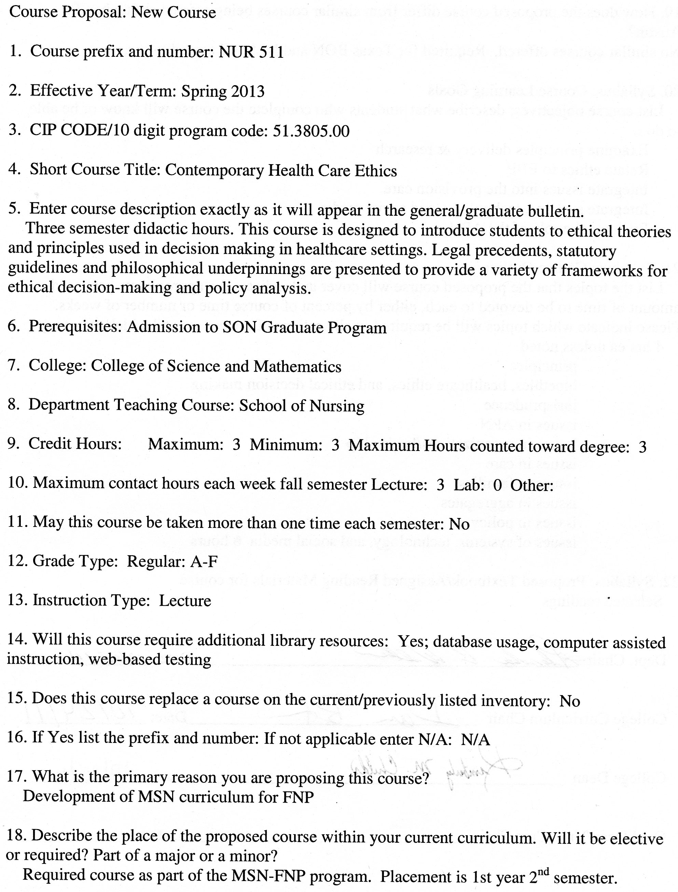

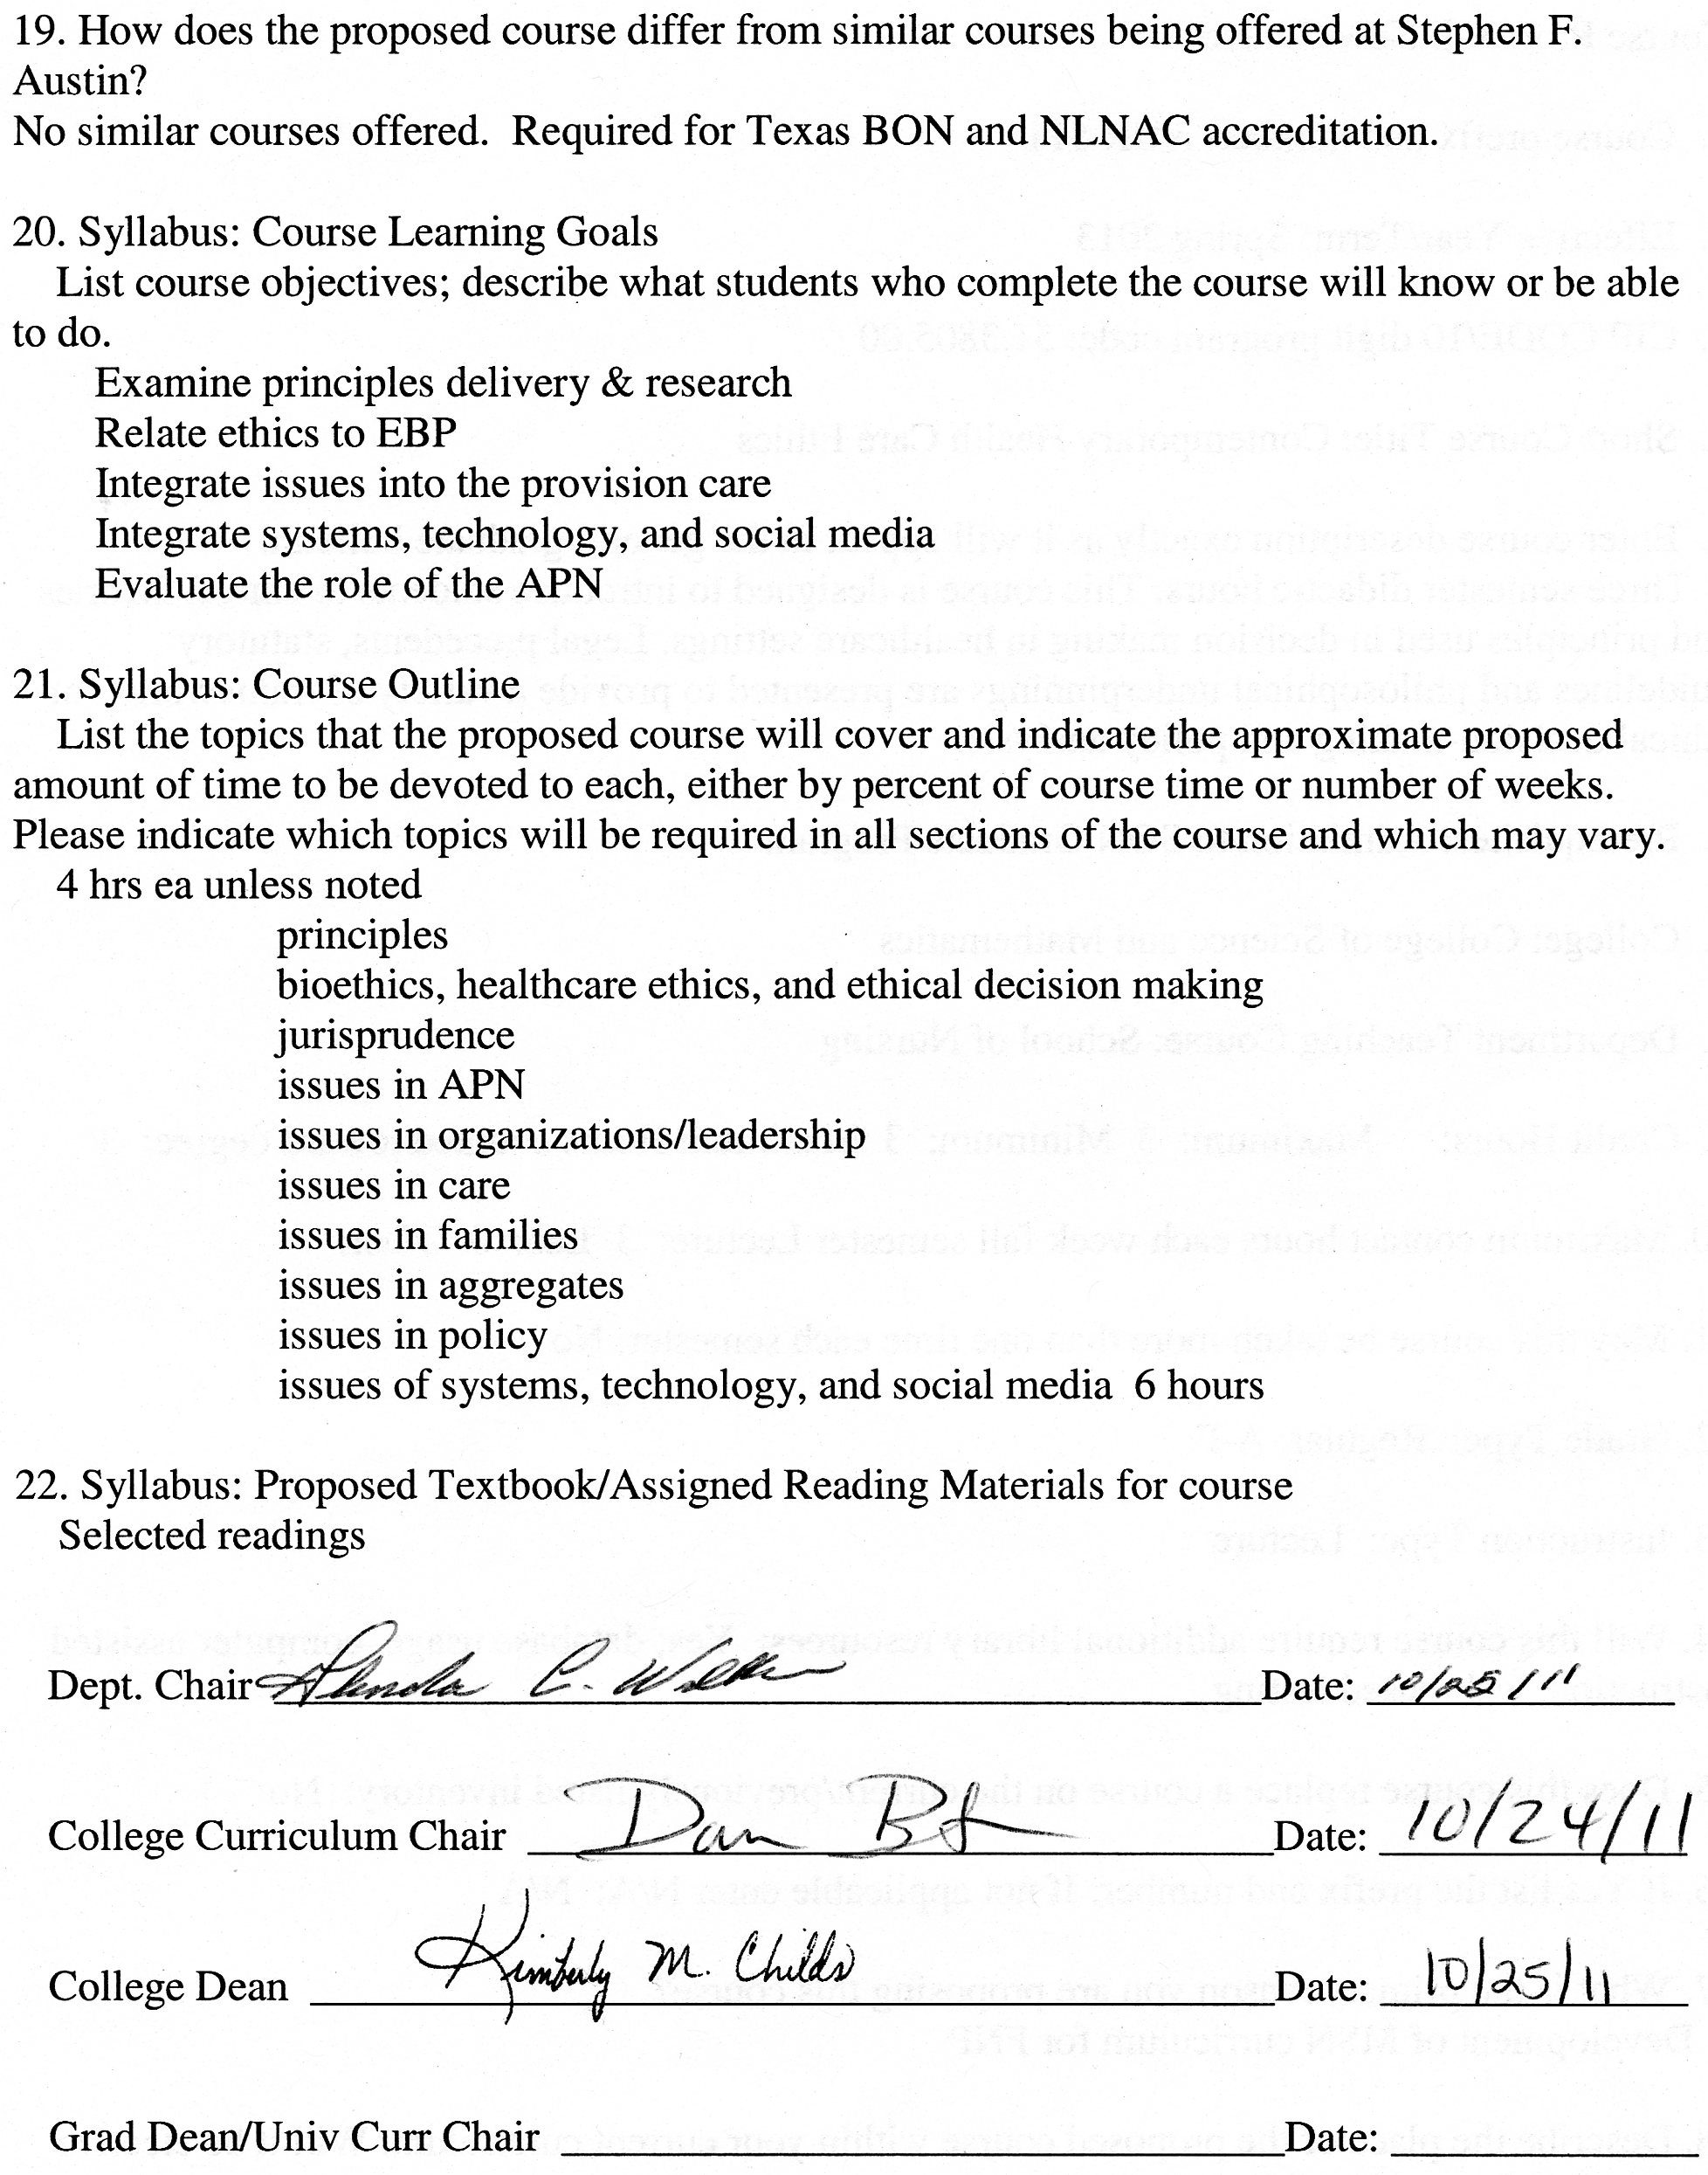

**Stephen F. Austin State University**

**DeWitt School of Nursing**

**Contemporary Healthcare Ethics**

**Course Number: NUR 511**

**ALL INFORMATION IN THIS SYLLABUS IS SUBJECT TO THE WRITTEN POLICIES AND PROCEDURES OF THE SCHOOL OF NURSING, STEPHEN F. AUSTIN STATE UNIVERSITY, NACOGDOCHES, TEXAS**

**IN THE CASE OF COMMISSION, OMISSION, AMBIGUITY, VAGUENESS, OR CONFLICT, THE POLICIES AND PROCEDURES OF THE SCHOOL OF NURSING SHALL CONTROL.**

**EACH STUDENT SHALL BE RESPONSIBLE FOR ACTUAL AND/OR CONSTRUCTIVE KNOWLEDGE OF THE POLICIES AND PROCEDURES OF THE SCHOOL OF NURSING AND FOR COMPLIANCE THEREWITH.**

**THE STUDENT IS RESPONSIBLE FOR ALL INFORMATION IN THIS SYLLABUS.**

***This syllabus is provided for information purposes only.***

**Faculty Information**

**Name:**

**Department: Nursing**

**Email:**

**Phone:**

**Office:**

**Office Hours:**

**Class Meeting Time and Place:** This course is taught in an online format.

|  |  |  |
| --- | --- | --- |
| Week | Date | Topic |
| 1 |  | Introduction  Review of Syllabus |
| 2 |  | Introduction to ethical principles and frameworks |
| 3 |  | Introduction to ethical principles and frameworks |
| 4 |  | Introduction to bioethics, healthcare ethics, and ethical decision making |
| 5 |  | Introduction to bioethics, healthcare ethics, and ethical decision making |
| 6 |  | Introduction to jurisprudence in the healthcare system |
| 7 |  | Ethics and legal issues in advanced nursing practice |
| 8 |  | Ethics and legal issues in organizations and leadership |
| 9 |  | Ethics and legal issues in the care of individuals |
| 10 |  | Ethics and legal issues in the care of families |
| 11 |  | Ethics and legal issues in the care of aggregates |
| 12 |  | Ethics and legal issues related to local, state, national and international policy |
| 13 |  | Ethics and legal issues involved in the use of healthcare information systems, patient care technology, and social media |
| 14 |  | Ethics and legal issues involved in the use of healthcare information systems, patient care technology, and social media |
| 15 |  | Ethical and legal issues related to drug use and research (Tuskegee Experiment) |
| 16 |  | Review and summary of course |

NUR 511: Contemporary Healthcare Ethics

**Course Description**

This course is designed to introduce students to ethical theories and principles used in decision making in Healthcare settings. Legal precedents, statutory guidelines and philosophical underpinnings are presented to provide a variety of frameworks for ethical decision-making and policy analysis.

**Prerequisites** Admission to SON Graduate Program

**Credit Hour Distribution**

3 credit hours

**Course Objectives**

Upon completion of this course, the student is expected to:

1. Assemble concepts and principles of the arts, sciences, humanities, and nursing in order to formulate both personal and professional responses to ethical issues encountered by advance practice nurses.
2. Examine ethical and legal principles used in healthcare delivery and research.
3. Related ethical frameworks to evidence based practice.
4. Integrate moral, ethical, economic, and legal issues into the provision of nursing care to clients, families, and the global community.
5. Integrate the use of healthcare information systems, patient care technology, and social media into the legal and ethical frameworks used in the delivery of healthcare.
6. Evaluate the role of the APN as a member of the interdisciplinary healthcare team, respecting holistic, socio-economic, spiritual, and ethno-culturally diverse characteristics of clients.

**Topics**

1. Introduction to ethical principles and frameworks
2. Introduction to bioethics, healthcare ethics, and ethical decision making
3. Introduction to jurisprudence in the healthcare system
4. Ethics and legal issues in advanced nursing practice
5. Ethics and legal issues in organizations and leadership
6. Ethics and legal issues in the care of individuals
7. Ethics and legal issues in the care of families
8. Ethics and legal issues in the care of aggregates
9. Ethics and legal issues related to local, state, national and international policy
10. Ethics and legal issues involved in the use of healthcare information systems, patient care technology, and social media

**Instructional Methods**

Discussion board, PowerPoint presentations, case studies, module exams and projects as assigned.

**Teaching Strategies**

Online discussion, reading assignments, case studies, online lecture modules, online exams and student online presentations.

**Required Textbooks**

Selected readings

**Grades and Grading**

*PowerPoint Presentation* 30%.

*Discussion Average*– 20 %

*Case Studies Average*  25%.

*Module Exam Average* 25%

**Grading Scale**

A 90-100

B 80-89

C 70-79

D 60-69

F <60

See current Stephen F. Austin State University Graduate Bulletin for probation, suspension, and readmission details.

PowerPoint Presentation on a Healthcare Law and a Case that interprets the Law*.* Refer to online assignments folder for presentation instructions. See PowerPoint Presentation Grading Rubric.

Discussions – Average of all Weekly Discussions. See Online Discussion Requirements and Grading Rubric.

Case Studies – There will be a minimum of three case studies. See grading rubric.

Module Exams will be given.

**Stephen F. Austin State University**

**MSN-FNP Online Discussion Requirements and Grading Rubric**

*Background and Rational for Weekly Discussion Requirements and Grading*

For this online nursing course, you are completing 16 weeks of class room time (3 hours per week), course work and assignments online. It is important for online learners to understand that guidelines for online learning are given by the U.S. Department of Education and professional accrediting bodies through which Stephen F. Austin State University and the DeWitt School of Nursing are accredited. The following has been prepared to clarify weekly discussion requirements and grading for students participating in online nursing courses.

The purpose of the Weekly Discussions is to develop a scholarly and dynamic exchange between you, faculty, and other students in the course promoting an active and engaging online learning community. Your success and the success of your classmates in a positive learning environment is dependent on discussion participation and timely completion of assignments.

*Weekly Discussion Requirements*

* Students are expected to participate in weekly discussions on at **least three separate days out of seven** in the electronic week.
* The three weekly posts consist of ***one Main post and a minimum of two responses to peers. All will be posted on separate days.***
* The electronic week begins on Monday at 12:01 am CST and ends on Sunday at 12 midnight CST.
* There are no “make-ups” for not posting to the Weekly Discussions. If you need to be away or do not have computer access, you need to make alternative arrangements for participation and actively engaging in the course to meet weekly discussion requirements.
* Students must post a Main post to the Discussion board each week on or before Wednesday at 12 midnight CST.
* One point per day will be deducted for not having the Main post completed on or before Wednesday each week ensuring that all students have the opportunity for active learning and engagement with peers and course faculty.
* Students must read and respond to ***a minimum of two peer posts*** each week.
* Students ***must provide references in current APA format for all posts.***
* It is recommended that you prepare your weekly discussion posts in Microsoft Word and then cut and paste into the Blackboard discussion. This is because Blackboard ‘times out’.
* All discussions posted must reflect proficient writing standards.
* Posts must be in the correct Weekly Discussion board or no points will be awarded.

*Grading Rubric for PowerPoint Presentation*

|  |  |  |  |  |  |
| --- | --- | --- | --- | --- | --- |
|  | 25 | 20 | 15 | 10 | 0 |
| Quality of Content  (25 points) | Rich in content, full of thought, insight and synthesis with clear connections to previous or current content and/or to real life situations made with depth and detail. | Substantial information, thought, insight and analysis has taken place with some connection to previous or current content and/or to real life situations but lack of depth and detail. | Generally competent in summarizing learning, but information is thin and commonplace with limited connections and vague generalities. | Rudimentary and superficial regurgitation of content with no connections and/or completely off topic. | Not submitted or instructions not followed. |
| Relevance  (25 points) | The key issues within the prompt are indentified and answered. The discussion is consistently clear with few digressions. | The key issues within the prompt are identified but not all answered. The discussion is clear most of the time. | Some of the key issues within the prompt are identified but not answered. The discussion is not clear. | Confused, hard to follow and the key issues within the prompt are not identified or answered. | Not submitted or instructions not followed. |
| Reading and Resources  (25 points) | Readings and other resource materials are used to support comments. All references are documented according to current APA format. No APA format errors. | There is some reference to readings and other resource material. Most references are documented according to current APA format. Minimal APA format errors. | Little if any reference is made to readings. Major errors in references documented according to current APA format. Major APA format errors. | Readings and resources are not cited. No APA references. | Not submitted or instructions not followed. |
| Professionalism  (25 points) | Written in a professional manner, free of typos, spelling and mechanical errors. | Most writing in a professional manner, free of typos, spelling and mechanical errors. | Some writing written in a professional manner, free of typos, spelling and mechanical errors. | Most writing NOT written in a professional manner, free of typos, spelling and mechanical errors. | Not submitted or instructions not followed. |

*Discussion Rubric*

|  |  |  |  |  |  |
| --- | --- | --- | --- | --- | --- |
| Category | Exceeds  3 | Average  2 | Below  1 | Unacceptable  0 | POINTS |
| Main Post Discussion | Displays an outstanding integration of required reading and other scholarly works supporting the points and topics of discussion. | Displays some integration of required reading and other scholarly works supporting the points and topics of discussion. | Displays poor integration of required reading and other scholarly works supporting the points and topics of discussion. | No post. |  |
| Peer Response Discussion | Displays outstanding knowledge of concepts and issues presented in the courses as well as in their peers’ postings. | Displays some knowledge of concepts and issues presented in the course as well as in their peers’ postings. | Displays poor knowledge of concepts and issues presented in the course as well as their peers’ postings. | No post. |  |
| Scholarly Writing | Posts have no grammar, spelling, or current APA edition format mistakes. | Posts have few grammar, spelling, and/or current APA edition format mistakes. | Posts have multiple grammar, spelling, and/or current APA edition format mistakes. | No post. |  |

*Grading Rubric for Case Studies*

|  |  |  |  |  |  |
| --- | --- | --- | --- | --- | --- |
|  | 25 | 20 | 15 | 10 | 0 |
| Quality of Content  (25 points) | Rich in content, full of thought, insight and synthesis with clear connections to previous or current content and/or to real life situations made with depth and detail. | Substantial information, thought, insight and analysis has taken place with some connection to previous or current content and/or to real life situations but lack of depth and detail. | Generally competent in summarizing learning, but information is thin and commonplace with limited connections and vague generalities. | Rudimentary and superficial regurgitation of content with no connections and/or completely off topic. | Not submitted or instructions not followed. |
| Relevance  (25 points) | The key issues within the prompt are indentified and answered. The discussion is consistently clear with few digressions. | The key issues within the prompt are identified but not all answered. The discussion is clear most of the time. | Some of the key issues within the prompt are identified but not answered. The discussion is not clear. | Confused, hard to follow and the key issues within the prompt are not identified or answered. | Not submitted or instructions not followed. |
| Reading and Resources  (25 points) | Readings and other resource materials are used to support comments. All references are documented according to current APA format. No APA format errors. | There is some reference to readings and other resource material. Most references are documented according to current APA format. Minimal APA format errors. | Little if any reference is made to readings. Major errors in references documented according to current APA format. Major APA format errors. | Readings and resources are not mentioned. No APA references. | Not submitted or instructions not followed. |
| Professionalism  (25 points) | Written in a professional manner, free of typos, spelling and mechanical errors. | Most writing in a professional manner, free of typos, spelling and mechanical errors. | Some writing written in a professional manner, free of typos, spelling and mechanical errors. | Most writing NOT written in a professional manner, free of typos, spelling and mechanical errors. | Not submitted or instructions not followed. |